UNITED STATES

SECURITIES AND EXCHANGE COMMISSION
Washington, D.C. 20549

FORM 8-K

CURRENT REPORT

Pursuant to Section 13 or 15(d) of the Securities Exchange Act of 1934

Date of Report (Date of earliest event reported): June 2, 2026

SINTX Technologies, Inc.

(Exact name of registrant as specified in its charter)

Delaware | 001-33624 |  |  |  |  | 84-1375299
(State or other jurisdiction |  |  | (Commission |  |  | (IRS Employer
of incorporation) |  |  | File Number) |  |  | Identification No.)
 |  |  | 1885 West 2100 South
 |  |  | Salt Lake City, UT 84119
 | (Address of principal executive offices, including Zip Code)
 | Registrant’s telephone number, including area code: (801) 839-3500

(Former name or former address, if changed since last report)

Check the appropriate box below if the Form 8-K filing is intended to simultaneously satisfy the filing obligation of the registrant under any of the following provisions:

- Written communications pursuant to Rule 425 under the Securities Act (17 CFR 230.425)

- Soliciting material pursuant to Rule 14a-12 under the Exchange Act (17 CFR 240.14a-12)

- Pre-commencement communications pursuant to Rule 14d-2(b) under the Exchange Act (17 CFR 240.14d-2(b))

- Pre-commencement communications pursuant to Rule 13e-4(c) under the Exchange Act (17 CFR 240.13e-4(c)) Securities registered pursuant to Section 12(b) of the Act:

Title of each class: |  | Trading Symbol(s): |  | Name of each exchange on which registered:
Common Stock, par value $0.01 per share |  | SINT |  | The NASDAQ Capital Market

Indicate by check mark whether the registrant is an emerging growth company as defined in Rule 405 of the Securities Act of 1933 (§ 230.405 of this chapter) or Rule 12b-2 of the Securities Exchange Act of 1934 (§ 240.12b-2 of this chapter).

Emerging growth company ☐

If an emerging growth company, indicate by check mark if the registrant has elected not to use the extended transition period for complying with any new or revised financial accounting standards provided pursuant to Section 13(a) of the Exchange Act. ☐

Item 1.01 Entry into a Material Definitive Agreement.

Securities Purchase Agreement

On June 2, 2026, SINTX Technologies, Inc. (the “Company”) entered into a Securities Purchase Agreement (the “Purchase Agreement”) with certain accredited investors (the “Purchasers”) pursuant to which the Company agreed to sell in a private placement (the “Offering”) an aggregate of 1,882,845 units (the “Units”) at a purchase price of $2.39 per Unit for aggregate gross proceeds of approximately $4.5 million, before deducting fees and offering expenses.

Each Unit consists of: one share of the Company’s common stock, par value $0.01 per share (the “Common Stock”); one Class A Common Stock Purchase Warrant (the “Class A Warrant”); and one Class B Common Stock Purchase Warrant (the “Class B Warrant”).

The Purchase Agreement contains customary representations, warranties, covenants and closing conditions by the Company and the Purchasers. The Company also agreed to file a resale registration statement covering the shares of Common Stock sold in the Offering and the shares issuable upon exercise of the warrants pursuant to a Registration Rights Agreement described below.

The foregoing description of the Purchase Agreement does not purport to be complete and is qualified in its entirety by reference to the Purchase Agreement, a copy of which is filed as Exhibit 10.1 to this Current Report on Form 8-K and incorporated herein by reference.

On April 6, 2026, the Company entered into a Confidential and Proprietary Information Agreement (the “Partner Capital Agreement”) with Partner Capital Group, LLC (“Partner Capital”), pursuant to which Partner Capital acted as non-exclusive marketing and consulting representative to represent the Company for an initial three (3) months term from the date of this Agreement (the “Initial Term”) in a potential bona fide capital raising transaction involving the offer and sale of equity, equity-linked or debt securities of the Company to financial investors for the primary purpose of raising capital. Pursuant to the Partner Capital Agreement, the Company agreed to pay Partner Capital a cash placement fee equal to 7% of the aggregate gross proceeds received by the Company from targeted, qualified potential investors identified and introduced in writing during the Initial Term by Partner Capital, together with any other investors that are directly introduced to the Company for a potential investment in the Company and to reimburse certain expenses incurred in connection with the Offering. The Company also agreed to provide customary indemnification and contribution rights to Partner Capital.

The Partner Capital Agreement contains customary representations, warranties, covenants and closing conditions of the parties.

The foregoing description of the Partner Capital Agreement does not purport to be complete and is qualified in its entirety by reference to the Partner Capital Agreement, a copy of which is filed as Exhibit 10.3 to this Current Report on Form 8-K and incorporated herein by reference.

Class A Common Stock Warrants

At the closing of the Offering, the Company will issue Class A Warrants to purchase an aggregate of 1,882,845 shares of Common Stock. Each Class A Warrant becomes exercisable upon issuance, has an exercise price equal to $2.14 per share, subject to adjustment as provided therein, and expires on the fifth anniversary of its issuance.

The Class A Warrants contain customary anti-dilution adjustments for stock splits, stock dividends and similar events. In addition, subject to compliance with applicable Nasdaq rules and stockholder approval requirements, the exercise price of the Class A Warrants is subject to adjustment if the Company issues Common Stock or Common Stock Equivalents in certain future equity financing transactions at a price below the then-current exercise price.

The Class A Warrants also contain customary provisions relating to fundamental transactions, including mergers, consolidations, sales of substantially all assets and similar transactions. Holders may exercise the warrants on a cashless basis under certain circumstances. The Class A Warrants are also subject to beneficial ownership limitations of 4.99% or 9.99%, at the election of the holder.

The foregoing description of the Class A Warrants does not purport to be complete and is qualified in its entirety by reference to the form of Class A Common Stock Warrant filed as Exhibit 4.1 to this Current Report on Form 8-K and incorporated herein by reference.

Class B Common Stock Warrants

At the closing of the Offering, the Company will issue Class B Warrants to purchase an aggregate of 1,882,845 shares of Common Stock. The Class B Warrants are immediately exercisable, have an exercise price of $2.14 per share, subject to adjustment as provided therein, and expire on the second anniversary of the initial exercise date.

The Class B Warrants contain customary anti-dilution adjustments for stock splits, stock dividends and similar events. In addition, subject to compliance with applicable Nasdaq rules and stockholder approval requirements, the exercise price of the Class B Warrants is subject to a adjustment if the Company completes certain future equity financings at a price below the then-current exercise price. The Class B Warrants also contain customary provisions relating to fundamental transactions, including mergers, consolidations and sales of substantially all of the Company’s assets. Under certain circumstances, holders may exercise the Class B Warrants on a cashless basis. The Class B Warrants are also subject to beneficial ownership limitations of 4.99% or 9.99%, at the election of the holder.

In addition, upon the occurrence of specified revenue milestones, the Company may require holders to exercise all or a portion of their then-outstanding Class B Warrants. Specifically, if the Company reports quarterly revenue of at least $2.0 million in a fiscal quarter, as evidenced in a Quarterly Report on Form 10-Q, Annual Report on Form 10-K, or certain Current Reports on Form 8-K, the Company may deliver a notice requiring the holder to exercise all or a specified portion of the outstanding Class B Warrants within five business days. Any portion of the called warrants not timely exercised would automatically expire without consideration, subject to the warrant’s beneficial ownership limitations.

The foregoing description of the Class B Warrants does not purport to be complete and is qualified in its entirety by reference to the form of Class B Common Stock Warrant filed as Exhibit 4.2 to this Current Report on Form 8-K and incorporated herein by reference.

Registration Rights Agreement

In connection with the Offering, the Company entered into a Registration Rights Agreement (the “Registration Rights Agreement”) with the Purchasers. Pursuant to the Registration Rights Agreement, the Company agreed to file with the Securities and Exchange Commission (the “SEC”) a registration statement covering the resale of the shares of Common Stock sold in the Offering and the shares issuable upon exercise of the warrants no later than 30 calendar days following the closing of the Offering and to use its best efforts to cause such registration statement to be declared effective within 60 calendar days after the closing (or 90 calendar days in the event of SEC review).

The Company also agreed to use its best efforts to maintain the effectiveness of the registration statement until all registrable securities covered thereby have been sold or may be sold without restriction pursuant to Rule 144 under the Securities Act of 1933, as amended (the “Securities Act”).

The foregoing description of the Registration Rights Agreement does not purport to be complete and is qualified in its entirety by reference to the Registration Rights Agreement, a copy of which is filed as Exhibit 10.2 to this Current Report on Form 8-K and incorporated herein by reference.

Item 3.02 Unregistered Sales of Equity Securities.

The disclosure set forth above under Item 1.01 is incorporated herein by reference.

On June 2, 2026, the Company entered into a private placement of 1,882,845 Units to accredited investors for aggregate gross proceeds of approximately $4.5 million, before deducting placement agent fees and offering expenses. Each Unit consisted of one share of Common Stock, one Class A Warrant and one Class B Warrant. The Class A Warrants and Class B Warrants each entitle the holder to purchase one share of Common Stock for each share of Common Stock purchased in the Offering, resulting in aggregate warrant coverage equal to 200% of the shares of Common Stock issued in the Offering.

The securities issued in the Offering were offered and sold in reliance upon the exemption from registration provided by Section 4(a)(2) of the Securities Act and Rule 506(b) of Regulation D promulgated thereunder. The Purchasers represented that they were accredited investors, acquired the securities for investment purposes only and not with a view toward distribution, and appropriate restrictive legends were placed on the securities issued in the Offering. The Offering was conducted without any general solicitation or general advertising.

The securities issued in the Offering have not been registered under the Securities Act or applicable state securities laws and may not be offered or sold in the United States absent registration or an applicable exemption from the registration requirements of the Securities Act and applicable state securities laws.

Item 8.01. Other Events

On June 3, 2026, the Company issued a press release announcing the Private Placement. A copy of the press release is attached hereto as Exhibit 99.1 and is incorporated herein by reference.

Item 9.01 Financial Statements and Exhibits.

(d) Exhibits.
 | Exhibit No. |  | Description
4.1 |  |  | Form of Class A Common Stock Purchase Warrant
4.2 |  |  | Form of Class B Common Stock Purchase Warrant
10.1 |  |  | Securities Purchase Agreement, dated June 2, 2026
10.2 |  |  | Registration Rights Agreement, dated June 2, 2026
10.3 |  |  | Partner Capital Agreement, dated April 6, 2026
99.1 |  |  | Press Release dated June 3, 2026
104 |  |  | Cover Page Interactive Data File (embedded within the Inline XBRL document)

SIGNATURES

Pursuant to the requirements of the Securities Exchange Act of 1934, the registrant has duly caused this report to be signed on its behalf by the undersigned hereunto duly authorized.

 |  | SINTX Technologies, Inc.
Date: June 3, 2026 |  | By: /s/ Eric K. Olson
 |  |  | Eric K. Olson
 |  |  | Chief Executive Officer

Exhibit 4.1

NEITHER THIS SECURITY NOR THE SECURITIES FOR WHICH THIS SECURITY IS EXERCISABLE HAVE BEEN REGISTERED WITH THE SECURITIES AND EXCHANGE COMMISSION OR THE SECURITIES COMMISSION OF ANY STATE IN RELIANCE UPON AN EXEMPTION FROM REGISTRATION UNDER THE SECURITIES ACT OF 1933, AS AMENDED (THE “SECURITIES ACT”), AND, ACCORDINGLY, MAY NOT BE OFFERED OR SOLD EXCEPT PURSUANT TO AN EFFECTIVE REGISTRATION STATEMENT UNDER THE SECURITIES ACT OR PURSUANT TO AN AVAILABLE EXEMPTION FROM, OR IN A TRANSACTION NOT SUBJECT TO, THE REGISTRATION REQUIREMENTS OF THE SECURITIES ACT AND IN ACCORDANCE WITH APPLICABLE STATE SECURITIES LAWS. THIS SECURITY AND THE SECURITIES ISSUABLE UPON EXERCISE OF THIS SECURITY MAY BE PLEDGED IN CONNECTION WITH A BONA FIDE MARGIN ACCOUNT OR OTHER LOAN SECURED BY SUCH SECURITIES.

CLASS A COMMON STOCK PURCHASE WARRANT

SINTX TECHNOLOGIES, INC.

Warrant Shares: _______

Initial Exercise Date: _______, 2026

THIS CLASS A COMMON STOCK PURCHASE WARRANT (the “Warrant”) certifies that, for value received, _____________ or its

assigns (the “Holder”) is entitled, upon the terms and subject to the limitations on exercise and the conditions hereinafter set forth, at any time on or after
the date hereof (the “Initial Exercise Date”) and on or prior to 5:00 p.m. (New York City time) on ________¹ (the “Termination Date”) but not thereafter, to
subscribe for and purchase from SINTX Technologies, Inc., a Delaware corporation (the “Company”), up to ______ shares (as subject to adjustment

hereunder, the “Warrant Shares”) of Common Stock. The purchase price of one share of Common Stock under this Warrant shall be equal to the Exercise Price, as defined in Section 2(b).

Section 1. Definitions. Capitalized terms used and not otherwise defined herein shall have the meanings set forth in that certain Securities Purchase Agreement (the “Purchase Agreement”), dated June 2, 2026, among the Company and the purchasers signatory thereto.

“Fundamental Transaction” means (i) any merger or consolidation of the Company with or into another entity, (ii) any sale of all or substantially all of the Company’s assets, (iii) any tender offer or exchange offer resulting in a change of control of the Company, or (iv) any reclassification, recapitalization or other transaction in which the Common Stock is converted into or exchanged for other securities, cash or property.

- Insert the date that is the five (5) year anniversary of the Initial Exercise Date.. 1

Section 2. Exercise.

- Exercise of Warrant. Exercise of the purchase rights represented by this Warrant may be made, in whole or in part, at any time or times on or after the Initial Exercise Date and on or before the Termination Date by delivery to the Company of a duly executed PDF copy submitted by e-mail (or e-mail attachment) of the Notice of Exercise in the form annexed hereto (the “Notice of Exercise”). Within the earlier of (i) one (1) Trading Day and (ii) the number of Trading Days comprising the Standard Settlement Period (as defined in Section 2(d)(i) herein) following the date of exercise as aforesaid, the Holder shall deliver the aggregate Exercise Price for the shares specified in the applicable Notice of Exercise by wire transfer or cashier’s check drawn on a United States bank unless the cashless exercise procedure specified in Section 2(c) below is specified in the applicable Notice of Exercise. No ink-original Notice of Exercise shall be required, nor shall any medallion guarantee (or other type of guarantee or notarization) of any Notice of Exercise be required. Notwithstanding anything herein to the contrary, the Holder shall not be required to physically surrender this Warrant to the Company until the Holder has purchased all of the Warrant Shares available hereunder and the Warrant has been exercised in full, in which case, the Holder shall surrender this Warrant to the Company for cancellation within three (3) Trading Days of the date on which the final Notice of Exercise is delivered to the Company. Partial exercises of this Warrant resulting in purchases of a portion of the total number of Warrant Shares available hereunder shall have the effect of lowering the outstanding number of Warrant Shares purchasable hereunder in an amount equal to the applicable number of Warrant Shares purchased. The Holder and the Company shall maintain records showing the number of Warrant Shares purchased and the date of such purchases. The Company shall deliver any objection to any Notice of Exercise on the Trading Day of receipt of such notice. The Holder and any assignee, by acceptance of this Warrant, acknowledge and agree that, by reason of the provisions of this paragraph, following the purchase of a portion of the Warrant Shares hereunder, the number of Warrant Shares available for purchase hereunder at any given time may be less than the amount stated on the face hereof.

- Exercise Price. The exercise price per share of Common Stock under this Warrant shall be equal to the Per Share Purchase Price (as defined in the Purchase Agreement), subject to adjustment hereunder (the “Exercise Price”). In no event shall the Exercise Price be less than the Minimum Price (as defined in the Purchase Agreement) as of the date of issuance of this Warrant.

- Cashless Exercise. If at any time after sixty (60) days after the Initial Exercise Date there is no effective registration statement registering, or the prospectus contained therein is not available for the resale of the Warrant Shares by the Holder, this Warrant may also be exercised on a cashless basis in which the Holder shall be entitled to receive a number of Warrant Shares determined as follows:

X = Y [(A-B)/A]

where:

“X” equals the number of Warrant Shares to be issued to the Holder;

“Y” equals the total number of Warrant Shares with respect to which this Warrant is then being exercised;

2

“A” as elected by the Holder: (i) the VWAP of the Common Stock on the Trading Day immediately preceding the date of the applicable Exercise Notice if such Exercise Notice is (1) both executed and delivered pursuant to Section 1(a) hereof on a day that is not a Trading Day or (2) both executed and delivered pursuant to Section 1(a) hereof on a Trading Day prior to the opening of “regular trading hours” (as defined in Rule 600(b)(64) of Regulation NMS promulgated under the federal securities laws) on such Trading Day, (ii) at the option of the Holder, either (y) the VWAP on the Trading Day immediately preceding the date of the applicable Exercise Notice or (z) the Bid Price of the Common Stock as of the time of the Holder’s execution of the applicable Exercise Notice if such Exercise Notice is executed during “regular trading hours” on a Trading Day and is delivered within two (2) hours thereafter pursuant to Section 1(a) hereof, or (iii) the Closing Sale Price of the Common Stock on the date of the applicable Exercise Notice if the date of such Exercise Notice is a Trading Day and such Exercise Notice is both executed and delivered pursuant to Section 1(a) hereof after the close of “regular trading hours” on such Trading Day.; and

“B” equals the Exercise Price then in effect for the applicable Warrant Shares at the time of such exercise.

- Mechanics of Exercise.

  - Delivery of Warrant Shares Upon Exercise. The Company shall cause the Warrant Shares purchased hereunder to be transmitted by the Transfer Agent to the Holder by crediting the account of the Holder’s or its designee’s balance account with The Depository Trust Company through its Deposit or Withdrawal at Custodian system (“DWAC”) if the Company is then a participant in such system and either (A) there is an effective registration statement permitting the issuance of the Warrant Shares to or resale of the Warrant Shares by the Holder or (B) the Warrant Shares are eligible for resale by the Holder without volume or manner-of-sale limitations pursuant to Rule 144 (assuming cashless exercise of the Warrants), and otherwise by physical delivery of a certificate, registered in the Company’s share register in the name of the Holder or its designee, for the number of Warrant Shares to which the Holder is entitled pursuant to such exercise to the address specified by the Holder in the Notice of Exercise by the date that is the earlier of (i) one (1) Trading Day after the delivery to the Company of the Notice of Exercise and (ii) the number of Trading Days comprising the Standard Settlement Period after the delivery to the Company of the Notice of Exercise (such date, the “Warrant Share Delivery Date”). Upon delivery of the Notice of Exercise, the Holder shall be deemed for all corporate purposes to have become the holder of record of the Warrant Shares with respect to which this Warrant has been exercised, irrespective of the date of delivery of the Warrant Shares, provided that payment of the aggregate Exercise Price (other than in the case of a cashless exercise) is received within the earlier of (i) one (1) Trading Day and (ii) the number of Trading Days comprising the Standard Settlement Period following delivery of the Notice of Exercise. The Company agrees to maintain a transfer agent that is a participant in the FAST program so long as this Warrant remains outstanding and exercisable. As used herein, “Standard Settlement Period” means the standard settlement period, expressed in a number of Trading Days, on the Company’s primary Trading Market with respect to the Common Stock as in effect on the date of delivery of the Notice of Exercise.

3

- Delivery of New Warrants Upon Exercise. If this Warrant shall have been exercised in part, the Company shall, at the request of a Holder and upon surrender of this Warrant certificate, at the time of delivery of the Warrant Shares, deliver to the Holder a new Warrant evidencing the rights of the Holder to purchase the unpurchased Warrant Shares called for by this Warrant, which new Warrant shall in all other respects be identical with this Warrant.

- Rescission Rights. If the Company fails to cause the Transfer Agent to transmit to the Holder the Warrant Shares pursuant to Section 2(d)(i) by the Warrant Share Delivery Date, then the Holder will have the right to rescind such exercise.

- No Fractional Shares or Scrip. No fractional shares or scrip representing fractional shares shall be issued upon the exercise of this Warrant. As to any fraction of a share which the Holder would otherwise be entitled to purchase upon such exercise, the Company shall, at its election, either pay a cash adjustment in respect of such final fraction in an amount equal to such fraction multiplied by the Exercise Price or round up to the next whole share.

- Charges, Taxes and Expenses. Issuance of Warrant Shares shall be made without charge to the Holder for any issue or transfer tax or other incidental expense in respect of the issuance of such Warrant Shares, all of which taxes and expenses shall be paid by the Company, and such Warrant Shares shall be issued in the name of the Holder or in such name or names as may be directed by the Holder; provided, however, that, in the event that Warrant Shares are to be issued in a name other than the name of the Holder, this Warrant when surrendered for exercise shall be accompanied by the Assignment Form attached hereto duly executed by the Holder and the Company may require, as a condition thereto, the payment of a sum sufficient to reimburse it for any transfer tax incidental thereto. For the avoidance of doubt, the Company shall not be responsible for any tax which may be payable in respect of any transfers involved in the registration of any book entry or certificates for Warrant Shares or Warrants in a name other than that of the Holder. The Company shall pay all Transfer Agent fees required for same-day processing of any Notice of Exercise and all fees to the Depository Trust Company (or another established clearing corporation performing similar functions) required for same-day electronic delivery of the Warrant Shares.

- Closing of Books. The Company will not close its stockholder books or records in any manner which prevents the timely exercise of this Warrant, pursuant to the terms hereof.

4

- Holder’s Exercise Limitations. The Company shall not effect any exercise of this Warrant, and a Holder shall not have the right to exercise any portion of this Warrant, pursuant to Section 2 or otherwise, to the extent that after giving effect to such issuance after exercise as set forth on the applicable Notice of Exercise, the Holder (together with the Holder’s Affiliates, and any other Persons acting as a group together with the Holder or any of the Holder’s Affiliates (such Persons, “Attribution Parties”)), would beneficially own in excess of the Beneficial Ownership Limitation (as defined below). For purposes of the foregoing sentence, the number of shares of Common Stock beneficially owned by the Holder and its Affiliates and Attribution Parties shall include the number of shares of Common Stock issuable upon exercise of this Warrant with respect to which such determination is being made, but shall exclude the number of shares of Common Stock which would be issuable upon (i) exercise of the remaining, nonexercised portion of this Warrant beneficially owned by the Holder or any of its Affiliates or Attribution Parties and (ii) exercise or conversion of the unexercised or nonconverted portion of any other securities of the Company (including, without limitation, any other Common Stock Equivalents) subject to a limitation on conversion or exercise analogous to the limitation contained herein beneficially owned by the Holder or any of its Affiliates or Attribution Parties. Except as set forth in the preceding sentence, for purposes of this Section 2(e), beneficial ownership shall be calculated in accordance with Section 13(d) of the Exchange Act and the rules and regulations promulgated thereunder, it being acknowledged by the Holder that the Company is not representing to the Holder that such calculation is in compliance with Section 13(d) of the Exchange Act and the Holder is solely responsible for any schedules required to be filed in accordance therewith. To the extent that the limitation contained in this Section 2(e) applies, the determination of whether this Warrant is exercisable (in relation to other securities owned by the Holder together with any Affiliates and Attribution Parties) and of which portion of this Warrant is exercisable shall be in the sole discretion of the Holder, and the submission of a Notice of Exercise shall be deemed to be the Holder’s determination of whether this Warrant is exercisable (in relation to other securities owned by the Holder together with any Affiliates and Attribution Parties) and of which portion of this Warrant is exercisable, in each case subject to the Beneficial Ownership Limitation, and the Company shall have no obligation to verify or confirm the accuracy of such determination. In addition, a determination as to any group status as contemplated above shall be determined in accordance with Section 13(d) of the Exchange Act and the rules and regulations promulgated thereunder. For purposes of this Section 2(e), in determining the number of outstanding shares of Common Stock, a Holder may rely on the number of outstanding shares of Common Stock as reflected in (A) the Company’s most recent periodic or annual report filed with the Commission, as the case may be, (B) a more recent public announcement by the Company or (C) a more recent written notice by the Company or the Transfer Agent setting forth the number of shares of Common Stock outstanding. Upon the written or oral request of a Holder, the Company shall within one Trading Day confirm orally and in writing to the Holder the number of shares of Common Stock then outstanding. In any case, the number of outstanding shares of Common Stock shall be determined after giving effect to the conversion or exercise of securities of the Company, including this Warrant, by the Holder or its Affiliates or Attribution Parties since the date as of which such number of outstanding shares of Common Stock was reported. The “Beneficial Ownership Limitation” shall be [4.99%][9.99%] of the number of shares of Common Stock outstanding immediately after giving effect to the issuance of shares of Common Stock issuable upon exercise of this Warrant. The Holder, upon notice to the Company, may increase or decrease the Beneficial Ownership Limitation provisions of this Section 2(e), provided that the Beneficial Ownership Limitation in no event exceeds 9.99% of the number of shares of the Common Stock outstanding immediately after giving effect to the issuance of shares of Common Stock upon exercise of this Warrant held by the Holder and the provisions of this Section 2(e) shall continue to apply. Any increase in the Beneficial Ownership Limitation

will not be effective until the 61st day after such notice is delivered to the Company. The provisions of this paragraph shall be construed and implemented in a manner otherwise than in strict conformity with the terms of this Section 2(e) to correct this paragraph (or any portion hereof) which may be defective or inconsistent with the intended Beneficial Ownership Limitation herein contained or to make changes or supplements necessary or desirable to properly give effect to such limitation. The limitations contained in this paragraph shall apply to a successor holder of this Warrant.

Section 3. Certain Adjustments.

- Stock Dividends and Splits. If the Company, at any time while this Warrant is outstanding: (i) pays a stock dividend or otherwise makes a distribution or distributions on shares of its Common Stock or any other equity or equity equivalent securities payable in shares of Common Stock (which, for avoidance of doubt, shall not include any shares of Common Stock issued by the Company upon exercise of this Warrant), (ii) subdivides outstanding shares of Common Stock into a larger number of shares, (iii) combines (including by way of reverse stock split) outstanding shares of Common Stock into a smaller number of shares, or (iv) issues by reclassification of shares of the Common Stock any shares of capital stock of the Company, then in each case the Exercise Price shall be multiplied by a fraction of which the numerator shall be the number of shares of Common Stock (excluding treasury shares, if any) outstanding immediately before such event and of which the denominator shall be the number of shares of Common Stock outstanding immediately after such event, and the number of shares issuable upon exercise of this Warrant shall be proportionately adjusted such that the aggregate Exercise Price of this Warrant shall remain unchanged. Any adjustment made pursuant to this Section 3(a) shall become effective immediately after the record date for the determination of stockholders entitled to receive such dividend or distribution and shall become effective immediately after the effective date in the case of a subdivision, combination or re-classification; provided that if such record date is fixed and such dividend is not fully paid or such Distribution is not fully made on the date fixed therefor, the Exercise Price shall be recomputed accordingly as of the close of business on such record date and thereafter such Exercise Price shall be adjusted pursuant to this Section 3(a) to reflect the actual payment of such dividends or Distributions.

5

- Subsequent Rights Offerings. In addition to any adjustments pursuant to Section 3(a) above, if at any time the Company grants, issues or sells any Common Stock Equivalents or rights to purchase stock, warrants, securities or other property pro rata to the record holders of any class of shares of Common Stock (the “Purchase Rights”), then the Holder will be entitled to acquire, upon the terms applicable to such Purchase Rights, the aggregate Purchase Rights which the Holder could have acquired if the Holder had held the number of shares of Common Stock acquirable upon complete exercise of this Warrant (without regard to any limitations on exercise hereof, including without limitation, the Beneficial Ownership Limitation) immediately before the date on which a record is taken for the grant, issuance or sale of such Purchase Rights, or, if no such record is taken, the date as of which the record holders of shares of Common Stock are to be determined for the grant, issue or sale of such Purchase Rights (provided, however, that, to the extent that the Holder’s right to participate in any such Purchase Right would result in the Holder exceeding the Beneficial Ownership Limitation, then the Holder shall not be entitled to participate in such Purchase Right to such extent (or beneficial ownership of such shares of Common Stock as a result of such Purchase Right to such extent) and such Purchase Right to such extent shall be held in abeyance for the Holder until such time, if ever, as its right thereto would not result in the Holder exceeding the Beneficial Ownership Limitation).

- Pro Rata Distributions. During such time as this Warrant is outstanding, if the Company shall declare or make any dividend or other distribution of its assets (or rights to acquire its assets) to holders of shares of Common Stock, by way of return of capital or otherwise (including, without limitation, any distribution of cash, stock or other securities, property or options by way of a dividend, spin off, reclassification, corporate rearrangement, scheme of arrangement or other similar transaction) (a “Distribution”), at any time after the issuance of this Warrant, then, in each such case, the Holder shall be entitled to participate in such Distribution to the same extent that the Holder would have participated therein if the Holder had held the number of shares of Common Stock acquirable upon complete exercise of this Warrant in full (without regard to any limitations on exercise hereof, including without limitation, the Beneficial Ownership Limitation) immediately before the date of which a record is taken for such Distribution, or, if no such record is taken, the date as of which the record holders of shares of Common Stock are to be determined for the participation in such Distribution (provided, however, that, to the extent that the Holder’s right to participate in any such Distribution would result in the Holder exceeding the Beneficial Ownership Limitation, then the Holder shall not be entitled to participate in such Distribution to such extent (or in the beneficial ownership of any shares of Common Stock as a result of such Distribution to such extent) and the portion of such Distribution shall be held in abeyance for the benefit of the Holder until such time, if ever, as its right thereto would not result in the Holder exceeding the Beneficial Ownership Limitation).

6

- Subsequent Financing Adjustment. If, at any time during the period commencing on the Initial Exercise Date and ending on the Termination Date, the Company issues or sells shares of Common Stock or Common Stock Equivalents in a bona fide equity financing transaction for cash at a price per share less than the then-current Exercise Price of this Warrant (a “Dilutive Issuance”), then, subject to the limitations set forth below, the Exercise Price of this Warrant shall be reduced to such lower price per share. Notwithstanding the foregoing, in no event shall the Exercise Price be reduced unless and until the Company shall have obtained stockholder approval of such adjustment to the extent required by the applicable rules and regulations of The Nasdaq Stock Market LLC, including Nasdaq Listing Rule 5635(d); if stockholder approval is required by Nasdaq rules for any adjustment below the Minimum Price the Company shall use its best efforts to obtain such approval and, if in the event such approval has not been obtained, then the Exercise Price shall not be adjusted below the Minimum Price unless and until such stockholder approval is obtained. This Section 3(d) shall not apply to any Exempt Issuance (as defined in the Securities Purchase Agreement), including, without limitation, any sales or issuances of Common Stock or Common Stock Equivalents pursuant to any “at-the-market” offering program of the Company in effect on the Initial Exercise Date or established thereafter in compliance with applicable Nasdaq rules. For purposes of this Section 3(d), “bona fide equity financing transaction for cash” means an issuance or sale by the Company of shares of Common Stock or Common Stock Equivalents in a capital raising transaction for cash consideration, the primary purpose of which is to raise equity capital for the Company and which does not constitute an Exempt Issuance.

- Fundamental Transaction. The Company shall not enter into or be party to a Fundamental Transaction unless (i) the Successor Entity assumes in writing all of the obligations of the Company under this Warrant and the other Transaction Documents (as defined in the Securities Purchase Agreement) in accordance with the provisions of this Section 3(e) pursuant to written agreements in form and substance satisfactory to the Holder and reasonably acceptable to the Holder prior to such Fundamental Transaction, including agreements to deliver to the Holder in exchange for this Warrant a security of the Successor Entity evidenced by a written instrument substantially similar in form and substance to this Warrant, including, without limitation, which is exercisable for a corresponding number of shares of capital stock equivalent to the shares of Common Stock acquirable and receivable upon exercise of this Warrant (without regard to any limitations on the exercise of this Warrant) prior to such Fundamental Transaction, and with an exercise price which applies the exercise price hereunder to such shares of capital stock (but taking into account the relative value of the shares of Common Stock pursuant to such Fundamental Transaction and the value of such shares of capital stock, such adjustments to the number of shares of capital stock and such exercise price being for the purpose of protecting the economic value of this Warrant immediately prior to the consummation of such Fundamental Transaction) and (ii) the Successor Entity (including its Parent Entity) is a publicly traded corporation whose equity securities are publicly traded on a nationally recognized securities exchange or quotation system. Upon the consummation of each Fundamental Transaction, the Successor Entity shall succeed to, and be substituted for (so that from and after the date of the applicable Fundamental Transaction, the provisions of this Warrant and the other Transaction Documents referring to the “Company” shall refer instead to the Successor Entity), and may exercise every right and power of the Company and shall assume all of the obligations of the Company under this Warrant and the other Transaction Documents with the same effect as if such Successor Entity had been named as the Company herein. Upon consummation of each Fundamental Transaction, the Successor Entity shall deliver to the Holder confirmation that there shall be issued upon exercise of this Warrant at any time after the consummation of the applicable Fundamental Transaction, in lieu of the shares of Common Stock (or other securities, cash, assets or other property (except such items still issuable under Sections 3(a) and 3(c) above, which shall continue to be receivable thereafter)) issuable upon the exercise of this Warrant prior to the applicable Fundamental Transaction, such shares of publicly traded common stock (or its equivalent) of the Successor Entity (including its Parent Entity) which the Holder would have been entitled to receive upon the happening of the applicable Fundamental Transaction had this Warrant been exercised immediately prior to the applicable Fundamental Transaction (without regard to any limitations on the exercise of this Warrant), as adjusted in accordance with the provisions of this Warrant. Notwithstanding the foregoing, and without limiting this Section 3(e) and the paragraph below regarding Black Scholes Value, the Holder may elect, at its sole option, by delivery of written notice to the Company to waive this Section 3(e) to permit the Fundamental Transaction without the assumption of this Warrant. In addition to and not in substitution for any other rights hereunder, prior to the consummation of each Fundamental Transaction pursuant to which holders of shares of Common Stock are entitled to receive securities or other assets with respect to or in exchange for shares of Common Stock (a “Corporate Event”), the Company shall make appropriate provision to insure that the Holder will thereafter have the right to receive upon an exercise of this Warrant at any time after the consummation of the applicable Fundamental Transaction but prior to the Expiration Date, in lieu of the shares of the Common Stock (or other securities, cash, assets or other property (except such items still issuable under Sections 3(a) and 3(c) above, which shall continue to be receivable thereafter)) issuable upon the exercise of the Warrant prior to such Fundamental Transaction, such shares of stock, securities, cash, assets or any other property whatsoever (including warrants or other purchase or subscription rights) which the Holder would have been entitled to receive upon the happening of the applicable Fundamental Transaction had this Warrant been exercised immediately prior to the applicable Fundamental Transaction (without regard to any limitations on the exercise of this Warrant). Provision made pursuant to the preceding sentence shall be in a form and substance reasonably satisfactory to the Holder.

7

Black Scholes Value. Notwithstanding the foregoing and the provisions of Section 3(e) above, at the request of the Holder delivered at any time commencing on the earliest to occur of (x) the public disclosure of any Fundamental Transaction, (y) the consummation of any Fundamental Transaction and (z) the Holder first becoming aware of any Fundamental Transaction through the date that is ninety (90) days after the public disclosure of the consummation of such Fundamental Transaction by the Company pursuant to a Current Report on Form 8-K filed with the SEC, the Company or the Successor Entity (as the case may be) shall purchase this Warrant from the Holder on the date of such request by paying to the Holder cash in an amount equal to the Black Scholes Value of the remaining unexercised portion of this Warrant. Payment of such amounts shall be made by the Company (or at the Company’s direction) to the Holder on or prior to the later of (x) the second (2nd) Trading Day after the date of such request and (y) the date of consummation of such Fundamental Transaction; provided, however, that if the Fundamental Transaction is not within the Company’s control, including in the event that such Fundamental Transaction is not approved by the board of directors of the Company, the Holder shall only be entitled to receive from the Company or any Successor Entity the same type or form of consideration (and in the same proportion), at the Black Scholes Value of the unexercised portion of this Warrant, that is being offered and paid to the holders of Common Stock of the Company in connection with the Fundamental Transaction, whether that consideration be in the form of cash, stock or any combination thereof, or whether the holders of Common Stock are given the choice to receive from among alternative forms of consideration in connection with the Fundamental Transaction; provided, further, that if holders of Common Stock of the Company are not offered or paid any consideration in such Fundamental Transaction, such holders of Common Stock will be deemed to have received common stock of the Successor Entity (which such Successor Entity may be the Company following such Fundamental Transaction) in such Fundamental Transaction.

“Black Scholes Value” means the value of this Warrant based on the Black-Scholes Option Pricing Model obtained from the “OV” function on Bloomberg, L.P. (“Bloomberg”) determined as of the day of consummation of the applicable Fundamental Transaction for pricing purposes and reflecting (A) a risk-free interest rate corresponding to the U.S. Treasury rate for a period equal to the time between the date of the public announcement of the applicable contemplated Fundamental Transaction and the Termination Date, (B) an expected volatility equal to the greater of (1) the 30 day volatility, (2) the 100 day volatility, each of clauses (1)-(2) as obtained from the HVT function on Bloomberg (determined utilizing a 365 day annualization factor) as of the Trading Day immediately following the public announcement of the applicable contemplated Fundamental Transaction, (C) the underlying price per share used in such calculation shall be the highest VWAP during the period beginning on the Trading Day immediately preceding the public announcement of the applicable contemplated Fundamental Transaction (or the consummation of the applicable Fundamental Transaction, if earlier) and ending on the Trading Day of the Holder’s request pursuant to this Section 3(d) and (D) a remaining option time equal to the time between the date of the public announcement of the applicable contemplated Fundamental Transaction and the Termination Date and (E) a zero cost of borrow.

- Calculations. All calculations under this Section 3 shall be made to the nearest cent or the nearest 1/100th of a share, as the case may be. For purposes of this Section 3, the number of shares of Common Stock deemed to be issued and outstanding as of a given date shall be the sum of the number of shares of Common Stock (excluding treasury shares, if any) issued and outstanding.

- Notice to Holder.

  - Adjustment to Exercise Price. Whenever the Exercise Price is adjusted pursuant to any provision of this Section 3, the Company shall promptly deliver to the Holder by email a notice setting forth the Exercise Price after such adjustment and any resulting adjustment to the number of Warrant Shares and setting forth a brief statement of the facts requiring such adjustment.

8

- Notice to Allow Exercise by Holder. If (A) the Company shall declare a dividend (or any other distribution in whatever form) on the Common Stock, (B) the Company shall declare a special nonrecurring cash dividend on or a redemption of the Common Stock, (C) the Company shall authorize the granting to all holders of the Common Stock rights or warrants to subscribe for or purchase any shares of capital stock of any class or of any rights, (D) the approval of any stockholders of the Company shall be required in connection with any reclassification of the Common Stock, any consolidation or merger to which the Company (or any of its Subsidiaries) is a party (other than a transaction solely to change the domicile of the Company), any sale or transfer of all or substantially all of its assets, or any compulsory share exchange whereby the Common Stock is converted into other securities, cash or property, or (E) the Company shall authorize the voluntary or involuntary dissolution, liquidation or winding up of the affairs of the Company, then, in each case, the Company shall cause to be delivered to the Holder at its last email address as it shall appear upon the Warrant Register (as defined below) of the Company, at least 20 calendar days prior to the applicable record or effective date hereinafter specified, a notice stating (x) the date on which a record is to be taken for the purpose of such dividend, distribution, redemption, rights or warrants, or if a record is not to be taken, the date as of which the holders of the Common Stock of record to be entitled to such dividend, distributions, redemption, rights or warrants are to be determined or (y) the date on which such reclassification, consolidation, merger, sale, transfer or share exchange is expected to become effective or close, and the date as of which it is expected that holders of the Common Stock of record shall be entitled to exchange their shares of the Common Stock for securities, cash or other property deliverable upon such reclassification, consolidation, merger, sale, transfer or share exchange; provided that the failure to deliver such notice or any defect therein or in the delivery thereof shall not affect the validity of the corporate action required to be specified in such notice. To the extent that any notice provided in this Warrant constitutes, or contains, material, non-public information regarding the Company or any of the Subsidiaries, the Company shall simultaneously file such notice with the Commission pursuant to a Current Report on Form 8-K. The Holder shall remain entitled to exercise this Warrant during the period commencing on the date of such notice to the effective date of the event triggering such notice except as may otherwise be expressly set forth herein.

Section 4. Transfer of Warrant.

- Transferability. Subject to compliance with any applicable securities laws and the conditions set forth in Section 4(d) hereof and to the provisions of Section 4.1 of the Purchase Agreement, this Warrant and all rights hereunder (including, without limitation, any registration rights) are transferable, in whole or in part, upon surrender of this Warrant at the principal office of the Company or its designated agent, together with a written assignment of this Warrant substantially in the form attached hereto duly executed by the Holder or its agent or attorney and funds sufficient to pay any transfer taxes payable upon the making of such transfer. Upon such surrender and, if required, such payment, the Company shall execute and deliver a new Warrant or Warrants in the name of the assignee or assignees, as applicable, and in the denomination or denominations specified in such instrument of assignment, and shall issue to the assignor a new Warrant evidencing the portion of this Warrant not so assigned, and this Warrant shall promptly be cancelled. Notwithstanding anything herein to the contrary, the Holder shall not be required to physically surrender this Warrant to the Company unless the Holder has assigned this Warrant in full, in which case, the Holder shall surrender this Warrant to the Company within three (3) Trading Days of the date on which the Holder delivers an assignment form to the Company assigning this Warrant in full. The Warrant, if properly assigned in accordance herewith, may be exercised by a new holder for the purchase of Warrant Shares without having a new Warrant issued.

9

- New Warrants. This Warrant may be divided or combined with other Warrants upon presentation hereof at the aforesaid office of the Company, together with a written notice specifying the names and denominations in which new Warrants are to be issued, signed by the Holder or its agent or attorney. Subject to compliance with Section 4(a), as to any transfer which may be involved in such division or combination, the Company shall execute and deliver a new Warrant or Warrants in exchange for the Warrant or Warrants to be divided or combined in accordance with such notice. All Warrants issued on transfers or exchanges shall be dated the Initial Exercise Date and shall be identical with this Warrant except as to the number of Warrant Shares issuable pursuant thereto.

- Warrant Register. The Company shall register this Warrant, upon records to be maintained by the Company for that purpose (the “Warrant Register”), in the name of the record Holder hereof from time to time. The Company may deem and treat the registered Holder of this Warrant as the absolute owner hereof for the purpose of any exercise hereof or any distribution to the Holder, and for all other purposes, absent actual notice to the contrary.

- Transfer Restrictions. If, at the time of the surrender of this Warrant in connection with any transfer of this Warrant, the transfer of this Warrant shall not be either (i) registered pursuant to an effective registration statement under the Securities Act and under applicable state securities or blue sky laws or (ii) eligible for resale without volume or manner-of-sale restrictions or current public information requirements pursuant to Rule 144, the Company may require, as a condition of allowing such transfer, that the Holder or transferee of this Warrant, as the case may be, comply with the provisions of Section 5.7 of the Purchase Agreement.

- Representation by the Holder. The Holder, by the acceptance hereof, represents and warrants that it is acquiring this Warrant and, upon any exercise hereof, will acquire the Warrant Shares issuable upon such exercise, for its own account and not with a view to or for distributing or reselling such Warrant Shares or any part thereof in violation of the Securities Act or any applicable state securities law, except pursuant to sales registered or exempted under the Securities Act.

10

Section 5. Miscellaneous.

- No Rights as Stockholder Until Exercise; No Settlement in Cash. This Warrant does not entitle the Holder to any voting rights, dividends or other rights as a stockholder of the Company prior to the exercise hereof as set forth in Section 2(d)(i), except as expressly set forth in Section 3. Without limiting any rights of a Holder to receive Warrant Shares on a “cashless exercise” pursuant to Section 2(c) or to receive cash payments pursuant to Section 2(d)(i) (solely with respect to fractional share payments) , in no event shall the Company be required to net cash settle an exercise of this Warrant.

- Loss, Theft, Destruction or Mutilation of Warrant. The Company covenants that upon receipt by the Company of evidence reasonably satisfactory to it of the loss, theft, destruction or mutilation of this Warrant or any stock certificate relating to the Warrant Shares, and in case of loss, theft or destruction, of indemnity or security reasonably satisfactory to it (which, in the case of the Warrant, shall not include the posting of any bond), and upon surrender and cancellation of such Warrant or stock certificate, if mutilated, the Company will make and deliver a new Warrant or stock certificate of like tenor and dated as of such cancellation, in lieu of such Warrant or stock certificate.

- Saturdays, Sundays, Holidays, etc. If the last or appointed day for the taking of any action or the expiration of any right required or granted herein shall not be a Business Day, then such action may be taken or such right may be exercised on the next succeeding Business Day.

- Authorized Shares.

The Company covenants that, during the period the Warrant is outstanding, it will reserve from its authorized and unissued Common Stock a sufficient number of shares to provide for the issuance of the Warrant Shares upon the exercise of any purchase rights under this Warrant. The Company further covenants that its issuance of this Warrant shall constitute full authority to its officers who are charged with the duty of issuing the necessary Warrant Shares upon the exercise of the purchase rights under this Warrant. The Company will take all such reasonable action as may be necessary to assure that such Warrant Shares may be issued as provided herein without violation of any applicable law or regulation, or of any requirements of the Trading Market upon which the Common Stock may be listed. The Company covenants that all Warrant Shares which may be issued upon the exercise of the purchase rights represented by this Warrant will, upon exercise of the purchase rights represented by this Warrant and payment for such Warrant Shares in accordance herewith, be duly authorized, validly issued, fully paid and nonassessable and free from all taxes, liens and charges created by the Company in respect of the issue thereof (other than taxes in respect of any transfer occurring contemporaneously with such issue).

11

Except and to the extent as waived or consented to by the Holder, the Company shall not by any action, including, without limitation, amending its certificate of incorporation or through any reorganization, transfer of assets, consolidation, merger, dissolution, issue or sale of securities or any other voluntary action, avoid or seek to avoid the observance or performance of any of the terms of this Warrant, but will at all times in good faith assist in the carrying out of all such terms and in the taking of all such actions as may be necessary or appropriate to protect the rights of Holder as set forth in this Warrant against impairment. Without limiting the generality of the foregoing, the Company will (i) not increase the par value of any Warrant Shares above the amount payable therefor upon such exercise immediately prior to such increase in par value, (ii) take all such action as may be necessary or appropriate in order that the Company may validly and legally issue fully paid and nonassessable Warrant Shares upon the exercise of this Warrant and (iii) use commercially reasonable efforts to obtain all such authorizations, exemptions or consents from any public regulatory body having jurisdiction thereof, as may be, necessary to enable the Company to perform its obligations under this Warrant.

Before taking any action which would result in an adjustment in the number of Warrant Shares for which this Warrant is exercisable or in the Exercise Price, the Company shall obtain all such authorizations or exemptions thereof, or consents thereto, as may be necessary from any public regulatory body or bodies having jurisdiction thereof.

- Jurisdiction. All questions concerning the construction, validity, enforcement and interpretation of this Warrant shall be determined in accordance with the provisions of the Purchase Agreement.

- Restrictions. The Holder acknowledges that the Warrant Shares acquired upon the exercise of this Warrant, if not registered, and the Holder does not utilize cashless exercise, will have restrictions upon resale imposed by state and federal securities laws.

- Nonwaiver and Expenses. No course of dealing or any delay or failure to exercise any right hereunder on the part of Holder shall operate as a waiver of such right or otherwise prejudice the Holder’s rights, powers or remedies, notwithstanding the fact that all rights hereunder terminate on the Termination Date. Without limiting any other provision of this Warrant or the Purchase Agreement, if the Company willfully and knowingly fails to comply with any provision of this Warrant, which results in any material damages to the Holder, the Company shall pay to the Holder such amounts as shall be sufficient to cover any costs and expenses including, but not limited to, reasonable attorneys’ fees, including those of appellate proceedings, incurred by the Holder in collecting any amounts due pursuant hereto or in otherwise enforcing any of its rights, powers or remedies hereunder.

- Notices. Any notice, request or other document required or permitted to be given or delivered to the Holder by the Company shall be delivered in accordance with the notice provisions of the Purchase Agreement.

12

- Limitation of Liability. No provision hereof, in the absence of any affirmative action by the Holder to exercise this Warrant to purchase Warrant Shares, and no enumeration herein of the rights or privileges of the Holder, shall give rise to any liability of the Holder for the purchase price of any Common Stock or as a stockholder of the Company, whether such liability is asserted by the Company or by creditors of the Company.

- Remedies. The Holder, in addition to being entitled to exercise all rights granted by law, including recovery of damages, will be entitled to specific performance of its rights under this Warrant. The Company agrees that monetary damages would not be adequate compensation for any loss incurred by reason of a breach by it of the provisions of this Warrant and hereby agrees to waive and not to assert the defense in any action for specific performance that a remedy at law would be adequate.

- Successors and Assigns. Subject to applicable securities laws, and the restrictions on transfer described herein or in the Purchase Agreement, this Warrant and the rights and obligations evidenced hereby shall inure to the benefit of and be binding upon the successors and permitted assigns of the Company and the successors and permitted assigns of Holder. The provisions of this Warrant are intended to be for the benefit of any Holder from time to time of this Warrant and shall be enforceable by the Holder or holder of Warrant Shares.

- Amendment. This Warrant may be modified or amended or the provisions hereof waived with the written consent of the Company and

the Holder.

- Severability. Wherever possible, each provision of this Warrant shall be interpreted in such manner as to be effective and valid under applicable law rule or regulation (including those of Nasdaq), but if any provision of this Warrant shall be prohibited by or invalid under applicable law, rule or regulation, such provision shall be ineffective to the extent of such prohibition or invalidity, without invalidating the remainder of such provisions or the remaining provisions of this Warrant.

- Headings. The headings used in this Warrant are for the convenience of reference only and shall not, for any purpose, be deemed a part of this Warrant.

********************

(Signature Page Follows)

13

IN WITNESS WHEREOF, the Company has caused this Warrant to be executed by its officer thereunto duly authorized as of the date first above indicated.

SINTX TECHNOLOGIES, INC.

By:

Name: Eric Olson

Title: Chairman and CEO

14

NOTICE OF EXERCISE

TO: SINTX TECHNOLOGIES, INC.

- The undersigned hereby elects to purchase ________ Warrant Shares of the Company pursuant to the terms of the attached Warrant (only if exercised in full), and tenders herewith payment of the Exercise Price in full, together with all applicable transfer taxes, if any.

- Payment shall take the form of (check applicable box):

[ ] in lawful money of the United States; or

[ ] if permitted the cancellation of such number of Warrant Shares as is necessary, pursuant to the cashless exercise provisions of Section 2(c), to exercise this Warrant with respect to the maximum number of Warrant Shares purchasable pursuant to the cashless exercise procedure set forth in subsection 2(c).

- Please issue said Warrant Shares in the name of the undersigned or in such other name as is specified below:

_______________________________

The Warrant Shares shall be delivered to the following DWAC Account Number:

_______________________________

_______________________________

_______________________________

- Accredited Investor. The undersigned is an “accredited investor” as defined in Regulation D promulgated under the Securities Act of

1933, as amended.

[SIGNATURE OF HOLDER]

Name of Investing Entity: ________________________________________________________________________

Signature of Authorized Signatory of Investing Entity: _________________________________________________

Name of Authorized Signatory: ___________________________________________________________________

Title of Authorized Signatory: ____________________________________________________________________

Date: ________________________________________________________________________________________

ASSIGNMENT FORM

(To assign the foregoing Warrant, execute this form and supply required information. Do not use this form to purchase shares.) FOR VALUE RECEIVED, the foregoing Warrant and all rights evidenced thereby are hereby assigned to
Name:

(Please Print)

Address:

(Please Print)

Phone Number:

Email Address:

Dated: _______________ __, ______

Holder’s Signature:______________________

Holder’s Address: ___________________

Exhibit 4.2

NEITHER THIS SECURITY NOR THE SECURITIES FOR WHICH THIS SECURITY IS EXERCISABLE HAVE BEEN REGISTERED WITH THE SECURITIES AND EXCHANGE COMMISSION OR THE SECURITIES COMMISSION OF ANY STATE IN RELIANCE UPON AN EXEMPTION FROM REGISTRATION UNDER THE SECURITIES ACT OF 1933, AS AMENDED (THE “SECURITIES ACT”), AND, ACCORDINGLY, MAY NOT BE OFFERED OR SOLD EXCEPT PURSUANT TO AN EFFECTIVE REGISTRATION STATEMENT UNDER THE SECURITIES ACT OR PURSUANT TO AN AVAILABLE EXEMPTION FROM, OR IN A TRANSACTION NOT SUBJECT TO, THE REGISTRATION REQUIREMENTS OF THE SECURITIES ACT AND IN ACCORDANCE WITH APPLICABLE STATE SECURITIES LAWS. THIS SECURITY AND THE SECURITIES ISSUABLE UPON EXERCISE OF THIS SECURITY MAY BE PLEDGED IN CONNECTION WITH A BONA FIDE MARGIN ACCOUNT OR OTHER LOAN SECURED BY SUCH SECURITIES.

CLASS B COMMON STOCK PURCHASE WARRANT

SINTX TECHNOLOGIES, INC.

Warrant Shares: _______

Initial Exercise Date: _______, 2026

THIS CLASS B COMMON STOCK PURCHASE WARRANT (the “Warrant”) certifies that, for value received, _____________ or its

assigns (the “Holder”) is entitled, upon the terms and subject to the limitations on exercise and the conditions hereinafter set forth, at any time on or after
the date hereof (the “Initial Exercise Date”) and on or prior to 5:00 p.m. (New York City time) on ________¹ (the “Termination Date”) but not thereafter, to
subscribe for and purchase from SINTX Technologies, Inc., a Delaware corporation (the “Company”), up to ______ shares (as subject to adjustment

hereunder, the “Warrant Shares”) of Common Stock. The purchase price of one share of Common Stock under this Warrant shall be equal to the Exercise Price, as defined in Section 2(b).

Section 1. Definitions. Capitalized terms used and not otherwise defined herein shall have the meanings set forth in that certain Securities Purchase Agreement (the “Purchase Agreement”), dated June 2, 2026, among the Company and the purchasers signatory thereto.

“Fundamental Transaction” means (i) any merger or consolidation of the Company with or into another entity, (ii) any sale of all or substantially all of the Company’s assets, (iii) any tender offer or exchange offer resulting in a change of control of the Company, or (iv) any reclassification, recapitalization or other transaction in which the Common Stock is converted into or exchanged for other securities, cash or property.

1 Insert the date that is the two (2) year anniversary of the Initial Exercise Date.

1

Section 2. Exercise.

- Exercise of Warrant. Exercise of the purchase rights represented by this Warrant may be made, in whole or in part, at any time or times on or after the Initial Exercise Date and on or before the Termination Date by delivery to the Company of a duly executed PDF copy submitted by e-mail (or e-mail attachment) of the Notice of Exercise in the form annexed hereto (the “Notice of Exercise”). Within the earlier of (i) one (1) Trading Day and (ii) the number of Trading Days comprising the Standard Settlement Period (as defined in Section 2(d)(i) herein) following the date of exercise as aforesaid, the Holder shall deliver the aggregate Exercise Price for the shares specified in the applicable Notice of Exercise by wire transfer or cashier’s check drawn on a United States bank unless the cashless exercise procedure specified in Section 2(c) below is specified in the applicable Notice of Exercise. No ink-original Notice of Exercise shall be required, nor shall any medallion guarantee (or other type of guarantee or notarization) of any Notice of Exercise be required. Notwithstanding anything herein to the contrary, the Holder shall not be required to physically surrender this Warrant to the Company until the Holder has purchased all of the Warrant Shares available hereunder and the Warrant has been exercised in full, in which case, the Holder shall surrender this Warrant to the Company for cancellation within three (3) Trading Days of the date on which the final Notice of Exercise is delivered to the Company. Partial exercises of this Warrant resulting in purchases of a portion of the total number of Warrant Shares available hereunder shall have the effect of lowering the outstanding number of Warrant Shares purchasable hereunder in an amount equal to the applicable number of Warrant Shares purchased. The Holder and the Company shall maintain records showing the number of Warrant Shares purchased and the date of such purchases. The Company shall deliver any objection to any Notice of Exercise on the Trading Day of receipt of such notice. The Holder and any assignee, by acceptance of this Warrant, acknowledge and agree that, by reason of the provisions of this paragraph, following the purchase of a portion of the Warrant Shares hereunder, the number of Warrant Shares available for purchase hereunder at any given time may be less than the amount stated on the face hereof.

- Exercise Price. The exercise price per share of Common Stock under this Warrant shall be equal to the Per Share Purchase Price (as defined in the Purchase Agreement), subject to adjustment hereunder (the “Exercise Price”). In no event shall the Exercise Price be less than the Minimum Price (as defined in the Purchase Agreement) as of the date of issuance of this Warrant.

- Cashless Exercise. If at any time after sixty (60) days after the Initial Exercise Date there is no effective registration statement registering, or the prospectus contained therein is not available for the resale of the Warrant Shares by the Holder, this Warrant may also be exercised on a cashless basis in which the Holder shall be entitled to receive a number of Warrant Shares determined as follows:

X = Y [(A-B)/A]

where:

“X” equals the number of Warrant Shares to be issued to the Holder;

“Y” equals the total number of Warrant Shares with respect to which this Warrant is then being exercised;

2

“A” as elected by the Holder: (i) the VWAP of the Common Stock on the Trading Day immediately preceding the date of the applicable Exercise Notice if such Exercise Notice is (1) both executed and delivered pursuant to Section 1(a) hereof on a day that is not a Trading Day or (2) both executed and delivered pursuant to Section 1(a) hereof on a Trading Day prior to the opening of “regular trading hours” (as defined in Rule 600(b)(64) of Regulation NMS promulgated under the federal securities laws) on such Trading Day, (ii) at the option of the Holder, either (y) the VWAP on the Trading Day immediately preceding the date of the applicable Exercise Notice or (z) the Bid Price of the Common Stock as of the time of the Holder’s execution of the applicable Exercise Notice if such Exercise Notice is executed during “regular trading hours” on a Trading Day and is delivered within two (2) hours thereafter pursuant to Section 1(a) hereof, or (iii) the Closing Sale Price of the Common Stock on the date of the applicable Exercise Notice if the date of such Exercise Notice is a Trading Day and such Exercise Notice is both executed and delivered pursuant to Section 1(a) hereof after the close of “regular trading hours” on such Trading Day.; and

“B” equals the Exercise Price then in effect for the applicable Warrant Shares at the time of such exercise.

- Mechanics of Exercise.

  - Delivery of Warrant Shares Upon Exercise. The Company shall cause the Warrant Shares purchased hereunder to be transmitted by the Transfer Agent to the Holder by crediting the account of the Holder’s or its designee’s balance account with The Depository Trust Company through its Deposit or Withdrawal at Custodian system (“DWAC”) if the Company is then a participant in such system and either (A) there is an effective registration statement permitting the issuance of the Warrant Shares to or resale of the Warrant Shares by the Holder or (B) the Warrant Shares are eligible for resale by the Holder without volume or manner-of-sale limitations pursuant to Rule 144 (assuming cashless exercise of the Warrants), and otherwise by physical delivery of a certificate, registered in the Company’s share register in the name of the Holder or its designee, for the number of Warrant Shares to which the Holder is entitled pursuant to such exercise to the address specified by the Holder in the Notice of Exercise by the date that is the earlier of (i) one (1) Trading Day after the delivery to the Company of the Notice of Exercise and (ii) the number of Trading Days comprising the Standard Settlement Period after the delivery to the Company of the Notice of Exercise (such date, the “Warrant Share Delivery Date”). Upon delivery of the Notice of Exercise, the Holder shall be deemed for all corporate purposes to have become the holder of record of the Warrant Shares with respect to which this Warrant has been exercised, irrespective of the date of delivery of the Warrant Shares, provided that payment of the aggregate Exercise Price (other than in the case of a cashless exercise) is received within the earlier of (i) one (1) Trading Day and (ii) the number of Trading Days comprising the Standard Settlement Period following delivery of the Notice of Exercise. The Company agrees to maintain a transfer agent that is a participant in the FAST program so long as this Warrant remains outstanding and exercisable. As used herein, “Standard Settlement Period” means the standard settlement period, expressed in a number of Trading Days, on the Company’s primary Trading Market with respect to the Common Stock as in effect on the date of delivery of the Notice of Exercise.

3

- Delivery of New Warrants Upon Exercise. If this Warrant shall have been exercised in part, the Company shall, at the request of a Holder and upon surrender of this Warrant certificate, at the time of delivery of the Warrant Shares, deliver to the Holder a new Warrant evidencing the rights of the Holder to purchase the unpurchased Warrant Shares called for by this Warrant, which new Warrant shall in all other respects be identical with this Warrant.

  - Rescission Rights. If the Company fails to cause the Transfer Agent to transmit to the Holder the Warrant Shares pursuant to Section 2(d)(i) by the Warrant Share Delivery Date, then the Holder will have the right to rescind such exercise.

  - No Fractional Shares or Scrip. No fractional shares or scrip representing fractional shares shall be issued upon the exercise of this Warrant. As to any fraction of a share which the Holder would otherwise be entitled to purchase upon such exercise, the Company shall, at its election, either pay a cash adjustment in respect of such final fraction in an amount equal to such fraction multiplied by the Exercise Price or round up to the next whole share.

  - Charges, Taxes and Expenses. Issuance of Warrant Shares shall be made without charge to the Holder for any issue or transfer tax or other incidental expense in respect of the issuance of such Warrant Shares, all of which taxes and expenses shall be paid by the Company, and such Warrant Shares shall be issued in the name of the Holder or in such name or names as may be directed by the Holder; provided, however, that, in the event that Warrant Shares are to be issued in a name other than the name of the Holder, this Warrant when surrendered for exercise shall be accompanied by the Assignment Form attached hereto duly executed by the Holder and the Company may require, as a condition thereto, the payment of a sum sufficient to reimburse it for any transfer tax incidental thereto. For the avoidance of doubt, the Company shall not be responsible for any tax which may be payable in respect of any transfers involved in the registration of any book entry or certificates for Warrant Shares or Warrants in a name other than that of the Holder. The Company shall pay all Transfer Agent fees required for same-day processing of any Notice of Exercise and all fees to the Depository Trust Company (or another established clearing corporation performing similar functions) required for same-day electronic delivery of the Warrant Shares.

  - Closing of Books. The Company will not close its stockholder books or records in any manner which prevents the timely exercise of this Warrant, pursuant to the terms hereof.

4

- Holder’s Exercise Limitations. The Company shall not effect any exercise of this Warrant, and a Holder shall not have the right to exercise any portion of this Warrant, pursuant to Section 2 or otherwise, to the extent that after giving effect to such issuance after exercise as set forth on the applicable Notice of Exercise, the Holder (together with the Holder’s Affiliates, and any other Persons acting as a group together with the Holder or any of the Holder’s Affiliates (such Persons, “Attribution Parties”)), would beneficially own in excess of the Beneficial Ownership Limitation (as defined below). For purposes of the foregoing sentence, the number of shares of Common Stock beneficially owned by the Holder and its Affiliates and Attribution Parties shall include the number of shares of Common Stock issuable upon exercise of this Warrant with respect to which such determination is being made, but shall exclude the number of shares of Common Stock which would be issuable upon (i) exercise of the remaining, nonexercised portion of this Warrant beneficially owned by the Holder or any of its Affiliates or Attribution Parties and (ii) exercise or conversion of the unexercised or nonconverted portion of any other securities of the Company (including, without limitation, any other Common Stock Equivalents) subject to a limitation on conversion or exercise analogous to the limitation contained herein beneficially owned by the Holder or any of its Affiliates or Attribution Parties. Except as set forth in the preceding sentence, for purposes of this Section 2(e), beneficial ownership shall be calculated in accordance with Section 13(d) of the Exchange Act and the rules and regulations promulgated thereunder, it being acknowledged by the Holder that the Company is not representing to the Holder that such calculation is in compliance with Section 13(d) of the Exchange Act and the Holder is solely responsible for any schedules required to be filed in accordance therewith. To the extent that the limitation contained in this Section 2(e) applies, the determination of whether this Warrant is exercisable (in relation to other securities owned by the Holder together with any Affiliates and Attribution Parties) and of which portion of this Warrant is exercisable shall be in the sole discretion of the Holder, and the submission of a Notice of Exercise shall be deemed to be the Holder’s determination of whether this Warrant is exercisable (in relation to other securities owned by the Holder together with any Affiliates and Attribution Parties) and of which portion of this Warrant is exercisable, in each case subject to the Beneficial Ownership Limitation, and the Company shall have no obligation to verify or confirm the accuracy of such determination. In addition, a determination as to any group status as contemplated above shall be determined in accordance with Section 13(d) of the Exchange Act and the rules and regulations promulgated thereunder. For purposes of this Section 2(e), in determining the number of outstanding shares of Common Stock, a Holder may rely on the number of outstanding shares of Common Stock as reflected in (A) the Company’s most recent periodic or annual report filed with the Commission, as the case may be, (B) a more recent public announcement by the Company or (C) a more recent written notice by the Company or the Transfer Agent setting forth the number of shares of Common Stock outstanding. Upon the written or oral request of a Holder, the Company shall within one Trading Day confirm orally and in writing to the Holder the number of shares of Common Stock then outstanding. In any case, the number of outstanding shares of Common Stock shall be determined after giving effect to the conversion or exercise of securities of the Company, including this Warrant, by the Holder or its Affiliates or Attribution Parties since the date as of which such number of outstanding shares of Common Stock was reported. The “Beneficial Ownership Limitation” shall be [4.99%][9.99%] of the number of shares of Common Stock outstanding immediately after giving effect to the issuance of shares of Common Stock issuable upon exercise of this Warrant. The Holder, upon notice to the Company, may increase or decrease the Beneficial Ownership Limitation provisions of this Section 2(e), provided that the Beneficial Ownership Limitation in no event exceeds 9.99% of the number of shares of the Common Stock outstanding immediately after giving effect to the issuance of shares of Common Stock upon exercise of this Warrant held by the Holder and the provisions of this Section 2(e) shall continue to apply. Any increase in the Beneficial Ownership Limitation

will not be effective until the 61st day after such notice is delivered to the Company. The provisions of this paragraph shall be construed and implemented in a manner otherwise than in strict conformity with the terms of this Section 2(e) to correct this paragraph (or any portion hereof) which may be defective or inconsistent with the intended Beneficial Ownership Limitation herein contained or to make changes or supplements necessary or desirable to properly give effect to such limitation. The limitations contained in this paragraph shall apply to a successor holder of this Warrant.

5

Section 3. Certain Adjustments.

- Stock Dividends and Splits. If the Company, at any time while this Warrant is outstanding: (i) pays a stock dividend or otherwise makes a distribution or distributions on shares of its Common Stock or any other equity or equity equivalent securities payable in shares of Common Stock (which, for avoidance of doubt, shall not include any shares of Common Stock issued by the Company upon exercise of this Warrant), (ii) subdivides outstanding shares of Common Stock into a larger number of shares, (iii) combines (including by way of reverse stock split) outstanding shares of Common Stock into a smaller number of shares, or (iv) issues by reclassification of shares of the Common Stock any shares of capital stock of the Company, then in each case the Exercise Price shall be multiplied by a fraction of which the numerator shall be the number of shares of Common Stock (excluding treasury shares, if any) outstanding immediately before such event and of which the denominator shall be the number of shares of Common Stock outstanding immediately after such event, and the number of shares issuable upon exercise of this Warrant shall be proportionately adjusted such that the aggregate Exercise Price of this Warrant shall remain unchanged. Any adjustment made pursuant to this Section 3(a) shall become effective immediately after the record date for the determination of stockholders entitled to receive such dividend or distribution and shall become effective immediately after the effective date in the case of a subdivision, combination or re-classification; provided that if such record date is fixed and such dividend is not fully paid or such Distribution is not fully made on the date fixed therefor, the Exercise Price shall be recomputed accordingly as of the close of business on such record date and thereafter such Exercise Price shall be adjusted pursuant to this Section 3(a) to reflect the actual payment of such dividends or Distributions.

- Subsequent Rights Offerings. In addition to any adjustments pursuant to Section 3(a) above, if at any time the Company grants, issues or sells any Common Stock Equivalents or rights to purchase stock, warrants, securities or other property pro rata to the record holders of any class of shares of Common Stock (the “Purchase Rights”), then the Holder will be entitled to acquire, upon the terms applicable to such Purchase Rights, the aggregate Purchase Rights which the Holder could have acquired if the Holder had held the number of shares of Common Stock acquirable upon complete exercise of this Warrant (without regard to any limitations on exercise hereof, including without limitation, the Beneficial Ownership Limitation) immediately before the date on which a record is taken for the grant, issuance or sale of such Purchase Rights, or, if no such record is taken, the date as of which the record holders of shares of Common Stock are to be determined for the grant, issue or sale of such Purchase Rights (provided, however, that, to the extent that the Holder’s right to participate in any such Purchase Right would result in the Holder exceeding the Beneficial Ownership Limitation, then the Holder shall not be entitled to participate in such Purchase Right to such extent (or beneficial ownership of such shares of Common Stock as a result of such Purchase Right to such extent) and such Purchase Right to such extent shall be held in abeyance for the Holder until such time, if ever, as its right thereto would not result in the Holder exceeding the Beneficial Ownership Limitation).

- Pro Rata Distributions. During such time as this Warrant is outstanding, if the Company shall declare or make any dividend or other distribution of its assets (or rights to acquire its assets) to holders of shares of Common Stock, by way of return of capital or otherwise (including, without limitation, any distribution of cash, stock or other securities, property or options by way of a dividend, spin off, reclassification, corporate rearrangement, scheme of arrangement or other similar transaction) (a “Distribution”), at any time after the issuance of this Warrant, then, in each such case, the Holder shall be entitled to participate in such Distribution to the same extent that the Holder would have participated therein if the Holder had held the number of shares of Common Stock acquirable upon complete exercise of this Warrant in full (without regard to any limitations on exercise hereof, including without limitation, the Beneficial Ownership Limitation) immediately before the date of which a record is taken for such Distribution, or, if no such record is taken, the date as of which the record holders of shares of Common Stock are to be determined for the participation in such Distribution (provided, however, that, to the extent that the Holder’s right to participate in any such Distribution would result in the Holder exceeding the Beneficial Ownership Limitation, then the Holder shall not be entitled to participate in such Distribution to such extent (or in the beneficial ownership of any shares of Common Stock as a result of such Distribution to such extent) and the portion of such Distribution shall be held in abeyance for the benefit of the Holder until such time, if ever, as its right thereto would not result in the Holder exceeding the Beneficial Ownership Limitation).

6

- Subsequent Financing Adjustment. If, at any time during the period commencing on the Initial Exercise Date and ending on the Termination Date, the Company issues or sells shares of Common Stock or Common Stock Equivalents in a bona fide equity financing transaction for cash at a price per share less than the then-current Exercise Price of this Warrant (a “Dilutive Issuance”), then, subject to the limitations set forth below, the Exercise Price of this Warrant shall be reduced, on a one-time basis only, to such lower price per share. Notwithstanding the foregoing, in no event shall the Exercise Price be reduced unless and until the Company shall have obtained stockholder approval of such adjustment to the extent required by the applicable rules and regulations of The Nasdaq Stock Market LLC, including Nasdaq Listing Rule 5635(d); if stockholder approval is required by Nasdaq rules for any adjustment below the Minimum Price the Company shall use its best efforts to obtain such approval and, if in the event such approval has not been obtained, then the Exercise Price shall not be adjusted below the Minimum Price unless and until such stockholder approval is obtained. This Section 3(d) shall not apply to any Exempt Issuance (as defined in the Securities Purchase Agreement), including, without limitation, any sales or issuances of Common Stock or Common Stock Equivalents pursuant to any “at-the-market” offering program of the Company in effect on the Initial Exercise Date or established thereafter in compliance with applicable Nasdaq rules. For purposes of this Section 3(d), “bona fide equity financing transaction for cash” means an issuance or sale by the Company of shares of Common Stock or Common Stock Equivalents in a capital raising transaction for cash consideration, the primary purpose of which is to raise equity capital for the Company and which does not constitute an Exempt Issuance.

- Fundamental Transaction. The Company shall not enter into or be party to a Fundamental Transaction unless (i) the Successor Entity assumes in writing all of the obligations of the Company under this Warrant and the other Transaction Documents (as defined in the Securities Purchase Agreement) in accordance with the provisions of this Section 3(e) pursuant to written agreements in form and substance satisfactory to the Holder and reasonably acceptable to the Holder prior to such Fundamental Transaction, including agreements to deliver to the Holder in exchange for this Warrant a security of the Successor Entity evidenced by a written instrument substantially similar in form and substance to this Warrant, including, without limitation, which is exercisable for a corresponding number of shares of capital stock equivalent to the shares of Common Stock acquirable and receivable upon exercise of this Warrant (without regard to any limitations on the exercise of this Warrant) prior to such Fundamental Transaction, and with an exercise price which applies the exercise price hereunder to such shares of capital stock (but taking into account the relative value of the shares of Common Stock pursuant to such Fundamental Transaction and the value of such shares of capital stock, such adjustments to the number of shares of capital stock and such exercise price being for the purpose of protecting the economic value of this Warrant immediately prior to the consummation of such Fundamental Transaction) and (ii) the Successor Entity (including its Parent Entity) is a publicly traded corporation whose equity securities are publicly traded on a nationally recognized securities exchange or quotation system. Upon the consummation of each Fundamental Transaction, the Successor Entity shall succeed to, and be substituted for (so that from and after the date of the applicable Fundamental Transaction, the provisions of this Warrant and the other Transaction Documents referring to the “Company” shall refer instead to the Successor Entity), and may exercise every right and power of the Company and shall assume all of the obligations of the Company under this Warrant and the other Transaction Documents with the same effect as if such Successor Entity had been named as the Company herein. Upon consummation of each Fundamental Transaction, the Successor Entity shall deliver to the Holder confirmation that there shall be issued upon exercise of this Warrant at any time after the consummation of the applicable Fundamental Transaction, in lieu of the shares of Common Stock (or other securities, cash, assets or other property (except such items still issuable under Sections 3(a) and 3(c) above, which shall continue to be receivable thereafter)) issuable upon the exercise of this Warrant prior to the applicable Fundamental Transaction, such shares of publicly traded common stock (or its equivalent) of the Successor Entity (including its Parent Entity) which the Holder would have been entitled to receive upon the happening of the applicable Fundamental Transaction had this Warrant been exercised immediately prior to the applicable Fundamental Transaction (without regard to any limitations on the exercise of this Warrant), as adjusted in accordance with the provisions of this Warrant. Notwithstanding the foregoing, and without limiting this Section 3(e) and the paragraph below regarding Black Scholes Value, the Holder may elect, at its sole option, by delivery of written notice to the Company to waive this Section 3(e) to permit the Fundamental Transaction without the assumption of this Warrant. In addition to and not in substitution for any other rights hereunder, prior to the consummation of each Fundamental Transaction pursuant to which holders of shares of Common Stock are entitled to receive securities or other assets with respect to or in exchange for shares of Common Stock (a “Corporate Event”), the Company shall make appropriate provision to insure that the Holder will thereafter have the right to receive upon an exercise of this Warrant at any time after the consummation of the applicable Fundamental Transaction but prior to the Expiration Date, in lieu of the shares of the Common Stock (or other securities, cash, assets or other property (except such items still issuable under Sections 3(a) and 3(c) above, which shall continue to be receivable thereafter)) issuable upon the exercise of the Warrant prior to such Fundamental Transaction, such shares of stock, securities, cash, assets or any other property whatsoever (including warrants or other purchase or subscription rights) which the Holder would have been entitled to receive upon the happening of the applicable Fundamental Transaction had this Warrant been exercised immediately prior to the applicable Fundamental Transaction (without regard to any limitations on the exercise of this Warrant). Provision made pursuant to the preceding sentence shall be in a form and substance reasonably satisfactory to the Holder.

7

Black Scholes Value. Notwithstanding the foregoing and the provisions of Section 3(e) above, at the request of the Holder delivered at any time commencing on the earliest to occur of (x) the public disclosure of any Fundamental Transaction, (y) the consummation of any Fundamental Transaction and (z) the Holder first becoming aware of any Fundamental Transaction through the date that is ninety (90) days after the public disclosure of the consummation of such Fundamental Transaction by the Company pursuant to a Current Report on Form 8-K filed with the SEC, the Company or the Successor Entity (as the case may be) shall purchase this Warrant from the Holder on the date of such request by paying to the Holder cash in an amount equal to the Black Scholes Value of the remaining unexercised portion of this Warrant. Payment of such amounts shall be made by the Company (or at the Company’s direction) to the Holder on or prior to the later of (x) the second (2nd) Trading Day after the date of such request and (y) the date of consummation of such Fundamental Transaction; provided, however, that if the Fundamental Transaction is not within the Company’s control, including in the event that such Fundamental Transaction is not approved by the board of directors of the Company, the Holder shall only be entitled to receive from the Company or any Successor Entity the same type or form of consideration (and in the same proportion), at the Black Scholes Value of the unexercised portion of this Warrant, that is being offered and paid to the holders of Common Stock of the Company in connection with the Fundamental Transaction, whether that consideration be in the form of cash, stock or any combination thereof, or whether the holders of Common Stock are given the choice to receive from among alternative forms of consideration in connection with the Fundamental Transaction; provided, further, that if holders of Common Stock of the Company are not offered or paid any consideration in such Fundamental Transaction, such holders of Common Stock will be deemed to have received common stock of the Successor Entity (which such Successor Entity may be the Company following such Fundamental Transaction) in such Fundamental Transaction.

“Black Scholes Value” means the value of this Warrant based on the Black-Scholes Option Pricing Model obtained from the “OV” function on Bloomberg, L.P. (“Bloomberg”) determined as of the day of consummation of the applicable Fundamental Transaction for pricing purposes and reflecting (A) a risk-free interest rate corresponding to the U.S. Treasury rate for a period equal to the time between the date of the public announcement of the applicable contemplated Fundamental Transaction and the Termination Date, (B) an expected volatility equal to the greater of (1) the 30 day volatility, (2) the 100 day volatility, each of clauses (1)-(2) as obtained from the HVT function on Bloomberg (determined utilizing a 365 day annualization factor) as of the Trading Day immediately following the public announcement of the applicable contemplated Fundamental Transaction, (C) the underlying price per share used in such calculation shall be the highest VWAP during the period beginning on the Trading Day immediately preceding the public announcement of the applicable contemplated Fundamental Transaction (or the consummation of the applicable Fundamental Transaction, if earlier) and ending on the Trading Day of the Holder’s request pursuant to this Section 3(d) and (D) a remaining option time equal to the time between the date of the public announcement of the applicable contemplated Fundamental Transaction and the Termination Date and (E) a zero cost of borrow.

- Calculations. All calculations under this Section 3 shall be made to the nearest cent or the nearest 1/100th of a share, as the case may be. For purposes of this Section 3, the number of shares of Common Stock deemed to be issued and outstanding as of a given date shall be the sum of the number of shares of Common Stock (excluding treasury shares, if any) issued and outstanding.

- Company Call Right.

  - Call Right; Trigger. Upon the first fiscal quarter of the Company for which the Company reports Quarterly Revenue of at least $2,000,000, as evidenced by the Company’s (i) Quarterly Report on Form 10-Q, (ii) Annual Report on Form 10-K, or (iii) a press release reporting such revenue that is furnished to the Commission on a Current Report on Form 8-K (each, a “Revenue Evidence Filing”), the Company shall have the right, upon written notice to the Holder, to call for exercise all or any portion of the then-outstanding and unexercised portion of this Warrant (the “Call Right”). The Warrant defines and uses terms including, without limitation, “Business Day,” “Trading Day,” “Trading Market,” “Closing Sale Price,” “Exercise Price,” “Notice,” “Standard Settlement Period,” and “Beneficial Ownership Limitation,” and such defined terms shall apply to this Section 3(g).

8

Definition of “Quarterly Revenue”. For purposes of this Section 3(g) Quarterly Revenue means, for any fiscal quarter, the Company’s gross revenue recognized in accordance with GAAP and consistently applied, derived solely from sales of the Company’s products and materials to unaffiliated third parties in the ordinary course of business, as reported in the applicable Revenue Evidence Filing, and expressly excluding, without limitation: (a) license fees, up-front payments, milestones, royalties, or other consideration from licensing or collaboration arrangements; (b) government or private grants, awards, subsidies, tax credits, or similar non-sales funding; (c) one-time or non-recurring items, including litigation or insurance recoveries and gain on sale or disposition of assets; (d) service, consulting, or contract research revenue not directly attributable to product or material sales; and (e) intercompany revenue and any amounts eliminated in consolidation.

- Call Notice; Contents. To exercise the Call Right, the Company shall deliver a written notice to the Holder (a “Call Notice”) stating: (i) that the Call Right has been triggered pursuant to this Section 3(g) and reasonably identifying the Revenue Evidence Filing (including the report type and filing or press release date); (ii) the number of Warrant Shares subject to the call (the “Called Shares”), which may be all or any part of this Warrant then outstanding; (iii) the date and time by which the Called Shares must be exercised (the “Call Expiration Time”), which shall be 5:00 p.m., New York City time, on the fifth (5th) Business Day following the Holder’s receipt of the Call Notice; and (iv) the Call Exercise Price determined pursuant to Section 3(g)(iii) below and the calculation thereof. Notice shall be delivered in accordance with Section 5(h) (Notices).

- Price Applicable to Called Exercise. Notwithstanding anything to the contrary herein, solely for exercises of Called Shares pursuant to a Call Notice, the per share exercise price shall be the lower of: (i) the Exercise Price then in effect, and (ii) the Closing Sale Price of the Common Stock on the Trading Market on the Trading Day immediately preceding the date of the Call Notice (the “Call Exercise Price”). “Exercise Price,” “Closing Sale Price,” “Trading Day,” and “Trading Market” have the meanings set forth in the Warrant.

9

- Holder’s Obligations During Call Period; Method of Exercise. (i) The Holder shall exercise the Called Shares by delivering a duly executed Notice of Exercise with respect to all or any portion of the Called Shares at any time on or prior to the Call Expiration Time; provided, that any exercise is subject to Section 2(e) (Beneficial Ownership Limitation Savings). The form and delivery mechanics for a Notice of Exercise are as set forth in Section 2(a). (ii) The Holder shall deliver to the Company the aggregate exercise price for such Called Shares, calculated using the Call Exercise Price, no later than the Call Expiration Time, it being expressly agreed that the Holder shall have five (5) Business Days from receipt of the Call Notice to deliver such payment. Wire or cashier’s check payment mechanics are as set forth in Section 2(a). (iii) If and to the extent a cashless exercise is otherwise permitted under the Warrant at the time of exercise, the Holder may elect a cashless exercise for any Called Shares in accordance with Section 2(c), and the number of Warrant Shares deliverable upon such cashless exercise shall be determined pursuant to Section 2(c), except that the “Exercise Price” used in such calculation shall be the Call Exercise Price. Cashless exercise mechanics and variables are as set forth in Section 2(c).

- Settlement; Delivery of Warrant Shares. Upon a timely exercise of Called Shares, the Company shall deliver the applicable Warrant Shares in accordance with Section 2(d), using the applicable Warrant Share Delivery Date calculated from the Holder’s Notice of Exercise. Delivery obligations, DWAC eligibility, and the Standard Settlement Period are as set forth in Section 2(d).

- Beneficial Ownership Limitation Savings. Notwithstanding anything to the contrary herein, no Call Notice, and no exercise required hereby, shall obligate the Holder to exercise any portion of this Warrant to the extent that, after giving effect to such exercise, the Holder (together with its Attribution Parties) would beneficially own in excess of the Beneficial Ownership Limitation then applicable under Section 2(e). Any portion of the Called Shares that would, if exercised, result in the Holder exceeding the Beneficial Ownership Limitation shall automatically be excluded from the call and shall remain outstanding and uncalled and may be subject to one or more subsequent Call Notices in compliance with this Section 3(g). The Beneficial Ownership Limitation and related calculation provisions are set forth in Section 2(e).

- Failure to Timely Exercise; Expiration of Called Portion. If the Holder fails to timely deliver a Notice of Exercise for any Called Shares on or prior to the Call Expiration Time, or, in the case of a cash exercise, fails to timely deliver the applicable aggregate exercise price in accordance with Section 2(a), then, in each case, the unexercised portion of such Called Shares shall automatically and without further action by any party expire and be cancelled as of the Call Expiration Time for no consideration, and the remaining uncalled portion (if any) shall continue in full force and effect in accordance with its terms.

10

  - Partial Calls; Determination of Called Shares. The Company may deliver one or more Call Notices from time to time, calling all or any portion of this Warrant then outstanding; provided, that each Call Notice shall specify the number of Called Shares subject to such Call Notice. Following any partial call and any exercises or expirations pursuant thereto, the number of Warrant Shares purchasable under this Warrant shall be reduced by the number of Called Shares so exercised or expired, and the Company shall, upon request and in accordance with Section 2(d)(ii), deliver a new warrant evidencing the unpurchased and uncalled Warrant Shares then remaining. Section 2(d)(ii) provides for delivery of a new Warrant upon partial exercise.

  - No Cash Redemption; Nature of Call. For the avoidance of doubt, the Call Right effects an exercise only and does not provide for or permit any cash redemption or net cash settlement by the Company. Section 5(a) provides that the Company shall not be required to net cash settle an exercise of the Warrant.

  - Exclusivity to Warrant. The Call Right set forth in this Section 3(g) applies solely to this Warrant and shall not apply to, or affect, any other warrant of the Company.

- Notice to Holder.

  - Adjustment to Exercise Price. Whenever the Exercise Price is adjusted pursuant to any provision of this Section 3, the Company shall promptly deliver to the Holder by email a notice setting forth the Exercise Price after such adjustment and any resulting adjustment to the number of Warrant Shares and setting forth a brief statement of the facts requiring such adjustment.

11

- Notice to Allow Exercise by Holder. If (A) the Company shall declare a dividend (or any other distribution in whatever form) on the Common Stock, (B) the Company shall declare a special nonrecurring cash dividend on or a redemption of the Common Stock, (C) the Company shall authorize the granting to all holders of the Common Stock rights or warrants to subscribe for or purchase any shares of capital stock of any class or of any rights, (D) the approval of any stockholders of the Company shall be required in connection with any reclassification of the Common Stock, any consolidation or merger to which the Company (or any of its Subsidiaries) is a party (other than a transaction solely to change the domicile of the Company), any sale or transfer of all or substantially all of its assets, or any compulsory share exchange whereby the Common Stock is converted into other securities, cash or property, or (E) the Company shall authorize the voluntary or involuntary dissolution, liquidation or winding up of the affairs of the Company, then, in each case, the Company shall cause to be delivered to the Holder at its last email address as it shall appear upon the Warrant Register (as defined below) of the Company, at least 20 calendar days prior to the applicable record or effective date hereinafter specified, a notice stating (x) the date on which a record is to be taken for the purpose of such dividend, distribution, redemption, rights or warrants, or if a record is not to be taken, the date as of which the holders of the Common Stock of record to be entitled to such dividend, distributions, redemption, rights or warrants are to be determined or (y) the date on which such reclassification, consolidation, merger, sale, transfer or share exchange is expected to become effective or close, and the date as of which it is expected that holders of the Common Stock of record shall be entitled to exchange their shares of the Common Stock for securities, cash or other property deliverable upon such reclassification, consolidation, merger, sale, transfer or share exchange; provided that the failure to deliver such notice or any defect therein or in the delivery thereof shall not affect the validity of the corporate action required to be specified in such notice. To the extent that any notice provided in this Warrant constitutes, or contains, material, non-public information regarding the Company or any of the Subsidiaries, the Company shall simultaneously file such notice with the Commission pursuant to a Current Report on Form 8-K. The Holder shall remain entitled to exercise this Warrant during the period commencing on the date of such notice to the effective date of the event triggering such notice except as may otherwise be expressly set forth herein.

Section 4. Transfer of Warrant.

- Transferability. Subject to compliance with any applicable securities laws and the conditions set forth in Section 4(d) hereof and to the provisions of Section 4.1 of the Purchase Agreement, this Warrant and all rights hereunder (including, without limitation, any registration rights) are transferable, in whole or in part, upon surrender of this Warrant at the principal office of the Company or its designated agent, together with a written assignment of this Warrant substantially in the form attached hereto duly executed by the Holder or its agent or attorney and funds sufficient to pay any transfer taxes payable upon the making of such transfer. Upon such surrender and, if required, such payment, the Company shall execute and deliver a new Warrant or Warrants in the name of the assignee or assignees, as applicable, and in the denomination or denominations specified in such instrument of assignment, and shall issue to the assignor a new Warrant evidencing the portion of this Warrant not so assigned, and this Warrant shall promptly be cancelled. Notwithstanding anything herein to the contrary, the Holder shall not be required to physically surrender this Warrant to the Company unless the Holder has assigned this Warrant in full, in which case, the Holder shall surrender this Warrant to the Company within three (3) Trading Days of the date on which the Holder delivers an assignment form to the Company assigning this Warrant in full. The Warrant, if properly assigned in accordance herewith, may be exercised by a new holder for the purchase of Warrant Shares without having a new Warrant issued.

12

- New Warrants. This Warrant may be divided or combined with other Warrants upon presentation hereof at the aforesaid office of the Company, together with a written notice specifying the names and denominations in which new Warrants are to be issued, signed by the Holder or its agent or attorney. Subject to compliance with Section 4(a), as to any transfer which may be involved in such division or combination, the Company shall execute and deliver a new Warrant or Warrants in exchange for the Warrant or Warrants to be divided or combined in accordance with such notice. All Warrants issued on transfers or exchanges shall be dated the Initial Exercise Date and shall be identical with this Warrant except as to the number of Warrant Shares issuable pursuant thereto.

- Warrant Register. The Company shall register this Warrant, upon records to be maintained by the Company for that purpose (the “Warrant Register”), in the name of the record Holder hereof from time to time. The Company may deem and treat the registered Holder of this Warrant as the absolute owner hereof for the purpose of any exercise hereof or any distribution to the Holder, and for all other purposes, absent actual notice to the contrary.

- Transfer Restrictions. If, at the time of the surrender of this Warrant in connection with any transfer of this Warrant, the transfer of this Warrant shall not be either (i) registered pursuant to an effective registration statement under the Securities Act and under applicable state securities or blue sky laws or (ii) eligible for resale without volume or manner-of-sale restrictions or current public information requirements pursuant to Rule 144, the Company may require, as a condition of allowing such transfer, that the Holder or transferee of this Warrant, as the case may be, comply with the provisions of Section 5.7 of the Purchase Agreement.

- Representation by the Holder. The Holder, by the acceptance hereof, represents and warrants that it is acquiring this Warrant and, upon any exercise hereof, will acquire the Warrant Shares issuable upon such exercise, for its own account and not with a view to or for distributing or reselling such Warrant Shares or any part thereof in violation of the Securities Act or any applicable state securities law, except pursuant to sales registered or exempted under the Securities Act.

Section 5. Miscellaneous.

- No Rights as Stockholder Until Exercise; No Settlement in Cash. This Warrant does not entitle the Holder to any voting rights, dividends or other rights as a stockholder of the Company prior to the exercise hereof as set forth in Section 2(d)(i), except as expressly set forth in Section 3. Without limiting any rights of a Holder to receive Warrant Shares on a “cashless exercise” pursuant to Section 2(c) or to receive cash payments pursuant to Section 2(d)(i) (solely with respect to fractional share payments) , in no event shall the Company be required to net cash settle an exercise of this Warrant.

- Loss, Theft, Destruction or Mutilation of Warrant. The Company covenants that upon receipt by the Company of evidence reasonably satisfactory to it of the loss, theft, destruction or mutilation of this Warrant or any stock certificate relating to the Warrant Shares, and in case of loss, theft or destruction, of indemnity or security reasonably satisfactory to it (which, in the case of the Warrant, shall not include the posting of any bond), and upon surrender and cancellation of such Warrant or stock certificate, if mutilated, the Company will make and deliver a new Warrant or stock certificate of like tenor and dated as of such cancellation, in lieu of such Warrant or stock certificate.

13

- Saturdays, Sundays, Holidays, etc. If the last or appointed day for the taking of any action or the expiration of any right required or granted herein shall not be a Business Day, then such action may be taken or such right may be exercised on the next succeeding Business Day.

- Authorized Shares.

The Company covenants that, during the period the Warrant is outstanding, it will reserve from its authorized and unissued Common Stock a sufficient number of shares to provide for the issuance of the Warrant Shares upon the exercise of any purchase rights under this Warrant. The Company further covenants that its issuance of this Warrant shall constitute full authority to its officers who are charged with the duty of issuing the necessary Warrant Shares upon the exercise of the purchase rights under this Warrant. The Company will take all such reasonable action as may be necessary to assure that such Warrant Shares may be issued as provided herein without violation of any applicable law or regulation, or of any requirements of the Trading Market upon which the Common Stock may be listed. The Company covenants that all Warrant Shares which may be issued upon the exercise of the purchase rights represented by this Warrant will, upon exercise of the purchase rights represented by this Warrant and payment for such Warrant Shares in accordance herewith, be duly authorized, validly issued, fully paid and nonassessable and free from all taxes, liens and charges created by the Company in respect of the issue thereof (other than taxes in respect of any transfer occurring contemporaneously with such issue).

Except and to the extent as waived or consented to by the Holder, the Company shall not by any action, including, without limitation, amending its certificate of incorporation or through any reorganization, transfer of assets, consolidation, merger, dissolution, issue or sale of securities or any other voluntary action, avoid or seek to avoid the observance or performance of any of the terms of this Warrant, but will at all times in good faith assist in the carrying out of all such terms and in the taking of all such actions as may be necessary or appropriate to protect the rights of Holder as set forth in this Warrant against impairment. Without limiting the generality of the foregoing, the Company will (i) not increase the par value of any Warrant Shares above the amount payable therefor upon such exercise immediately prior to such increase in par value, (ii) take all such action as may be necessary or appropriate in order that the Company may validly and legally issue fully paid and nonassessable Warrant Shares upon the exercise of this Warrant and (iii) use commercially reasonable efforts to obtain all such authorizations, exemptions or consents from any public regulatory body having jurisdiction thereof, as may be, necessary to enable the Company to perform its obligations under this Warrant.

14

Before taking any action which would result in an adjustment in the number of Warrant Shares for which this Warrant is exercisable or in the Exercise Price, the Company shall obtain all such authorizations or exemptions thereof, or consents thereto, as may be necessary from any public regulatory body or bodies having jurisdiction thereof.

- Jurisdiction. All questions concerning the construction, validity, enforcement and interpretation of this Warrant shall be determined in accordance with the provisions of the Purchase Agreement.

- Restrictions. The Holder acknowledges that the Warrant Shares acquired upon the exercise of this Warrant, if not registered, and the Holder does not utilize cashless exercise, will have restrictions upon resale imposed by state and federal securities laws.

- Nonwaiver and Expenses. No course of dealing or any delay or failure to exercise any right hereunder on the part of Holder shall operate as a waiver of such right or otherwise prejudice the Holder’s rights, powers or remedies, notwithstanding the fact that all rights hereunder terminate on the Termination Date. Without limiting any other provision of this Warrant or the Purchase Agreement, if the Company willfully and knowingly fails to comply with any provision of this Warrant, which results in any material damages to the Holder, the Company shall pay to the Holder such amounts as shall be sufficient to cover any costs and expenses including, but not limited to, reasonable attorneys’ fees, including those of appellate proceedings, incurred by the Holder in collecting any amounts due pursuant hereto or in otherwise enforcing any of its rights, powers or remedies hereunder.

- Notices. Any notice, request or other document required or permitted to be given or delivered to the Holder by the Company shall be delivered in accordance with the notice provisions of the Purchase Agreement.

- Limitation of Liability. No provision hereof, in the absence of any affirmative action by the Holder to exercise this Warrant to purchase Warrant Shares, and no enumeration herein of the rights or privileges of the Holder, shall give rise to any liability of the Holder for the purchase price of any Common Stock or as a stockholder of the Company, whether such liability is asserted by the Company or by creditors of the Company.

- Remedies. The Holder, in addition to being entitled to exercise all rights granted by law, including recovery of damages, will be entitled to specific performance of its rights under this Warrant. The Company agrees that monetary damages would not be adequate compensation for any loss incurred by reason of a breach by it of the provisions of this Warrant and hereby agrees to waive and not to assert the defense in any action for specific performance that a remedy at law would be adequate.

- Successors and Assigns. Subject to applicable securities laws, and the restrictions on transfer described herein or in the Purchase Agreement, this Warrant and the rights and obligations evidenced hereby shall inure to the benefit of and be binding upon the successors and permitted assigns of the Company and the successors and permitted assigns of Holder. The provisions of this Warrant are intended to be for the benefit of any Holder from time to time of this Warrant and shall be enforceable by the Holder or holder of Warrant Shares.

- Amendment. This Warrant may be modified or amended or the provisions hereof waived with the written consent of the Company and

the Holder.

- Severability. Wherever possible, each provision of this Warrant shall be interpreted in such manner as to be effective and valid under applicable law rule or regulation (including those of Nasdaq), but if any provision of this Warrant shall be prohibited by or invalid under applicable law, rule or regulation, such provision shall be ineffective to the extent of such prohibition or invalidity, without invalidating the remainder of such provisions or the remaining provisions of this Warrant.

- Headings. The headings used in this Warrant are for the convenience of reference only and shall not, for any purpose, be deemed a part of this Warrant.

********************

(Signature Page Follows)

15

IN WITNESS WHEREOF, the Company has caused this Warrant to be executed by its officer thereunto duly authorized as of the date first above indicated.

SINTX TECHNOLOGIES, INC.

By:

Name: Eric Olson

Title: Chairman and CEO

16

NOTICE OF EXERCISE

TO: SINTX TECHNOLOGIES, INC.

- The undersigned hereby elects to purchase ________ Warrant Shares of the Company pursuant to the terms of the attached Warrant (only if exercised in full), and tenders herewith payment of the Exercise Price in full, together with all applicable transfer taxes, if any.

- Payment shall take the form of (check applicable box):

[ ] in lawful money of the United States; or

[ ] if permitted the cancellation of such number of Warrant Shares as is necessary, pursuant to the cashless exercise provisions of Section 2(c), to exercise this Warrant with respect to the maximum number of Warrant Shares purchasable pursuant to the cashless exercise procedure set forth in subsection 2(c).

- Please issue said Warrant Shares in the name of the undersigned or in such other name as is specified below:

_______________________________

The Warrant Shares shall be delivered to the following DWAC Account Number:

_______________________________

_______________________________

_______________________________

- Accredited Investor. The undersigned is an “accredited investor” as defined in Regulation D promulgated under the Securities Act of

1933, as amended.

[SIGNATURE OF HOLDER]

Name of Investing Entity: ________________________________________________________________________

Signature of Authorized Signatory of Investing Entity: _________________________________________________

Name of Authorized Signatory: ___________________________________________________________________

Title of Authorized Signatory: ____________________________________________________________________

Date: ________________________________________________________________________________________

ASSIGNMENT FORM

(To assign the foregoing Warrant, execute this form and supply required information. Do not use this form to purchase shares.) FOR VALUE RECEIVED, the foregoing Warrant and all rights evidenced thereby are hereby assigned to
Name:

(Please Print)

Address:

(Please Print)

Phone Number:

Email Address:

Dated: _______________ __, ______

Holder’s Signature: _________________________

Holder’s Address: _________________________

Exhibit 10.1

SECURITIES PURCHASE AGREEMENT

This Securities Purchase Agreement (this “Agreement”) is dated as of June 2, 2026, between SINTX Technologies, Inc., a Delaware corporation (the “Company”), and each purchaser identified on the signature pages hereto (each, including its successors and assigns, a “Purchaser” and collectively, the “Purchasers”).

WHEREAS, subject to the terms and conditions set forth in this Agreement and pursuant to Section 4(a)(2) of the Securities Act (as defined below), and Rule 506 promulgated thereunder, the Company desires to issue and sell to each Purchaser, and each Purchaser, severally and not jointly, desires to purchase from the Company, securities of the Company as more fully described in this Agreement.

NOW, THEREFORE, IN CONSIDERATION of the mutual covenants contained in this Agreement, and for other good and valuable consideration, the receipt and adequacy of which are hereby acknowledged, the Company and each Purchaser agree as follows:

ARTICLE I.

DEFINITIONS

1.1 Definitions. In addition to the terms defined elsewhere in this Agreement, for all purposes of this Agreement, the following terms have the meanings set forth in this Section 1.1:

“Affiliate” means any Person that, directly or indirectly through one or more intermediaries, controls or is controlled by or is under common control with a Person, as such terms are used in and construed under Rule 405 under the Securities Act.

“Board of Directors” means the board of directors of the Company.

“Bona Fide Equity Financing Transaction for Cash” means an issuance or sale by the Company of Common Stock or Common Stock Equivalents in a transaction the primary purpose of which is to raise equity capital for cash consideration, and shall not include any Exempt Issuance.

“Business Day” means any day other than Saturday, Sunday or other day on which commercial banks in The City of New York are authorized or required by law to remain closed; provided, however, for clarification, commercial banks shall not be deemed to be authorized or required by law to remain closed due to “stay at home”, “shelter-in-place”, “non-essential employee” or any other similar orders or restrictions or the closure of any physical branch locations at the direction of any governmental authority so long as the electronic funds transfer systems (including for wire transfers) of commercial banks in The City of New York are generally open for use by customers on such day.

“Class A Warrant” means the Class A Common Stock Purchase Warrant issued pursuant to this Agreement in the form attached as Exhibit A-1.

1

“Class B Warrant” means the Class B Common Stock Purchase Warrant issued pursuant to this Agreement in the form attached as Exhibit A-2.

“Class A Warrant Shares” means the shares of Common Stock issuable upon exercise of the Class A Warrant.

“Class B Warrant Shares” means the shares of Common Stock issuable upon exercise of the Class B Warrant.

“Closing” means the closing of the purchase and sale of the Securities pursuant to Section 2.1.

“Closing Date” means the Trading Day on which all of the Transaction Documents have been executed and delivered by the applicable parties thereto, and all conditions precedent to (i) the Purchasers’ obligations to pay the Subscription Amount and (ii) the Company’s obligations to deliver the Securities, in each case, have been satisfied or waived.

“Commission” means the United States Securities and Exchange Commission.

“Common Stock” means the common stock of the Company, par value $0.01 per share, and any other class of securities into which such securities may hereafter be reclassified or changed.

“Common Stock Equivalents” means any securities of the Company or the Subsidiaries which would entitle the holder thereof to acquire at any time Common Stock, including, without limitation, any debt, preferred stock, right, option, warrant or other instrument that is at any time convertible into or exercisable or exchangeable for, or otherwise entitles the holder thereof to receive, Common Stock.

“Disclosure Schedules” means the Disclosure Schedules of the Company delivered concurrently herewith.

“Exchange Act” means the Securities Exchange Act of 1934, as amended, and the rules and regulations promulgated thereunder.

“Exempt Issuance” means any issuance of (a) shares of Common Stock, options or other equity awards to employees, officers, directors or consultants of the Company pursuant to any equity incentive plan or arrangement approved by the Board of Directors or a committee thereof,
- securities issued upon the exercise, exchange or conversion of any securities outstanding on the date of this Agreement, provided that such securities are not amended after the date hereof to increase the number of shares issuable thereunder or to decrease the applicable exercise, exchange or conversion price thereof (other than customary anti-dilution adjustments for stock splits, stock dividends or similar events), (c) securities issued pursuant to acquisitions, strategic transactions, commercial collaborations, licensing arrangements, joint ventures or other similar non-financing transactions approved by the Board of Directors, provided that such issuances are not primarily for the purpose of raising capital,

- shares of Common Stock or Common Stock Equivalents issued pursuant to any at-the-market offering program, equity distribution agreement or similar continuous offering program established in compliance with applicable Nasdaq rules, (e) securities issued pursuant to equipment financings, commercial bank facilities, venture debt arrangements or similar non-convertible debt financings approved by the Board of Directors, and (f) any other securities designated by the Board of Directors in good faith as not constituting a financing transaction undertaken primarily for capital raising purposes.

2

“FDA” shall have the meaning ascribed to such term in Section 3.1(kk).

“GAAP” shall have the meaning ascribed to such term in Section 3.1(h).

“Indebtedness” shall have the meaning ascribed to such term in Section 3.1(bb).

“Intellectual Property Rights” shall have the meaning ascribed to such term in Section 3.1(p).

“Legend Removal Date” shall have the meaning ascribed to such term in Section 4.1(c).

“Liens” means a lien, charge, pledge, security interest, encumbrance, right of first refusal, preemptive right or other restriction.

“Material Adverse Effect” shall have the meaning assigned to such term in Section 3.1(b).

“Material Permits” shall have the meaning ascribed to such term in Section 3.1(n).

“Per Share Purchase Price” means $2.14, representing the portion of the aggregate purchase price allocated to each share of Common Stock sold pursuant to this Agreement. The aggregate purchase price per Unit is $2.39, consisting of one share of Common Stock, one Class A Warrant and one Class B Warrant, with $0.125 of the purchase price allocated to each Class A Warrant and Class B Warrant.

“Per Unit Purchase Price” means $2.39 per Unit.

“Person” means an individual or corporation, partnership, trust, incorporated or unincorporated association, joint venture, limited liability company, joint stock company, government (or an agency or subdivision thereof) or other entity of any kind.

“Proceeding” means an action, claim, suit, investigation or proceeding (including, without limitation, an informal investigation or partial proceeding, such as a deposition), whether commenced or threatened.

3

“Registration Rights Agreement” means the Registration Rights Agreement, dated on or about the date hereof, among the Company and the Purchasers, in the form of Exhibit B attached hereto.

“Registration Statement” means a registration statement meeting the requirements set forth in the Registration Rights Agreement and covering the resale by the Purchasers of the Shares and the Warrant Shares.

“Required Approvals” shall have the meaning ascribed to such term in Section 3.1(d).

“Rule 144” means Rule 144 promulgated by the Commission pursuant to the Securities Act, as such Rule may be amended or interpreted from time to time, or any similar rule or regulation hereafter adopted by the Commission having substantially the same purpose and effect as such Rule.

“SEC Reports” shall have the meaning ascribed to such term in Section 3.1(h).

“Securities” means the Shares, the Warrants and the Warrant Shares.

“Securities Act” means the Securities Act of 1933, as amended, and the rules and regulations promulgated thereunder.

“Shares” means the shares of Common Stock issued and sold pursuant to this Agreement..

“Subscription Amount” means, as to each Purchaser, the aggregate purchase price paid by a Purchaser for Units purchased pursuant to this Agreement..

“Subsidiaries” means any entities disclosed in SEC Reports or as defined in Rule 405

“Trading Day” means a day on which the principal Trading Market is open for trading.

“Trading Market” means any of the following markets or exchanges on which the Common Stock is listed or quoted for trading on the date in question: the NYSE American, the Nasdaq Capital Market, the Nasdaq Global Market, the Nasdaq Global Select Market or the New York Stock Exchange (or any successors to any of the foregoing).

“Transaction Documents” means this Agreement, the Class A Warrant Agreement and the Class B Warrant Agreement, each in the respective forms attached, and the Registration Rights Agreement, all exhibits and schedules thereto.

“Transfer Agent” means Equiniti Trust Company, the current transfer agent of the Company, with a mailing address of 48 Wall Street, 22nd Floor, New York, NY 10005 and any successor transfer agent of the Company.

4

“Unit” means one (1) share of Common Stock, one (1) Class A Warrant and one (1) Class B Warrant.

“Warrant Shares” means the shares of Common Stock issuable upon exercise of the Warrants.

“Warrants” shall mean the Class A Warrant and the Class B Warrant.

ARTICLE II.

PURCHASE AND SALE

2.1 Closing. The Company shall raise a minimum aggregate Subscription Amount of $5,000,000 and up to a maximum aggregate Subscription Amount of $7,000,000 pursuant to this Agreement.

On the Closing Date, upon the terms and subject to the conditions set forth herein, the Company agrees to sell, and each Purchaser agrees to purchase, at the Closing, such number of Units as determined by dividing such Purchaser’s Subscription Amount by the Per Unit Purchase Price, substantially concurrent with the execution and delivery of this Agreement by the parties hereto. Each Unit shall consist of one (1) Share, one (1) Class A Warrant and one (1) Class B Warrant. The closing of the purchase and sale of the Securities (each, a “Closing”) may occur in one or more tranches, with each Closing to occur on a date mutually agreed by the Company and the applicable Purchasers. Upon satisfaction of the covenants and conditions set forth in Sections 2.2 and 2.3, the Closing shall take place remotely by electronic transfer of the Closing documentation.

2.2 Deliveries.

- On or prior to the Closing Date (except as specified below), the Company shall deliver or cause to be delivered to each Purchaser the

following:

  - this Agreement duly executed by the Company;

  - evidence of the issuance of the Shares to such Purchaser in book-entry form registered in the name of such Purchaser;

  - the Class A Warrant, in the form attached as Exhibit A-1 hereto, and the Class B Warrant, in the form attached as Exhibit A-2 hereto, each registered in the name of such Purchaser, with each such Warrant entitling the holder to purchase a number of shares of Common Stock equal to one hundred percent (100%) of the number of Shares issued to such Purchaser at the Closing, with an exercise price and term as set forth therein;

  - the Company shall have provided each Purchaser with the Company’s wire instructions, on Company letterhead and executed by the Chief Executive Officer or Chief Financial Officer; and

5

  - on the date hereof, the Registration Rights Agreement duly executed by the Company.

- On or prior to the Closing Date (except as specified below), each Purchaser shall deliver or cause to be delivered to the Company the

following:

  - this Agreement duly executed by such Purchaser;

- such Purchaser’s Subscription Amount by wire transfer to the account specified in writing by the Company;

- if such Purchaser is a natural person or other non-institutional investor, if requested by the Company, a fully completed and duly executed Accredited Investor Questionnaire, satisfactory to the Company; and

- on the date hereof, the Registration Rights Agreement duly executed by such Purchaser.

2.3 Closing Conditions.

- The obligations of the Company hereunder in connection with the Closing are subject to the following conditions being met:

  - the accuracy in all material respects (or, to the extent representations or warranties are qualified by materiality, in all respects) on the Closing Date of the representations and warranties of the Purchasers contained herein (unless as of a specific date therein in which case they shall be accurate in all material respects (or, to the extent representations or warranties are qualified by materiality, in all respects) as of such date);

  - all obligations, covenants and agreements of each Purchaser required to be performed at or prior to the Closing Date shall have been performed; and

  - the delivery by each Purchaser of the items set forth in Section 2.2(b) of this Agreement.

- The respective obligations of the Purchasers hereunder in connection with the Closing are subject to the following conditions being

met:

- the accuracy in all material respects (or, to the extent representations or warranties are qualified by materiality or Material Adverse Effect, in all respects) when made and on the Closing Date of the representations and warranties of the Company contained herein (unless as of a specific date therein in which case they shall be accurate in all material respects or, to the extent representations or warranties are qualified by materiality or Material Adverse Effect, in all respects) as of such date);

6

- all obligations, covenants and agreements of the Company required to be performed at or prior to the Closing Date shall have been performed;

- the delivery by the Company of the items set forth in Section 2.2(a) of this Agreement.

ARTICLE III.

REPRESENTATIONS AND WARRANTIES

3.1 Representations and Warranties of the Company. Except as set forth in the Disclosure Schedules, which Disclosure Schedules shall be deemed a part hereof and shall qualify any representation made herein to the extent of the disclosure contained in the corresponding section of the Disclosure Schedules, the Company hereby makes the following representations and warranties to each Purchaser:

- Organization and Qualification. The Company and each of the Subsidiaries is an entity duly incorporated or otherwise organized, validly existing and in good standing under the laws of the jurisdiction of its incorporation or organization, with the requisite power and authority to own and use its properties and assets and to carry on its business as currently conducted. Neither the Company nor any Subsidiary is in violation nor default of any of the provisions of its respective certificate or articles of incorporation, bylaws or other organizational or charter documents. Each of the Company and the Subsidiaries is duly qualified to conduct business and is in good standing as a foreign corporation or other entity in each jurisdiction in which the nature of the business conducted or property owned by it makes such qualification necessary, except where the failure to be so qualified or in good standing, as the case may be, could not have or reasonably be expected to result in: (i) a material adverse effect on the legality, validity or enforceability of any Transaction Document, (ii) a material adverse effect on the results of operations, assets, business, prospects or condition (financial or otherwise) of the Company and the Subsidiaries, taken as a whole, or (iii) a material adverse effect on the Company’s ability to perform in any material respect on a timely basis its obligations under any Transaction Document (any of (i), (ii) or (iii), a “Material Adverse Effect”) and no Proceeding has been instituted in any such jurisdiction revoking, limiting or curtailing or seeking to revoke, limit or curtail such power and authority or qualification.

- Authorization; Enforcement. The Company has the requisite corporate power and authority to enter into and to consummate the transactions contemplated by this Agreement and each of the other Transaction Documents and otherwise to carry out its obligations hereunder and thereunder. The execution and delivery of this Agreement and each of the other Transaction Documents by the Company and the consummation by it of the transactions contemplated hereby and thereby have been duly authorized by all necessary action on the part of the Company and no further action is required by the Company, the Board of Directors or the Company’s stockholders in connection herewith or therewith other than in connection with the Required Approvals. This Agreement and each other Transaction Document to which it is a party has been (or upon delivery will have been) duly executed by the Company and, when delivered in accordance with the terms hereof and thereof, will constitute the valid and binding obligation of the Company enforceable against the Company in accordance with its terms, except (i) as limited by general equitable principles and applicable bankruptcy, insolvency, reorganization, moratorium and other laws of general application affecting enforcement of creditors’ rights generally, (ii) as limited by laws relating to the availability of specific performance, injunctive relief or other equitable remedies and (iii) insofar as indemnification and contribution provisions may be limited by applicable law.

7

- No Conflicts. The execution, delivery and performance by the Company of this Agreement and the other Transaction Documents to which it is a party, the issuance and sale of the Securities and the consummation by it of the transactions contemplated hereby and thereby do not and will not (i) conflict with or violate any provision of the Company’s or any Subsidiary’s certificate or articles of incorporation, bylaws or other organizational or charter documents, or (ii) conflict with, or constitute a default (or an event that with notice or lapse of time or both would become a default) under, result in the creation of any Lien upon any of the properties or assets of the Company or any Subsidiary, or give to others any rights of termination, amendment, anti-dilution or similar adjustments, acceleration or cancellation (with or without notice, lapse of time or both) of, any agreement, credit facility, debt or other instrument (evidencing a Company or Subsidiary debt or otherwise) or other understanding to which the Company or any Subsidiary is a party or by which any property or asset of the Company or any Subsidiary is bound or affected, or (iii) subject to the Required Approvals, conflict with or result in a violation of any law, rule, regulation, order, judgment, injunction, decree or other restriction of any court or governmental authority to which the Company or a Subsidiary is subject (including federal and state securities laws and regulations), or by which any property or asset of the Company or a Subsidiary is bound or affected; except in the case of each of clauses (ii) and (iii), such as could not have or reasonably be expected to result in a Material Adverse Effect.

- Filings, Consents and Approvals. The Company is not required to obtain any consent, waiver, authorization or order of, give any notice to, or make any filing or registration with, any court or other federal, state, local or other governmental authority or other Person in connection with the execution, delivery and performance by the Company of the Transaction Documents, other than: (i) the filings required pursuant to Section 4.4 of this Agreement, (ii) the filing with the Commission pursuant to the Registration Rights Agreement, (iii) the notice and/or application(s) to each applicable Trading Market for the issuance and sale of the Securities and the listing of the Shares and Warrant Shares for trading thereon in the time and manner required thereby, and (iv) the filing of Form D with the Commission and such filings as are required to be made under applicable state securities laws (collectively, the “Required Approvals”).

- Issuance of the Securities. The Securities are duly authorized and, when issued and paid for in accordance with the applicable Transaction Documents, will be duly and validly issued, fully paid and nonassessable, free and clear of all Liens imposed by the Company other than restrictions on transfer provided for in the Transaction Documents. The Warrant Shares, when issued in accordance with the terms of the Transaction Documents, will be validly issued, fully paid and nonassessable, free and clear of all Liens imposed by the Company other than restrictions on transfer provided for in the Transaction Documents. The Company has reserved from its duly authorized capital stock the maximum number of shares of Common Stock issuable pursuant to this Agreement and the Warrants.

8

- Capitalization. The capitalization of the Company as of the date hereof is as set forth in the Company’s most recent SEC Reports. All outstanding shares of Common Stock are duly authorized, validly issued, fully paid and nonassessable. Except as disclosed in the SEC Reports, (i) there are no outstanding securities convertible into or exercisable for Common Stock, and no agreements or commitments to issue any such securities, (ii) no Person has any preemptive or similar rights to participate in the transactions contemplated hereby, and (iii) the issuance and sale of the Securities will not obligate the Company to issue securities to any other Person. No further approval of the Company’s stockholders is required for the issuance and sale of the Securities (other than as may be required under Nasdaq rules).

- SEC Reports; Financial Statements. The Company has filed all reports, schedules, forms, statements and other documents required to be filed by the Company under the Securities Act and the Exchange Act, including pursuant to Section 13(a) or 15(d) thereof, for the two years preceding the date hereof (or such shorter period as the Company was required by law or regulation to file such material) (the foregoing materials, including the exhibits thereto and documents incorporated by reference therein, being collectively referred to herein as the “SEC Reports”) on a timely basis or has received a valid extension of such time of filing and has filed any such SEC Reports prior to the expiration of any such extension. As of their respective dates, the SEC Reports complied in all material respects with the requirements of the Securities Act and the Exchange Act, as applicable, and none of the SEC Reports, when filed, contained any untrue statement of a material fact or omitted to state a material fact required to be stated therein or necessary in order to make the statements therein, in the light of the circumstances under which they were made, not misleading. The Company has never been an issuer subject to Rule 144(i) under the Securities Act. The financial statements of the Company included in the SEC Reports comply in all material respects with applicable accounting requirements and the rules and regulations of the Commission with respect thereto as in effect at the time of filing. Such financial statements have been prepared in accordance with United States generally accepted accounting principles applied on a consistent basis during the periods involved (“GAAP”), except as may be otherwise specified in such financial statements or the notes thereto and except that unaudited financial statements may not contain all footnotes required by GAAP, and fairly present in all material respects the financial position of the Company and its consolidated Subsidiaries as of and for the dates thereof and the results of operations and cash flows for the periods then ended, subject, in the case of unaudited statements, to normal, immaterial, year-end audit adjustments.

- Material Changes; Undisclosed Events, Liabilities or Developments. Since the date of the latest financial statements included in the SEC Reports, there has not been any Material Adverse Effect.

9

- Litigation. Except as set forth in the Company’s SEC Reports or on Schedule 3.1(i), there is no action, suit, inquiry, notice of violation, proceeding or investigation pending or, to the knowledge of the Company, threatened against or affecting the Company or any Subsidiary that would reasonably be expected to result in a Material Adverse Effect (collectively, “Material Actions”). To the knowledge of the Company, none of the Material Actions, if determined adversely, would adversely affect the legality, validity or enforceability of the Transaction Documents or the Securities. To the knowledge of the Company, there is no material investigation by the Commission pending or threatened against the Company or any current or former director or officer of the Company, and the Commission has not issued any stop order suspending the effectiveness of any registration statement filed by the Company under the Securities Act.

- Labor Relations. The Company and its Subsidiaries are in compliance in all material respects with applicable employment and labor laws, and the Company is not aware of any material liability relating to employment or labor matters that would reasonably be expected to result in a Material Adverse Effect.

- Compliance. The Company and its Subsidiaries are in compliance in all material respects with applicable laws, rules, regulations, judgments and orders, and are not in default in any material respect under any material agreements to which they are a party, except, in each case, where such non-compliance or default would not reasonably be expected to result in a Material Adverse Effect.

- Regulatory Permits. The Company and the Subsidiaries possess all certificates, authorizations and permits issued by the appropriate federal, state, local or foreign regulatory authorities necessary to conduct their respective businesses as described in the SEC Reports, except where the failure to possess such permits could not reasonably be expected to result in a Material Adverse Effect (“Material Permits”), and neither the Company nor any Subsidiary has received any notice of proceedings relating to the revocation or modification of any Material Permit.

- Title to Assets. The Company and its Subsidiaries have good title to their material assets, free and clear of Liens, except as would not reasonably be expected to result in a Material Adverse Effect.

- Intellectual Property. The Company and its Subsidiaries own or have rights to use all intellectual property necessary to conduct their business as described in the SEC Reports, except where the failure to do so would not reasonably be expected to result in a Material Adverse Effect. The Company has not received written notice of any material infringement claim that remains unresolved.

- Transactions with Affiliates and Employees. Except as disclosed in the SEC Reports, there are no material related party transactions that would be required to be disclosed under applicable securities laws.

10

- Certain Fees. Except as set forth on Schedule 3.1(p), and other than fees payable by the Company to the Placement Agent, no brokerage or finder’s fees or commissions are or will be payable by the Company or any Subsidiary to any broker, financial advisor or consultant, finder, placement agent, investment banker, bank or other Person with respect to the transactions contemplated by the Transaction Documents. The Purchasers shall have no obligation with respect to any fees or with respect to any claims made by or on behalf of other Persons for fees of a type contemplated in this Section that may be due in connection with the transactions contemplated by the Transaction Documents.

- Private Placement. Assuming the accuracy of the Purchasers’ representations and warranties set forth in Section 3.2 and the accuracy of the information disclosed in the Accredited Investor Questionnaires, no registration under the Securities Act is required for the offer and sale of the Securities by the Company to the Purchasers as contemplated hereby. The issuance and sale of the Securities hereunder does not contravene the rules and regulations of the Trading Market.

- Investment Company. The Company is not, and is not an Affiliate of, and immediately after receipt of payment for the Securities, will not be or be an Affiliate of, an “investment company” within the meaning of the Investment Company Act of 1940, as amended. The Company shall conduct its business in a manner so that it will not become an “investment company” subject to registration under the Investment Company Act of 1940, as amended.

- Listing and Maintenance Requirements. The Common Stock is registered pursuant to Section 12(b) or 12(g) of the Exchange Act, and the Company has taken no action designed to, or which to its knowledge is likely to have the effect of, terminating the registration of the Common Stock under the Exchange Act nor has the Company received any notification that the Commission is contemplating terminating such registration. Except as set forth on Schedule 3.1(s), the Company has not, in the 12 months preceding the date hereof, received notice from any Trading Market on which the Common Stock is or has been listed or quoted to the effect that the Company is not in compliance with the listing or maintenance requirements of such Trading Market. Except as set forth on Schedule 3.1(s), the Company is, and has no reason to believe that it will not in the foreseeable future continue to be, in compliance with all such listing and maintenance requirements. The Common Stock is currently eligible for electronic transfer through the Depository Trust Company or another established clearing corporation and the Company is current in payment of the fees to the Depository Trust Company (or such other established clearing corporation) in connection with such electronic transfer.

- Application of Takeover Protections. The Company and the Board of Directors have taken all necessary action, if any, in order to render inapplicable any control share acquisition, business combination, poison pill (including any distribution under a rights agreement) or other similar anti-takeover provision under the Company’s certificate of incorporation (or similar charter documents) or the laws of its state of incorporation that is or could become applicable to the Purchasers as a result of the Purchasers and the Company fulfilling their obligations or exercising their rights under the Transaction Documents, including without limitation as a result of the Company’s issuance of the Securities and the Purchasers’ ownership of the Securities.

11

- Tax Status. The Company and its Subsidiaries have filed all material tax returns required to be filed and have paid all material taxes due, except where the failure to do so would not reasonably be expected to result in a Material Adverse Effect. The Company is not aware of any material unpaid tax liabilities or material claims for taxes that would reasonably be expected to result in a Material Adverse Effect.

- No General Solicitation. Neither the Company nor any Person acting on behalf of the Company has offered or sold any of the Securities by any form of general solicitation or general advertising. The Company has offered the Securities for sale only to the Purchasers and certain other “accredited investors” within the meaning of Rule 501 under the Securities Act.

- Acknowledgment Regarding Purchasers’ Purchase of Securities. The Company acknowledges and agrees that each of the Purchasers is acting solely in the capacity of an arm’s length purchaser with respect to the Transaction Documents and the transactions contemplated thereby. The Company further acknowledges that no Purchaser is acting as a financial advisor or fiduciary of the Company (or in any similar capacity) with respect to the Transaction Documents and the transactions contemplated thereby and any advice given by any Purchaser or any of their respective representatives or agents in connection with the Transaction Documents and the transactions contemplated thereby is merely incidental to the Purchasers’ purchase of the Securities. The Company further represents to each Purchaser that the Company’s decision to enter into this Agreement and the other Transaction Documents has been based solely on the independent evaluation of the transactions contemplated hereby by the Company and its representatives.

- FDA. The Company is, and has been, in compliance in all material respects with applicable laws, rules and regulations of the U.S. Food and Drug Administration (“FDA”) and other applicable regulatory authorities governing its products and operations, except where the failure to be in compliance would not reasonably be expected to result in a Material Adverse Effect. The Company has not received any written notice from the FDA or other governmental authority alleging material non-compliance with applicable regulatory requirements that remains unresolved, and, to the knowledge of the Company, there is no pending or threatened material action by the FDA or any other governmental authority that would reasonably be expected to result in a Material Adverse Effect.

- No Disqualification Events. With respect to the Securities to be offered and sold hereunder in reliance on Rule 506 under the Securities Act, none of the Company, any of its predecessors, any affiliated issuer, any director, executive officer, other officer of the Company participating in the offering hereunder, any beneficial owner of 20% or more of the Company’s outstanding voting equity securities, calculated on the basis of voting power, nor any promoter (as that term is defined in Rule 405 under the Securities Act) connected with the Company in any capacity at the time of sale (each, an “Issuer Covered Person” and, together, “Issuer Covered Persons”) is subject to any of the “Bad Actor” disqualifications described in Rule 506(d)(1)(i) to (viii) under the Securities Act (a “Disqualification Event”), except for a Disqualification Event covered by Rule 506(d)(2) or (d)(3). The Company has exercised reasonable care to determine whether any Issuer Covered Person is subject to a Disqualification Event. The Company has complied, to the extent applicable, with its disclosure obligations under Rule 506(e), and has furnished to the Purchasers a copy of any disclosures provided thereunder.

12

3.2 Representations and Warranties of the Purchasers. Each Purchaser, for itself and for no other Purchaser, hereby represents and warrants as of the date hereof and as of the Closing Date to the Company as follows (unless as of a specific date therein, in which case they shall be accurate as of such date):

- Organization; Authority. Such Purchaser is either an individual or an entity duly incorporated or formed, validly existing and in good standing under the laws of the jurisdiction of its incorporation or formation with full right, corporate, partnership, limited liability company or similar power and authority to enter into and to consummate the transactions contemplated by the Transaction Documents and otherwise to carry out its obligations hereunder and thereunder. The execution and delivery of the Transaction Documents and performance by such Purchaser of the transactions contemplated by the Transaction Documents have been duly authorized by all necessary corporate, partnership, limited liability company or similar action, as applicable, on the part of such Purchaser. Each Transaction Document to which it is a party has been duly executed by such Purchaser, and when delivered by such Purchaser in accordance with the terms hereof, will constitute the valid and legally binding obligation of such Purchaser, enforceable against it in accordance with its terms, except (i) as limited by general equitable principles and applicable bankruptcy, insolvency, reorganization, moratorium and other laws of general application affecting enforcement of creditors’ rights generally, (ii) as limited by laws relating to the availability of specific performance, injunctive relief or other equitable remedies and (iii) insofar as indemnification and contribution provisions may be limited by applicable law.

- Own Account. Such Purchaser understands that the Securities are “restricted securities” and have not been registered under the Securities Act or any applicable state securities law and is acquiring the Securities as principal for its own account and not with a view to or for distributing or reselling such Securities or any part thereof in violation of the Securities Act or any applicable state securities law, has no present intention of distributing any of such Securities in violation of the Securities Act or any applicable state securities law and has no direct or indirect arrangement or understandings with any other persons to distribute or regarding the distribution of such Securities in violation of the Securities Act or any applicable state securities law (this representation and warranty not limiting such Purchaser’s right to sell the Securities pursuant to the Registration Statement or otherwise in compliance with applicable federal and state securities laws). Such Purchaser is acquiring the Securities hereunder in the ordinary course of its business.

13

- Purchaser Status. At the time such Purchaser was offered the Securities, it was, and as of the date hereof it is, and on each date on which it exercises any Warrants, it will be an “accredited investor” as defined in Rule 501(a) under the Securities Act.

- Experience of Such Purchaser. Such Purchaser, either alone or together with its representatives, has such knowledge, sophistication and experience in business and financial matters so as to be capable of evaluating the merits and risks of the prospective investment in the Securities, and has so evaluated the merits and risks of such investment. Such Purchaser is able to bear the economic risk of an investment in the Securities and, at the present time, is able to afford a complete loss of such investment.

- General Solicitation. Such Purchaser is not, to such Purchaser’s knowledge, purchasing the Securities as a result of any advertisement, article, notice or other communication regarding the Securities published in any newspaper, magazine or similar media or broadcast over television or radio or presented at any seminar or, to the knowledge of such Purchaser, any other general solicitation or general advertisement.

- Access to Information. Such Purchaser acknowledges that it has had the opportunity to review the Transaction Documents (including all exhibits and schedules thereto) and the SEC Reports and has been afforded (i) the opportunity to ask such questions as it has deemed necessary of, and to receive answers from, representatives of the Company concerning the terms and conditions of the offering of the Securities and the merits and risks of investing in the Securities; (ii) access to information about the Company and its financial condition, results of operations, business, properties, management and prospects sufficient to enable it to evaluate its investment; and (iii) the opportunity to obtain such additional information that the Company possesses or can acquire without unreasonable effort or expense that is necessary to make an informed investment decision with respect to the investment. Such Purchaser acknowledges and agrees that neither the Placement Agent nor any Affiliate of the Placement Agent has provided such Purchaser with any information or advice with respect to the Securities nor is such information or advice necessary or desired. Neither the Placement Agent nor any Affiliate has made or makes any representation as to the Company or the quality of the Securities and the Placement Agent and any Affiliate may have acquired non-public information with respect to the Company which such Purchaser agrees need not be provided to it. In connection with the issuance of the Securities to such Purchaser, neither the Placement Agent nor any of its Affiliates has acted as a financial advisor or fiduciary to such Purchaser.

14

- Certain Transactions and Confidentiality. Other than consummating the transactions contemplated hereunder, such Purchaser has not, nor has any Person acting on behalf of or pursuant to any understanding with such Purchaser, directly or indirectly executed any purchases or sales, including Short Sales, of the securities of the Company during the period commencing as of the time that such Purchaser first received a term sheet (written or oral) from the Company or any other Person representing the Company setting forth the material terms of the transactions contemplated hereunder and ending immediately prior to the execution hereof. Notwithstanding the foregoing, in the case of a Purchaser that is a multi-managed investment vehicle whereby separate portfolio managers manage separate portions of such Purchaser’s assets and the portfolio managers have no direct knowledge of the investment decisions made by the portfolio managers managing other portions of such Purchaser’s assets, the representation set forth above shall only apply with respect to the portion of assets managed by the portfolio manager that made the investment decision to purchase the Securities covered by this Agreement. Other than to other Persons party to this Agreement or to such Purchaser’s representatives, including, without limitation, its officers, directors, partners, legal and other advisors, employees, agents and Affiliates, such Purchaser has maintained the confidentiality of all disclosures made to it in connection with this transaction (including the existence and terms of this transaction). Notwithstanding the foregoing, for the avoidance of doubt, nothing contained herein shall constitute a representation or warranty, or preclude any actions, with respect to locating or borrowing shares in order to effect Short Sales or similar transactions in the future.

The Company acknowledges and agrees that the representations contained in this Section 3.2 shall not modify, amend or affect such Purchaser’s right to rely on the Company’s representations and warranties contained in this Agreement or any representations and warranties contained in any other Transaction Document or any other document or instrument executed and/or delivered in connection with this Agreement or the consummation of the transactions contemplated hereby. Notwithstanding the foregoing, for the avoidance of doubt, nothing contained herein shall constitute a representation or warranty, or preclude any actions, with respect to locating or borrowing shares in order to effect Short Sales or similar transactions in the future.

ARTICLE IV.

OTHER AGREEMENTS OF THE PARTIES

4.1 Transfer Restrictions.

- The Securities may only be disposed of in compliance with state and federal securities laws. In connection with any transfer of Securities other than pursuant to an effective registration statement or Rule 144, to the Company or to an Affiliate of a Purchaser or in connection with a pledge as contemplated in Section 4.1(b), the Company may require the transferor thereof to provide to the Company an opinion of counsel selected by the transferor and reasonably acceptable to the Company, the form and substance of which opinion shall be reasonably satisfactory to the Company, to the effect that such transfer does not require registration of such transferred Securities under the Securities Act. As a condition of transfer, any such transferee shall agree in writing to be bound by the terms of this Agreement and the Registration Rights Agreement and shall have the rights and obligations of a Purchaser under this Agreement and the Registration Rights Agreement.

- The Purchasers agree to the imprinting, so long as is required by this Section 4.1, of a legend on any of the Securities in the following

form:

15

THIS SECURITY HAS NOT BEEN REGISTERED WITH THE SECURITIES AND EXCHANGE COMMISSION OR THE SECURITIES COMMISSION OF ANY STATE IN RELIANCE UPON AN EXEMPTION FROM REGISTRATION UNDER THE SECURITIES ACT OF 1933, AS AMENDED (THE “SECURITIES ACT”), AND, ACCORDINGLY, MAY NOT BE OFFERED OR SOLD EXCEPT PURSUANT TO AN EFFECTIVE REGISTRATION STATEMENT UNDER THE SECURITIES ACT OR PURSUANT TO AN AVAILABLE EXEMPTION FROM, OR IN A TRANSACTION NOT SUBJECT TO, THE REGISTRATION REQUIREMENTS OF THE SECURITIES ACT AND IN ACCORDANCE WITH APPLICABLE STATE SECURITIES LAWS. THIS SECURITY MAY BE PLEDGED IN CONNECTION WITH A BONA FIDE MARGIN ACCOUNT WITH A REGISTERED BROKER-DEALER OR OTHER LOAN WITH A FINANCIAL INSTITUTION THAT IS AN “ACCREDITED INVESTOR” AS DEFINED IN RULE 501(a) UNDER THE SECURITIES ACT OR OTHER LOAN SECURED BY SUCH SECURITIES.

The Company acknowledges and agrees that a Purchaser may from time to time pledge pursuant to a bona fide margin agreement with a registered broker-dealer or grant a security interest in some or all of the Securities to a financial institution that is an “accredited investor” as defined in Rule 501(a) under the Securities Act and, if required under the terms of such arrangement, such Purchaser may transfer pledged or secured Securities to the pledgees or secured parties. Such a pledge or transfer would not be subject to approval of the Company and no legal opinion of legal counsel of the pledgee, secured party or pledgor shall be required in connection therewith. Further, no notice shall be required of such pledge. At the appropriate Purchaser’s expense, the Company will execute and deliver such reasonable documentation as a pledgee or secured party of Securities may reasonably request in connection with a pledge or transfer of the Securities, including, if the Securities are subject to registration pursuant to the Registration Rights Agreement, the preparation and filing of any required prospectus supplement under Rule 424(b)

- under the Securities Act or other applicable provision of the Securities Act to appropriately amend the list of Selling Stockholders (as defined in the Registration Rights Agreement) thereunder.

  - Certificates evidencing the Shares and Warrant Shares shall not contain any legend (including the legend set forth in Section 4.1(b) hereof), (i) while a registration statement (including the Registration Statement) covering the resale of such security is effective under the Securities Act, (ii) following any sale of such Shares or Warrant Shares pursuant to Rule 144 (assuming cashless exercise of the Warrants), (iii) if such Shares or Warrant Shares are eligible for sale under Rule 144 (assuming cashless exercise of the Warrants) or (iv) if such legend is not required under applicable requirements of the Securities Act (including judicial interpretations and pronouncements issued by the staff of the Commission). The Company shall cause its counsel to issue a legal opinion to the Transfer Agent or the Purchaser if required by the Transfer Agent to effect the removal of the legend hereunder, or if requested by a Purchaser, respectively. If all or any portion of a Warrant is exercised at a time when there is an effective registration statement to cover the resale of the Warrant Shares, or if such Shares or Warrant Shares may be sold under Rule 144 and the Company is then in compliance with the current public information required under Rule 144 (assuming cashless exercise of the Warrants), or if the Shares or Warrant Shares may be sold under Rule 144 without the requirement for the Company to be in compliance with the current public information required under Rule 144 as to such Shares or Warrant Shares or if such legend is not otherwise required under applicable requirements of the Securities Act (including judicial interpretations and pronouncements issued by the staff of the Commission) then such Warrant Shares shall be issued free of all legends. The Company agrees that at such time as such legend is no longer required under this Section 4.1(c), it will, no later than the earlier of (i) one (1) Trading Day and (ii) the number of Trading Days comprising the Standard Settlement Period (as defined below) following the delivery by a Purchaser to the Company or the Transfer Agent of a certificate representing Shares or Warrant Shares, as the case may be, issued with a restrictive legend (such date, the “Legend Removal Date”), deliver or cause to be delivered to such Purchaser a certificate representing such shares that is free from all restrictive and other legends. The Company may not make any notation on its records or give instructions to the Transfer Agent that enlarge the restrictions on transfer set forth in this Section 4. Certificates for Securities subject to legend removal hereunder shall be transmitted by the Transfer Agent to the Purchaser by crediting the account of the Purchaser’s prime broker with the Depository Trust Company System as directed by such Purchaser. As used herein, “Standard Settlement Period” means the standard settlement period, expressed in a number of Trading Days, on the Company’s primary Trading Market with respect to the Common Stock as in effect on the date of delivery of a certificate representing Shares or Warrant Shares, as the case may be, issued with a restrictive legend.

16

- Each Purchaser, severally and not jointly with the other Purchasers, agrees with the Company that such Purchaser will sell any Securities pursuant to either the registration requirements of the Securities Act, including any applicable prospectus delivery requirements, or an exemption therefrom, and that if Securities are sold pursuant to a Registration Statement, they will be sold in compliance with the plan of distribution set forth therein, and acknowledges that the removal of the restrictive legend from certificates representing Securities as set forth in this Section 4.1 is predicated upon the Company’s reliance upon this understanding.

4.2 Furnishing of Information; Public Information.

- Until the earlier of the time that (i) no Purchaser owns Securities or (ii) the Warrants have expired, the Company covenants to maintain the registration of the Common Stock under Section 12(b) or 12(g) of the Exchange Act and to timely file (or obtain extensions in respect thereof and file within the applicable grace period) all reports required to be filed by the Company after the date hereof pursuant to the Exchange Act even if the Company is not then subject to the reporting requirements of the Exchange Act.

- At any time during the period commencing from the six (6) month anniversary of the date hereof and ending at such time that all of the Securities may be sold without the requirement for the Company to be in compliance with Rule 144(c)(1) and otherwise without restriction or limitation pursuant to Rule 144, if the Company (i) shall fail for any reason to satisfy the current public information requirement under Rule 144(c) or (ii) has ever been an issuer described in Rule 144(i)(1)(i) or becomes an issuer in the future, and the Company shall fail to satisfy any condition set forth in Rule 144(i)(2) (a “Public Information Failure”) then, in addition to such Purchaser’s other available remedies, the Company shall pay to a Purchaser, in cash, as partial liquidated damages and not as a penalty, by reason of any such delay in or reduction of its ability to sell the Securities, an amount in cash equal to two percent (2.0%) of the aggregate Subscription Amount of such Purchaser’s Securities on the day of a

Public Information Failure and on every thirtieth (30th) day (pro rated for periods totaling less than thirty days) thereafter until the earlier of (a) the date such Public Information Failure is cured and (b) such time that such public information is no longer required for the Purchasers to transfer the Shares and Warrant Shares pursuant to Rule 144. The payments to which a Purchaser shall be entitled pursuant to this Section 4.2(b) are referred to herein as “Public Information Failure Payments.” Public Information Failure Payments shall be paid on the earlier of (i) the last day of the

calendar month during which such Public Information Failure Payments are incurred and (ii) the third (3rd) Business Day after the event or failure giving rise to the Public Information Failure Payments is cured. In the event the Company fails to make Public Information Failure Payments in a timely manner, such Public Information Failure Payments shall bear interest at the rate of 1.5% per month (prorated for partial months) until paid in full. Nothing herein shall limit such Purchaser’s right to pursue actual damages for the Public Information Failure, and such Purchaser shall have the right to pursue all remedies available to it at law or in equity including, without limitation, a decree of specific performance and/or injunctive relief.

17

4.3 Integration. The Company shall not sell, offer for sale or solicit offers to buy or otherwise negotiate in respect of any security (as defined in Section 2 of the Securities Act) that would be integrated with the offer or sale of the Securities in a manner that would require the registration under the Securities Act of the sale of the Securities or that would be integrated with the offer or sale of the Securities for purposes of the rules and regulations of any Trading Market such that it would require shareholder approval prior to the closing of such other transaction unless shareholder approval is obtained before the closing of such subsequent transaction.

4.4 Securities Laws Disclosure; Publicity. The Company shall (a) promptly following execution, issue a press release disclosing the material terms of the transactions contemplated hereby, and (b) file a Current Report on Form 8-K, including the Transaction Documents as exhibits thereto, with the Commission within the time required by the Exchange Act. From and after the issuance of such press release, the Company represents to the Purchasers that it shall have publicly disclosed all material, non-public information delivered to any of the Purchasers by the Company or any of its Subsidiaries, or any of their respective officers, directors, employees, Affiliates or agents, in connection with the transactions contemplated by the Transaction Documents. In addition, effective upon the issuance of such press release, the Company acknowledges and agrees that any and all confidentiality or similar obligations under any agreement, whether written or oral, between the Company, any of its Subsidiaries or any of their respective officers, directors, employees, Affiliates or agents, including, on the one hand, and any of the Purchasers or any of their Affiliates on the other hand, shall terminate and be of no further force or effect. The Company understands and confirms that each Purchaser shall be relying on the foregoing covenant in effecting transactions in securities of the Company. Notwithstanding the foregoing, the Company shall not publicly disclose the name of any Purchaser, or include the name of any Purchaser in any filing with the Commission or any regulatory agency or Trading Market, without the prior written consent of such Purchaser, except (a) as required by federal securities law in connection with (i) any registration statement contemplated by the Registration Rights Agreement and (ii) the filing of final Transaction Documents with the Commission and (b) to the extent such disclosure is required by law or Trading Market regulations, in which case the Company shall provide the Purchasers with prior notice of such disclosure permitted under this clause (b) and reasonably cooperate with such Purchaser regarding such disclosure.

18

4.5 Short Sales; Hedging Restrictions. Each Purchaser agrees that, from the date of this Agreement until the earlier of (i) ninety (90) days following the initial Closing Date and (ii) such time as a Registration Statement covering the resale of the Shares and Warrant Shares is declared effective by the Commission, such Purchaser shall not, directly or indirectly, (a) engage in any “short sales” (as defined in Rule 200 of Regulation SHO under the Exchange Act) of the Common Stock or (b) lend, pledge, or otherwise transfer any Shares or Warrant Shares for the purpose of facilitating any short sales or hedging transactions in the Common Stock.

Notwithstanding the foregoing, nothing herein shall restrict (i) sales of Shares or Warrant Shares by a Purchaser in compliance with applicable securities laws, (ii) customary hedging transactions by a Purchaser that do not involve short sales of the Common Stock, or (iii) activities of any Affiliates of a Purchaser that are managed independently and without knowledge of the transactions contemplated hereby.

4.6 Shareholder Rights Plan. No claim will be made or enforced by the Company or, with the consent of the Company, any other Person, that any Purchaser is an “Acquiring Person” under any control share acquisition, business combination, poison pill (including any distribution under a rights agreement) or similar anti-takeover plan or arrangement in effect or hereafter adopted by the Company, or that any Purchaser could be deemed to trigger the provisions of any such plan or arrangement, by virtue of receiving Securities under the Transaction Documents or under any other agreement between the Company and the Purchasers.

4.7 Non-Public Information. Except with respect to the material terms and conditions of the transactions contemplated by the Transaction Documents, which shall be disclosed pursuant to Section 4.4, the Company covenants and agrees that neither it, nor any other Person acting on its behalf will provide any Purchaser or its agents or counsel with any information that constitutes, or the Company reasonably believes constitutes, material non-public information, unless prior thereto such Purchaser shall have consented in writing to the receipt of such information and agreed in writing with the Company to keep such information confidential. The Company understands and confirms that each Purchaser shall be relying on the foregoing covenant in effecting transactions in securities of the Company. To the extent that the Company, any of its Subsidiaries, or any of their respective officers, directors, agents, employees or Affiliates delivers any material, non-public information to a Purchaser without such Purchaser’s consent, the Company hereby covenants and agrees that such Purchaser shall not have any duty of confidentiality to the Company, any of its Subsidiaries, or any of their respective officers, directors, employees, Affiliates or agents, including, without limitation, the Placement Agent, or a duty to the Company, any of its Subsidiaries or any of their respective officers, directors, employees, Affiliates or agents, including, without limitation, the Placement Agent, not to trade on the basis of, such material, non-public information, provided that the Purchaser shall remain subject to applicable law. To the extent that any notice provided pursuant to any Transaction Document constitutes, or contains, material, non-public information regarding the Company or any Subsidiaries, the Company shall simultaneously with the delivery of such notice file such notice with the Commission pursuant to a Current Report on Form 8-K. The Company understands and confirms that each Purchaser shall be relying on the foregoing covenant in effecting transactions in securities of the Company.

19

4.8 Use of Proceeds. Except as set forth on Schedule 4.7 attached hereto, the Company shall use the net proceeds from the sale of the Securities hereunder for working capital purposes and shall not use such proceeds: (a) for the satisfaction of any portion of the Company’s debt (other than payment of trade payables in the ordinary course of the Company’s business and prior practices), (b) for the redemption of any Common Stock or Common Stock Equivalents, (c) for the settlement of any outstanding litigation or (d) in violation of FCPA or OFAC regulations.

4.9 Indemnification of Purchasers. Subject to the provisions of this Section 4.8, the Company will indemnify and hold each Purchaser and its directors, officers, shareholders, members, partners, employees and agents (and any other Persons with a functionally equivalent role of a Person holding such titles notwithstanding a lack of such title or any other title), each Person who controls such Purchaser (within the meaning of Section 15 of the Securities Act and Section 20 of the Exchange Act), and the directors, officers, shareholders, agents, members, partners or employees (and any other Persons with a functionally equivalent role of a Person holding such titles notwithstanding a lack of such title or any other title) of such controlling persons (each, a “Purchaser Party”) harmless from any and all losses, liabilities, obligations, claims, contingencies, damages, costs and expenses, including all judgments, amounts paid in settlements, court costs and reasonable attorneys’ fees and costs of investigation that any such Purchaser Party may suffer or incur as a result of or relating to (a) any breach of any of the representations, warranties, covenants or agreements made by the Company in this Agreement or in the other Transaction Documents, (b) any action instituted against the Purchaser Parties in any capacity, or any of them or their respective Affiliates, by any stockholder of the Company who is not an Affiliate of such Purchaser Party, with respect to any of the transactions contemplated by the Transaction Documents (unless such action is solely based upon a material breach of such Purchaser Party’s representations, warranties or covenants under the Transaction Documents or any agreements or understandings such Purchaser Party may have with any such stockholder or any violations by such Purchaser Party of state or federal securities laws or any conduct by such Purchaser Party which is finally judicially determined to constitute fraud, gross negligence or willful misconduct or (c) in connection with any registration statement of the Company providing for the resale by the Purchasers of the Securities, the Company will indemnify each Purchaser Party, to the fullest extent permitted by applicable law, from and against any and all losses, claims, damages, liabilities, costs (including, without limitation, reasonable attorneys’ fees) and expenses, as incurred, arising out of or relating to (i) any untrue or alleged untrue statement of a material fact contained in such registration statement, any prospectus or any form of prospectus or in any amendment or supplement thereto or in any preliminary prospectus, or arising out of or relating to any omission or alleged omission of a material fact required to be stated therein or necessary to make the statements therein (in the case of any prospectus or supplement thereto, in the light of the circumstances under which they were made) not misleading, except to the extent, but only to the extent, that such untrue statements or omissions are based solely upon information regarding such Purchaser Party furnished in writing to the Company by such Purchaser Party expressly for use therein, or (ii) any violation or alleged violation by the Company of the Securities Act, the Exchange Act or any state securities law, or any rule or regulation thereunder in connection therewith. If any action shall be brought against any Purchaser Party in respect of which indemnity may be sought pursuant to this Agreement, such Purchaser Party shall promptly notify the Company in writing, and, the Company shall have the right to assume the defense thereof with counsel of its own choosing reasonably acceptable to the Purchaser Party. Any Purchaser Party shall have the right to employ separate counsel in any such action and participate in the defense thereof, but the fees and expenses of such counsel shall be at the expense of such Purchaser Party except to the extent that (x) the employment thereof has been specifically authorized by the Company in writing, (y) the Company has failed after a reasonable period of time to assume such defense and to employ counsel or (z) in such action there is, in the reasonable opinion of counsel a material conflict on any material issue between the position of the Company and the position of such Purchaser Party, in which case the Company shall be responsible for the reasonable fees and expenses of no more than one such separate counsel. The Company will not be liable to any Purchaser Party under this Agreement (1) for any settlement by a Purchaser Party effected without the Company’s prior written consent, which shall not be unreasonably withheld or delayed; or (2) to the extent, but only to the extent that a loss, claim, damage or liability is attributable to any Purchaser Party’s breach of any of the representations and warranties of such Purchaser Party in this Agreement. The indemnification required by this Section 4.8 shall be made by periodic payments of the amount thereof during the course of the investigation or defense, as and when bills are received or are incurred. The indemnity agreements contained herein shall be in addition to any cause of action or similar right of any Purchaser Party against the Company or others and any liabilities the Company may be subject to pursuant to law.

20

4.10 Reservation of Common Stock. As of the date hereof, the Company has reserved and the Company shall continue to reserve and keep available at all times, free of preemptive rights, a sufficient number of shares of Common Stock for the purpose of enabling the Company to issue Shares pursuant to this Agreement and Warrant Shares pursuant to any exercise of the Warrants.

4.11 Listing of Common Stock. The Company hereby agrees to use best efforts to maintain the listing or quotation of the Common Stock on the Trading Market on which it is currently listed, and concurrently with the Closing, the Company shall apply to list or quote all of the Shares and Warrant Shares on such Trading Market and promptly secure the listing of all of the Shares and Warrant Shares on such Trading Market. The Company further agrees, if the Company applies to have the Common Stock traded on any other Trading Market, it will then include in such application all of the Shares and Warrant Shares, and will take such other action as is necessary to cause all of the Shares and Warrant Shares to be listed or quoted on such other Trading Market as promptly as possible. The Company will then take all action reasonably necessary to continue the listing and trading of its Common Stock on a Trading Market and will comply in all respects with the Company’s reporting, filing and other obligations under the bylaws or rules of the Trading Market. The Company agrees to maintain the eligibility of the Common Stock for electronic transfer through the Depository Trust Company or another established clearing corporation, including, without limitation, by timely payment of fees to the Depository Trust Company or such other established clearing corporation in connection with such electronic transfer.

4.12 Subsequent Equity Sales. From the date hereof until sixty (60) days after the Closing Date, neither the Company nor any Subsidiary shall (i) issue, enter into any agreement to issue or announce the issuance or proposed issuance of any shares of Common Stock or Common Stock Equivalents in a Bona Fide Equity Financing Transaction for Cash or (ii) file any registration statement or any amendment or supplement thereto, in each case other than

- as contemplated pursuant to the Registration Rights Agreement, (B) a registration statement on Form S-8 in connection with any employee benefit plan, or (C) any Exempt Issuance.

4.13 Equal Treatment of Purchasers. No consideration (including any modification of this Agreement) shall be offered or paid to any Person to amend or consent to a waiver or modification of any provision of this Agreement unless the same consideration is also offered to all of the parties to this Agreement. For clarification purposes, this provision constitutes a separate right granted to each Purchaser by the Company and negotiated separately by each Purchaser, and is intended for the Company to treat the Purchasers as a class and shall not in any way be construed as the Purchasers acting in concert or as a group with respect to the purchase, disposition or voting of Securities or otherwise.

4.14 Certain Transactions and Confidentiality. Each Purchaser, severally and not jointly with the other Purchasers, covenants that neither it, nor any Affiliate acting on its behalf or pursuant to any understanding with it will execute any purchases or sales, including Short Sales, of any of the Company’s securities during the period commencing with the execution of this Agreement and ending at such time that the transactions contemplated by this Agreement are first publicly announced pursuant to the initial press release as described in Section 4.4. Each Purchaser, severally and not jointly with the other Purchasers, covenants that until such time as the transactions contemplated by this Agreement are publicly disclosed by the Company pursuant to the initial press release as described in Section 4.4, such Purchaser will maintain the confidentiality of the existence and terms of this transaction and the information included in the Disclosure Schedules (other than as disclosed to its legal and other representatives). Notwithstanding the foregoing and notwithstanding anything contained in this Agreement to the contrary, the Company expressly acknowledges and agrees that (i) no Purchaser makes any representation, warranty or covenant hereby that it will not engage in effecting transactions in any securities of the Company after the time that the transactions contemplated by this Agreement are first publicly announced pursuant to the initial press release as described in Section 4.4, (ii) no Purchaser shall be restricted or prohibited from effecting any transactions in any securities of the Company in accordance with applicable securities laws from and after the time that the transactions contemplated by this Agreement are first publicly announced pursuant to the initial press release as described in Section 4.4 and (iii) no Purchaser shall have any duty of confidentiality or duty not to trade in the securities of the Company to the Company, any of its Subsidiaries, or any of their respective officers, directors, employees, Affiliates or agent, including , without limitation, the Placement Agent after the issuance of the initial press release as described in Section 4.4. Notwithstanding the foregoing, in the case of a Purchaser that is a multi-managed investment vehicle whereby separate portfolio managers manage separate portions of such Purchaser’s assets and the portfolio managers have no direct knowledge of the investment decisions made by the portfolio managers managing other portions of such Purchaser’s assets, the covenant set forth above shall only apply with respect to the portion of assets managed by the portfolio manager that made the investment decision to purchase the Securities covered by this Agreement.

21

4.15 Form D; Blue Sky Filings. The Company agrees to timely file a Form D with respect to the Securities as required under Regulation D and to provide a copy thereof, promptly upon request of any Purchaser. The Company shall take such action as the Company shall reasonably determine is necessary in order to obtain an exemption for, or to qualify the Securities for, sale to the Purchasers at the Closing under applicable securities or “Blue Sky” laws of the states of the United States, and shall provide evidence of such actions promptly upon request of any Purchaser.

4.16 Acknowledgment of Dilution. The Company acknowledges that the issuance of the Securities may result in dilution of the outstanding shares of Common Stock, which dilution may be substantial under certain market conditions. The Company further acknowledges that its obligations under the Transaction Documents, including, without limitation, its obligation to issue the Shares and Warrant Shares pursuant to the Transaction Documents, are unconditional and absolute and not subject to any right of set off, counterclaim, delay or reduction, regardless of the effect of any such dilution or any claim the Company may have against any Purchaser and regardless of the dilutive effect that such issuance may have on the ownership of the other stockholders of the Company.

4.17 Exercise Procedures. The form of Notice of Exercise included in the Warrants set forth the totality of the procedures required of the Purchasers in order to exercise the Warrants. No additional legal opinion, other information or instructions shall be required of the Purchasers to exercise their Warrants. Without limiting the preceding sentences, no ink-original Notice of Exercise shall be required, nor shall any medallion guarantee (or other type of guarantee or notarization) of any Notice of Exercise form be required in order to exercise the Warrants. The Company shall honor exercises of the Warrants and shall deliver Warrant Shares in accordance with the terms, conditions and time periods set forth in the Transaction Documents.

4.18 Variable Rate Transaction. The Company shall not enter into any Variable Rate Transaction (as defined below) during the twelve (12) month period following the Closing Date without the prior written consent of Purchasers holding a majority of the Shares issued hereunder. “Variable Rate Transaction” means a transaction in which the Company issues or sells any Common Stock or Common Stock Equivalents with a conversion price, exercise price or exchange rate that is based upon or varies with the trading prices of the Common Stock after the date of issuance, excluding any Exempt Issuance.

ARTICLE V.

MISCELLANEOUS

5.1 Termination. This Agreement may be terminated by any Purchaser, as to such Purchaser’s obligations hereunder only and without any effect whatsoever on the obligations between the Company and the other Purchasers, by written notice to the other parties, if the Closing has not been
consummated on or before the fifth (5th) Trading Day following the date hereof; provided, however, that no such termination will affect the right of any party to sue for any breach by any other party (or parties).

22

5.2 Fees and Expenses. Except as expressly set forth in the Transaction Documents to the contrary, each party shall pay the fees and expenses of its advisers, counsel, accountants and other experts, if any, and all other expenses incurred by such party incident to the negotiation, preparation, execution, delivery and performance of this Agreement. The Company shall pay all Transfer Agent fees (including, without limitation, any fees required for same-day processing of any instruction letter delivered by the Company and any exercise notice delivered by a Purchaser), stamp taxes and other taxes and duties levied in connection with the delivery of any Securities to the Purchasers.

5.3 Entire Agreement. The Transaction Documents, together with the exhibits and schedules thereto, contain the entire understanding of the parties with respect to the subject matter hereof and thereof and supersede all prior agreements and understandings, oral or written, with respect to such matters, which the parties acknowledge have been merged into such documents, exhibits and schedules.

5.4 Notices. Any and all notices or other communications or deliveries required or permitted to be provided hereunder shall be in writing and shall be deemed given and effective on the earliest of: (a) the time of transmission, if such notice or communication is delivered via email attachment at the email address as set forth on the signature pages attached hereto at or prior to 5:30 p.m. (New York City time) on a Trading Day, (b) the next Trading Day after the time of transmission, if such notice or communication is delivered via email attachment at the email address as set forth on the signature pages

attached hereto on a day that is not a Trading Day or later than 5:30 p.m. (New York City time) on any Trading Day, (c) the second (2nd) Trading Day following the date of mailing, if sent by U.S. nationally recognized overnight courier service or (d) upon actual receipt by the party to whom such notice is required to be given. The address for such notices and communications shall be as set forth on the signature pages attached hereto.

5.5 Amendments; Waivers. No provision of this Agreement may be waived, modified, supplemented or amended except in a written instrument signed, in the case of an amendment, by the Company and Purchasers which purchased at least 50.1% in interest based on the initial Subscription Amounts hereunder (or, prior to the Closing, the Company and each Purchaser) or, in the case of a waiver, by the party against whom enforcement of any such waived provision is sought, provided that if any amendment, modification or waiver disproportionately and adversely impacts a Purchaser (or multiple Purchasers), the consent of such disproportionately impacted Purchaser (or at least 50.1% in interest of such multiple Purchasers) shall also be required. No waiver of any default with respect to any provision, condition or requirement of this Agreement shall be deemed to be a continuing waiver in the future or a waiver of any subsequent default or a waiver of any other provision, condition or requirement hereof, nor shall any delay or omission of any party to exercise any right hereunder in any manner impair the exercise of any such right. Any amendment effected in accordance with this Section 5.5 shall be binding upon each Purchaser and holder of Securities and the Company.

5.6 Headings. The headings herein are for convenience only, do not constitute a part of this Agreement and shall not be deemed to limit or affect any of the provisions hereof.

5.7 Successors and Assigns. This Agreement shall be binding upon and inure to the benefit of the parties and their successors and permitted assigns. The Company may not assign this Agreement or any rights or obligations hereunder without the prior written consent of each Purchaser (other than by merger). Any Purchaser may assign any or all of its rights under this Agreement to any Person to whom such Purchaser assigns or transfers any Securities, provided that such transferee agrees in writing to be bound, with respect to the transferred Securities, by the provisions of the Transaction Documents that apply to the “Purchasers.”

23

5.8 No Third-Party Beneficiaries. The Placement Agent shall be the third party beneficiary of the representations, warranties, and covenants of the Company in this Agreement and the representations, warranties, and covenants of the Purchasers in this Agreement. This Agreement is intended for the benefit of the parties hereto and their respective successors and permitted assigns and is not for the benefit of, nor may any provision hereof be enforced by, any other Person, except as otherwise set forth in Section 4.8 and this Section 5.8.

5.9 Governing Law. All questions concerning the construction, validity, enforcement and interpretation of the Transaction Documents shall be governed by and construed and enforced in accordance with the internal laws of the State of New York, without regard to the principles of conflicts of law thereof. Each party agrees that all legal Proceedings concerning the interpretations, enforcement and defense of the transactions contemplated by this Agreement and any other Transaction Documents (whether brought against a party hereto or its respective affiliates, directors, officers, shareholders, partners, members, employees or agents) shall be commenced exclusively in the state and federal courts sitting in the City of New York. Each party hereby irrevocably submits to the exclusive jurisdiction of the state and federal courts sitting in the City of New York, Borough of Manhattan for the adjudication of any dispute hereunder or in connection herewith or with any transaction contemplated hereby or discussed herein (including with respect to the enforcement of any of the Transaction Documents), and hereby irrevocably waives, and agrees not to assert in any Action or Proceeding, any claim that it is not personally subject to the jurisdiction of any such court, that such Action or Proceeding is improper or is an inconvenient venue for such Proceeding. Each party hereby irrevocably waives personal service of process and consents to process being served in any such Action or Proceeding by mailing a copy thereof via registered or certified mail or overnight delivery (with evidence of delivery) to such party at the address in effect for notices to it under this Agreement and agrees that such service shall constitute good and sufficient service of process and notice thereof. Nothing contained herein shall be deemed to limit in any way any right to serve process in any other manner permitted by law. If any party shall commence an Action or Proceeding to enforce any provisions of the Transaction Documents, then, in addition to the obligations of the Company under Section 4.8, the prevailing party in such Action or Proceeding shall be reimbursed by the non-prevailing party for its reasonable attorneys’ fees and other costs and expenses incurred with the investigation, preparation and prosecution of such Action or Proceeding.

5.10 Survival. The representations and warranties contained herein shall survive the Closing and the delivery of the Securities.

5.11 Execution. This Agreement may be executed in two or more counterparts, all of which when taken together shall be considered one and the same agreement and shall become effective when counterparts have been signed by each party and delivered to each other party, it being understood that the parties need not sign the same counterpart. In the event that any signature is delivered by e-mail delivery of a “.pdf” format data file, such signature shall create a valid and binding obligation of the party executing (or on whose behalf such signature is executed) with the same force and effect as if such “.pdf” signature page were an original thereof.

24

5.12 Severability. If any term, provision, covenant or restriction of this Agreement is held by a court of competent jurisdiction to be invalid, illegal, void or unenforceable, the remainder of the terms, provisions, covenants and restrictions set forth herein shall remain in full force and effect and shall in no way be affected, impaired or invalidated, and the parties hereto shall use their commercially reasonable efforts to find and employ an alternative means to achieve the same or substantially the same result as that contemplated by such term, provision, covenant or restriction. It is hereby stipulated and declared to be the intention of the parties that they would have executed the remaining terms, provisions, covenants and restrictions without including any of such that may be hereafter declared invalid, illegal, void or unenforceable.

5.13 Rescission and Withdrawal Right. Notwithstanding anything to the contrary contained in (and without limiting any similar provisions of) any of the other Transaction Documents, whenever any Purchaser exercises a right, election, demand or option under a Transaction Document and the Company does not timely perform its related obligations within the periods therein provided, then such Purchaser may rescind or withdraw, in its sole discretion from time to time upon written notice to the Company, any relevant notice, demand or election in whole or in part without prejudice to its future actions and rights; provided, however, that, in the case of a rescission of an exercise of a Warrant, the applicable Purchaser shall be required to return any shares of Common Stock subject to any such rescinded exercise notice concurrently with the return to such Purchaser of the aggregate exercise price paid to the Company for such shares and the restoration of such Purchaser’s right to acquire such shares pursuant to such Purchaser’s Warrants (including, issuance of a replacement warrant certificate evidencing such restored right).

5.14 Replacement of Securities. If any certificate or instrument evidencing any Securities is mutilated, lost, stolen or destroyed, the Company shall issue or cause to be issued in exchange and substitution for and upon cancellation thereof (in the case of mutilation), or in lieu of and substitution therefor, a new certificate or instrument, but only upon receipt of evidence reasonably satisfactory to the Company of such loss, theft or destruction. The applicant for a new certificate or instrument under such circumstances shall also pay any reasonable third-party costs (including customary indemnity) associated with the issuance of such replacement Securities.

5.15 Remedies. In addition to being entitled to exercise all rights provided herein or granted by law, including recovery of damages, each of the Purchasers and the Company will be entitled to specific performance under the Transaction Documents. The parties agree that monetary damages may not be adequate compensation for any loss incurred by reason of any breach of obligations contained in the Transaction Documents and hereby agree to waive and not to assert in any Action for specific performance of any such obligation the defense that a remedy at law would be adequate.

25

5.16 Payment Set Aside. To the extent that the Company makes a payment or payments to any Purchaser pursuant to any Transaction Document or a Purchaser enforces or exercises its rights thereunder, and such payment or payments or the proceeds of such enforcement or exercise or any part thereof are subsequently invalidated, declared to be fraudulent or preferential, set aside, recovered from, disgorged by or are required to be refunded, repaid or otherwise restored to the Company, a trustee, receiver or any other Person under any law (including, without limitation, any bankruptcy law, state or federal law, common law or equitable cause of action), then to the extent of any such restoration the obligation or part thereof originally intended to be satisfied shall be revived and continued in full force and effect as if such payment had not been made or such enforcement or setoff had not occurred.

5.17 Independent Nature of Purchasers’ Obligations and Rights. The obligations of each Purchaser under any Transaction Document are several and not joint with the obligations of any other Purchaser, and no Purchaser shall be responsible in any way for the performance or non-performance of the obligations of any other Purchaser under any Transaction Document. Nothing contained herein or in any other Transaction Document, and no action taken by any Purchaser pursuant hereto or thereto, shall be deemed to constitute the Purchasers as a partnership, an association, a joint venture or any other kind of entity, or create a presumption that the Purchasers are in any way acting in concert or as a group with respect to such obligations or the transactions contemplated by the Transaction Documents. Each Purchaser shall be entitled to independently protect and enforce its rights including, without limitation, the rights arising out of this Agreement or out of the other Transaction Documents, and it shall not be necessary for any other Purchaser to be joined as an additional party in any Proceeding for such purpose. Each Purchaser has been represented by its own separate legal counsel in its review and negotiation of the Transaction Documents.

5.18 Liquidated Damages. The Company’s obligations to pay any partial liquidated damages or other amounts owing under the Transaction Documents is a continuing obligation of the Company and shall not terminate until all unpaid partial liquidated damages and other amounts have been paid notwithstanding the fact that the instrument or security pursuant to which such partial liquidated damages or other amounts are due and payable shall have been canceled.

5.19 Saturdays, Sundays, Holidays, etc. If the last or appointed day for the taking of any action or the expiration of any right required or granted herein shall not be a Business Day, then such action may be taken or such right may be exercised on the next succeeding Business Day.

5.20 Construction. The parties agree that each of them and/or their respective counsel have reviewed and had an opportunity to revise the Transaction Documents and, therefore, the normal rule of construction to the effect that any ambiguities are to be resolved against the drafting party shall not be employed in the interpretation of the Transaction Documents or any amendments thereto. In addition, each and every reference to share prices and shares of Common Stock in any Transaction Document shall be subject to adjustment for reverse and forward stock splits, stock dividends, stock combinations and other similar transactions of the Common Stock that occur after the date of this Agreement.

5.21 WAIVER OF JURY TRIAL. IN ANY ACTION, SUIT, OR PROCEEDING IN ANY JURISDICTION BROUGHT BY ANY PARTY AGAINST ANY OTHER PARTY, THE PARTIES EACH KNOWINGLY AND INTENTIONALLY, TO THE GREATEST EXTENT PERMITTED BY APPLICABLE LAW, HEREBY ABSOLUTELY, UNCONDITIONALLY, IRREVOCABLY AND EXPRESSLY WAIVES FOREVER TRIAL BY JURY.

(Signature Pages Follow)

26

IN WITNESS WHEREOF, the parties hereto have caused this Securities Purchase Agreement to be duly executed by their respective authorized signatories as of the date first indicated above.

SINTX TECHNOLOGIES, INC. |  |  |  | Address for Notice:
By: |  |  |  | Email: SINTX Legal
Name: | Eric Olson |  |  | 1885 W 2100 S
Title: Chairman and CEO |  |  |  | Salt Lake City, UT 84119
 |  |  |  | legalnotices@sintx.com
 |  |  |  | kontiveros@sintx.com
 |  | [REMAINDER OF PAGE INTENTIONALLY LEFT BLANK
 |  | SIGNATURE PAGE FOR PURCHASER FOLLOWS]
 |  | 27

[PURCHASER SIGNATURE PAGES TO SINT SECURITIES PURCHASE AGREEMENT]

IN WITNESS WHEREOF, the undersigned have caused this Securities Purchase Agreement to be duly executed by their respective authorized signatories as of the date first indicated above.

Name of Purchaser: ________________________________________________________

Signature of Authorized Signatory of Purchaser: __________________________________

Name of Authorized Signatory: ____________________________________________________

Title of Authorized Signatory: _____________________________________________________

Email Address of Authorized Signatory: ______________________________________________

Address for Notice to Purchaser:

Address for Delivery of Securities to Purchaser (if not same as address for notice):

Subscription Amount: $_________________

Units: __________

Shares: _________________

Class A Warrant Shares: ______________ Beneficial Ownership Blocker ☐ 4.99% or ☐ 9.99%

Class B Warrant Shares: ______________ Beneficial Ownership Blocker ☐ 4.99% or ☐ 9.99%

EIN Number: _______________________

[SIGNATURE PAGES CONTINUE]

28

Exhibit A-1

Form of Class A Common Stock Purchase Warrant

29

Exhibit A-2

Form of Class B Common Stock Purchase Warrant

30

Exhibit B

Registration Rights Agreement

31

Schedule of Exceptions

Schedule 3.1(s). On May 22, 2026, SINTX Technologies, Inc. (the “Company”) received a letter (the “Notice”) from the Listing Qualifications Department of The Nasdaq Stock Market LLC (“Nasdaq”) notifying the Company that it is not in compliance with Nasdaq Listing Rule 5550(b)(1), which requires companies listed on The Nasdaq Capital Market to maintain a minimum of $2.5 million in stockholders’ equity for continued listing. See the Current Report on Form 8-K filed with the SEC on May 27, 2026.

32

Exhibit 10.2

REGISTRATION RIGHTS AGREEMENT

This Registration Rights Agreement (this “Agreement”) is made and entered into as of June 2, 2026, between SINTX Technologies, Inc., a Delaware corporation (the “Company”), and each of the several purchasers signatory hereto (each such purchaser, a “Purchaser” and, collectively, the “Purchasers”).

This Agreement is made pursuant to the Securities Purchase Agreement, dated as of the date hereof, between the Company and each Purchaser (the “Purchase Agreement”).

The Company and each Purchaser hereby agrees as follows:

- Definitions.

Capitalized terms used and not otherwise defined herein that are defined in the Purchase Agreement shall have the meanings given such terms in the Purchase Agreement. As used in this Agreement, the following terms shall have the following meanings:

“Advice” shall have the meaning set forth in Section 6(c).

“Effectiveness Date” means, with respect to the Initial Registration Statement required to be filed hereunder, the 60th calendar day following the Closing Date (as defined in the Purchase Agreement), or, in the event of a “full review” by the Commission, the 90th calendar day following Closing Date, and with respect to any additional Registration Statements which may be required pursuant to Section 2(c) or Section 3(c), the 60th calendar day following the date on which an additional Registration Statement is required to be filed hereunder (or, in the event of a
“full review” by the Commission, the 90th calendar day following the date such additional Registration Statement is required to be filed hereunder); provided, however, that in the event the Company is notified by the Commission that one or more of the above Registration Statements will not be reviewed or is no longer subject to further review and comments, the Effectiveness Date as to such Registration Statement shall be the fifth Trading Day following the date on which the Company is so notified if such date precedes the dates otherwise required above, provided, further, if such Effectiveness Date falls on a day that is not a Trading Day, then the Effectiveness Date shall be the next succeeding Trading Day.

“Effectiveness Period” shall have the meaning set forth in Section 2(a).

“Filing Date” means, with respect to the Initial Registration Statement required hereunder, the 30th calendar day following the date hereof and, with respect to any additional Registration Statements which may be required pursuant to Section 2(c) or Section 3(c), the earliest practical date on which the Company is permitted by SEC Guidance to file such additional Registration Statement related to the Registrable Securities.

“Holder” or “Holders” means the holder or holders, as the case may be, from time to time of Registrable Securities.

“Indemnified Party” shall have the meaning set forth in Section 5(c).

“Indemnifying Party” shall have the meaning set forth in Section 5(c).

“Initial Registration Statement” means the initial Registration Statement filed pursuant to this Agreement.

“Losses” shall have the meaning set forth in Section 5(a).

“Plan of Distribution” shall have the meaning set forth in Section 2(a).

“Prospectus” means the prospectus included in a Registration Statement (including, without limitation, a prospectus that includes any information previously omitted from a prospectus filed as part of an effective registration statement in reliance upon Rule 430A promulgated by the Commission pursuant to the Securities Act), as amended or supplemented by any prospectus supplement, with respect to the terms of the offering of any portion of the Registrable Securities covered by a Registration Statement, and all other amendments and supplements to the Prospectus, including post-effective amendments, and all material incorporated by reference or deemed to be incorporated by reference in such Prospectus.

“Registrable Securities” means, as of any date of determination, (a) all Shares, (b) all Warrant Shares then issued and issuable upon exercise of the Warrants (assuming on such date the Warrants are exercised in full without regard to any exercise limitations therein), (c) any additional shares of Common Stock issued and issuable in connection with any anti-dilution provisions in the Warrants (in each case, without giving effect to any limitations on exercise set forth in the Warrants) and (d) any securities issued or then issuable upon any stock split, dividend or other distribution, recapitalization or similar event with respect to the foregoing; provided, however, that any such Registrable Securities shall cease to be Registrable Securities (and the Company shall not be required to maintain the effectiveness of any, or file another, Registration Statement hereunder with respect thereto) for so long as (a) a Registration Statement with respect to the sale of such Registrable Securities is declared effective by the Commission under the Securities Act and such Registrable Securities have been disposed of by the Holder in accordance with such effective Registration Statement, (b) such Registrable Securities have been previously sold in accordance with Rule 144, or (c) such securities become eligible for resale without volume or manner-of-sale restrictions and without current public information pursuant to Rule 144 as set forth in a written opinion letter to such effect, addressed, delivered and acceptable to the Transfer Agent and the affected Holders (assuming that such securities and any securities issuable upon exercise, conversion or exchange of which, or as a dividend upon which, such securities were issued or are issuable, were at no time held by any Affiliate of the Company), as reasonably determined by the Company, upon the advice of counsel to the Company.

“Registration Statement” means any registration statement required to be filed hereunder pursuant to Section 2(a) and any additional registration statements contemplated by Section 2(c) or Section 3(c), including (in each case) the Prospectus, amendments and supplements to any such registration statement or Prospectus, including pre- and post-effective amendments, all exhibits thereto, and all material incorporated by reference or deemed to be incorporated by reference in any such registration statement.

“Rule 415” means Rule 415 promulgated by the Commission pursuant to the Securities Act, as such Rule may be amended or interpreted from time to time, or any similar rule or regulation hereafter adopted by the Commission having substantially the same purpose and effect as such Rule.

“Rule 424” means Rule 424 promulgated by the Commission pursuant to the Securities Act, as such Rule may be amended or interpreted from time to time, or any similar rule or regulation hereafter adopted by the Commission having substantially the same purpose and effect as such Rule.

“Selling Stockholder Questionnaire” shall have the meaning set forth in Section 3(a).

“SEC Guidance” means (i) any publicly-available written or oral guidance of the Commission staff, or any comments, requirements or requests of the Commission staff and (ii) the Securities Act.

- Shelf Registration.

  - On or prior to each Filing Date, the Company shall prepare and file with the Commission a Registration Statement covering the resale of all of the Registrable Securities that are not then registered on an effective Registration Statement for an offering to be made on a continuous basis pursuant to Rule 415. Each Registration Statement filed hereunder shall be on Form S-3 (except if the Company is not then eligible to register for resale the Registrable Securities on Form S-3, in which case such registration shall be on another appropriate form in accordance herewith, subject to the provisions of Section 2(e)) and shall contain (unless otherwise directed by at least 85% in interest of the Holders) substantially the “Plan of Distribution” attached hereto as Annex A and substantially the “Selling Stockholder” section attached hereto as Annex B; provided, however, that no Holder shall be required to be named as an “underwriter” without such Holder’s express prior written consent. Subject to the terms of this Agreement, the Company shall use its best efforts to cause a Registration Statement filed under this Agreement (including, without limitation, under Section 3(c)) to be declared effective under the Securities Act as promptly as possible after the filing thereof, but in any event no later than the applicable Effectiveness Date, and shall use its best efforts to keep such Registration Statement continuously effective under the Securities Act until the date that all Registrable Securities covered by such Registration Statement (i) have been sold, thereunder or pursuant to Rule 144, or (ii) may be sold without volume or manner-of-sale restrictions pursuant to Rule 144 and without the requirement for the Company to be in compliance with the current public information requirement under Rule 144, as determined by the counsel to the Company pursuant to a written opinion letter to such effect, addressed and acceptable to the Transfer Agent and the affected Holders (the “Effectiveness Period”). The Company shall request effectiveness of a Registration Statement as of 5:00 p.m. (New York City time) on a Trading Day. The Company shall promptly notify the Holders via e-mail of the effectiveness of a Registration Statement on the same Trading Day that the Company telephonically confirms effectiveness with the Commission, which shall be the date requested for effectiveness of such Registration Statement. The Company shall, by 9:30 a.m. (New York City time) on the Trading Day after the effective date of such Registration Statement, file a final Prospectus with the Commission as required by Rule 424.

- Notwithstanding the registration obligations set forth in Section 2(a), if the Commission informs the Company that all of the Registrable Securities cannot, as a result of the application of Rule 415, be registered for resale as a secondary offering on a single registration statement, the Company agrees to promptly inform each of the Holders thereof and use its commercially reasonable efforts to file amendments to the Initial Registration Statement as required by the Commission, covering the maximum number of Registrable Securities permitted to be registered by the Commission, on Form S-3 or such other form available to register for resale the Registrable Securities as a secondary offering; provided, however, that prior to filing such amendment, the Company shall be obligated to use diligent efforts to advocate with the Commission for the registration of all of the Registrable Securities in accordance with the SEC Guidance, including without limitation, Compliance and Disclosure Interpretation 612.09.

- Notwithstanding any other provision of this Agreement, if the Commission or any SEC Guidance sets forth a limitation on the number of Registrable Securities permitted to be registered on a particular Registration Statement as a secondary offering (and notwithstanding that the Company used diligent efforts to advocate with the Commission for the registration of all or a greater portion of Registrable Securities), unless otherwise directed in writing by a Holder as to its Registrable Securities, the number of Registrable Securities to be registered on such Registration Statement will be reduced as follows:

- First, the Company shall reduce or eliminate any securities to be included other than Registrable Securities;

- Second, the Company shall reduce Registrable Securities represented by Common Warrant Shares (applied, in the case that some Common Warrant Shares may be registered, to the Holders on a pro rata basis based on the total number of unregistered Common Warrant Shares held by such Holders); and

- Third, the Company shall reduce Registrable Securities represented by Shares and Warrant Shares (applied, in the case that some Shares and Warrant Shares may be registered, to the Holders on a pro rata basis based on the total number of unregistered Shares and Warrant Shares held by such Holders).

In the event of a cutback hereunder, the Company shall give the Holder at least three (3) Trading Days prior written notice along with the calculations as to such Holder’s allotment. In the event the Company amends the Initial Registration Statement in accordance with the foregoing, the Company will use its best efforts to file with the Commission, as promptly as allowed by Commission or SEC Guidance provided to the Company or to registrants of securities in general, one or more registration statements on Form S-3 or such other form available to register for resale those Registrable Securities that were not registered for resale on the Initial Registration Statement, as amended.

- Registration Procedures.

In connection with the Company’s registration obligations hereunder, the Company shall:

- Not less than five (5) Trading Days prior to the filing of each Registration Statement and not less than one (1) Trading Day prior to the filing of any related Prospectus or any amendment or supplement thereto (excluding any document that would be incorporated or deemed to be incorporated therein by reference), the Company shall (i) furnish to each Holder copies of all such documents proposed to be filed, which documents (other than those incorporated or deemed to be incorporated by reference) will be subject to the review of such Holders, and (ii) cause its officers and directors, counsel and independent registered public accountants to respond to such inquiries as shall be necessary, in the reasonable opinion of respective counsel to each Holder, to conduct a reasonable investigation within the meaning of the Securities Act. Each Holder agrees to furnish to the Company a completed questionnaire in the form attached to this Agreement as Annex C (a “Selling Stockholder

Questionnaire”) on a date that is not less than two (2) Trading Days prior to the Filing Date or by the end of the fourth (4th) Trading Day following the date on which such Holder receives draft materials in accordance with this Section.

  - (i) Prepare and file with the Commission such amendments, including post-effective amendments, to a Registration Statement and the Prospectus used in connection therewith as may be necessary to keep a Registration Statement continuously effective as to the applicable Registrable Securities for the Effectiveness Period and prepare and file with the Commission such additional Registration Statements in order to register for resale under the Securities Act all of the Registrable Securities, (ii) cause the related Prospectus to be amended or supplemented by any required Prospectus supplement (subject to the terms of this Agreement), and, as so supplemented or amended, to be filed pursuant to Rule 424,

- respond as promptly as reasonably possible to any comments received from the Commission with respect to a Registration Statement or any amendment thereto and provide as promptly as reasonably possible to the Holders true and complete copies of all correspondence from and to the Commission relating to a Registration Statement (provided that, the Company shall excise any information contained therein which would constitute material non-public information regarding the Company or any of its Subsidiaries), and (iv) comply in all material respects with the applicable provisions of the Securities Act and the Exchange Act with respect to the disposition of all Registrable Securities covered by a Registration Statement during the applicable period in accordance (subject to the terms of this Agreement) with the intended methods of disposition by the Holders thereof set forth in such Registration Statement as so amended or in such Prospectus as so supplemented.

  - If during the Effectiveness Period, the number of Registrable Securities at any time exceeds 100% of the number of shares of Common Stock then registered in a Registration Statement, then the Company shall file as soon as reasonably practicable and in accordance with applicable law an additional Registration Statement covering the resale by the Holders of not less than the number of such Registrable Securities.

  - Notify the Holders of Registrable Securities to be sold (which notice shall, pursuant to clauses (iii) through (vi) hereof, be accompanied by an instruction to suspend the use of the Prospectus until the requisite changes have been made) as promptly as reasonably possible following the day (i)(A) when a Prospectus or any Prospectus supplement or post-effective amendment to a Registration Statement is proposed to be filed, (B) when the Commission notifies the Company whether there will be a “review” of such Registration Statement and whenever the Commission comments in writing on such Registration Statement, and (C) with respect to a Registration Statement or any post-effective amendment, when the same has become effective, (ii) of any request by the Commission or any other federal or state governmental authority for amendments or supplements to a Registration Statement or Prospectus or for additional information, (iii) of the issuance by the Commission or any other federal or state governmental authority of any stop order suspending the effectiveness of a Registration Statement covering any or all of the Registrable Securities or the initiation of any Proceedings for that purpose, (iv) of the receipt by the Company of any notification with respect to the suspension of the qualification or exemption from qualification of any of the Registrable Securities for sale in any jurisdiction, or the initiation or threatening of any Proceeding for such purpose, (v) of the occurrence of any event or passage of time that makes the financial statements included in a Registration Statement ineligible for inclusion therein or any statement made in a Registration Statement or Prospectus or any document incorporated or deemed to be incorporated therein by reference untrue in any material respect or that requires any revisions to a Registration Statement, Prospectus or other documents so that, in the case of a Registration Statement or the Prospectus, as the case may be, it will not contain any untrue statement of a material fact or omit to state any material fact required to be stated therein or necessary to make the statements therein, in light of the circumstances under which they were made, not misleading, and (vi) of the occurrence or existence of any pending corporate development with respect to the Company that the Company believes may be material and that, in the determination of the Company, makes it not in the best interest of the Company to allow continued availability of a Registration Statement or Prospectus; provided, however, that in no event shall any such notice contain any information which would constitute material, non-public information regarding the Company or any of its Subsidiaries, and the Company agrees that the Holders shall not have any duty of confidentiality to the Company or any of its Subsidiaries and shall not have any duty to the Company or any of its Subsidiaries not to trade on the basis of such information.

  - The Company may require each selling Holder to furnish to the Company a certified statement as to the number of shares of Common Stock beneficially owned by such Holder and, if required by the Commission, the natural persons thereof that have voting and dispositive control over the shares.

- Registration Expenses. All fees and expenses incident to the performance of or compliance with, this Agreement by the Company shall be borne by the Company whether or not any Registrable Securities are sold pursuant to a Registration Statement. The fees and expenses referred to in the foregoing sentence shall include, without limitation, (i) all registration and filing fees (including, without limitation, fees and expenses of the Company’s counsel and independent registered public accountants) (A) with respect to filings made with the Commission, (B) with respect to filings required to be made with any Trading Market on which the Common Stock is then listed for trading, and (C) in compliance with applicable state securities or Blue Sky laws reasonably agreed to by the Company in writing (including, without limitation, fees and disbursements of counsel for the Company in connection with Blue Sky qualifications or exemptions of the Registrable Securities), (ii) printing expenses (including, without limitation, expenses of printing certificates for Registrable Securities), (iii) messenger, telephone and delivery expenses, (iv) fees and disbursements of counsel for the Company, (v) Securities Act liability insurance, if the Company so desires such insurance, and (vi) fees and expenses of all other Persons retained by the Company in connection with the consummation of the transactions contemplated by this Agreement. In addition, the Company shall be responsible for all of its internal expenses incurred in connection with the consummation of the transactions contemplated by this Agreement (including, without limitation, all salaries and expenses of its officers and employees performing legal or accounting duties), the expense of any annual audit and the fees and expenses incurred in connection with the listing of the Registrable Securities on any securities exchange as required hereunder. In no event shall the Company be responsible for any broker or similar commissions of any Holder or, except to the extent provided for in the Transaction Documents, any legal fees or other costs of the Holders.

- Indemnification.

  - Indemnification by the Company. The Company shall, notwithstanding any termination of this Agreement, indemnify and hold harmless each Holder, the officers, directors, members, partners, agents, brokers (including brokers who offer and sell Registrable Securities as principal as a result of a pledge or any failure to perform under a margin call of Common Stock), investment advisors and employees (and any other Persons with a functionally equivalent role of a Person holding such titles, notwithstanding a lack of such title or any other title) of each of them, each Person who controls any such Holder (within the meaning of Section 15 of the Securities Act or Section 20 of the Exchange Act) and the officers, directors, members, stockholders, partners, agents and employees (and any other Persons with a functionally equivalent role of a Person holding such titles, notwithstanding a lack of such title or any other title) of each such controlling Person, to the fullest extent permitted by applicable law, from and against any and all losses, claims, damages, liabilities, costs (including, without limitation, reasonable attorneys’ fees) and expenses (collectively, “Losses”), as incurred, arising out of or relating to (1) any untrue or alleged untrue statement of a material fact contained in a Registration Statement, any Prospectus or any form of prospectus or in any amendment or supplement thereto or in any preliminary prospectus, or arising out of or relating to any omission or alleged omission of a material fact required to be stated therein or necessary to make the statements therein (in the case of any Prospectus or supplement thereto, in light of the circumstances under which they were made) not misleading or (2) any violation or alleged violation by the Company of the Securities Act, the Exchange Act or any state securities law, or any rule or regulation thereunder, in connection with the performance of its obligations under this Agreement, except to the extent, but only to the extent, that (i) such untrue statements or omissions are based solely upon information regarding such Holder furnished in writing to the Company by such Holder expressly for use therein, or to the extent that such information relates to such Holder or such Holder’s proposed method of distribution of Registrable Securities and was reviewed and expressly approved in writing by such Holder expressly for use in a Registration Statement, such Prospectus or in any amendment or supplement thereto (it being understood that the Holder has approved Annex A hereto for this purpose) or (ii) in the case of an occurrence of an event of the type specified in Section 3(d)(iii)-(vi), the use by such Holder of an outdated, defective or otherwise unavailable Prospectus after the Company has notified such Holder in writing that the Prospectus is outdated, defective or otherwise unavailable for use by such Holder and prior to the receipt by such Holder of the Advice contemplated in Section 6(c). The Company shall notify the Holders promptly of the institution, threat or assertion of any Proceeding arising from or in connection with the transactions contemplated by this Agreement of which the Company is aware. Such indemnity shall remain in full force and effect regardless of any investigation made by or on behalf of such indemnified person and shall survive the transfer of any Registrable Securities by any of the Holders in accordance with Section 6(f).

- Indemnification by Holders. Each Holder shall, severally and not jointly, indemnify and hold harmless the Company, its directors, officers, agents and employees, each Person who controls the Company (within the meaning of Section 15 of the Securities Act and Section 20 of the Exchange Act), and the directors, officers, agents or employees of such controlling Persons, to the fullest extent permitted by applicable law, from and against all Losses, as incurred, to the extent arising out of or based solely upon: any untrue or alleged untrue statement of a material fact contained in any Registration Statement, any Prospectus, or in any amendment or supplement thereto or in any preliminary prospectus, or arising out of or relating to any omission or alleged omission of a material fact required to be stated therein or necessary to make the statements therein (in the case of any Prospectus or supplement thereto, in light of the circumstances under which they were made) not misleading (i) to the extent, but only to the extent, that such untrue statement or omission is contained in any information so furnished in writing by such Holder to the Company expressly for inclusion in such Registration Statement or such Prospectus or (ii) to the extent, but only to the extent, that such information relates to such Holder’s information provided in the Selling Stockholder Questionnaire or the proposed method of distribution of Registrable Securities and was reviewed and expressly approved in writing by such Holder expressly for use in a Registration Statement (it being understood that the Holder has approved Annex A hereto for this purpose), such Prospectus or in any amendment or supplement thereto. In no event shall the liability of a selling Holder be greater in amount than the dollar amount of the proceeds (net of all expenses paid by such Holder in connection with any claim relating to this Section 5 and the amount of any damages such Holder has otherwise been required to pay by reason of such untrue statement or omission) received by such Holder upon the sale of the Registrable Securities included in the Registration Statement giving rise to such indemnification obligation.

- Conduct of Indemnification Proceedings. If any Proceeding shall be brought or asserted against any Person entitled to indemnity hereunder (an “Indemnified Party”), such Indemnified Party shall promptly notify the Person from whom indemnity is sought (the “Indemnifying Party”) in writing, and the Indemnifying Party shall have the right to assume the defense thereof, including the employment of counsel reasonably satisfactory to the Indemnified Party and the payment of all fees and expenses incurred in connection with defense thereof, provided that the failure of any Indemnified Party to give such notice shall not relieve the Indemnifying Party of its obligations or liabilities pursuant to this Agreement, except (and only) to the extent that it shall be finally determined by a court of competent jurisdiction (which determination is not subject to appeal or further review) that such failure shall have materially and adversely prejudiced the Indemnifying Party.

An Indemnified Party shall have the right to employ separate counsel in any such Proceeding and to participate in the defense thereof, but the fees and expenses of such counsel shall be at the expense of such Indemnified Party or Parties unless: (1) the Indemnifying Party has agreed in writing to pay such fees and expenses, (2) the Indemnifying Party shall have failed promptly to assume the defense of such Proceeding and to employ counsel reasonably satisfactory to such Indemnified Party in any such Proceeding, or (3) the named parties to any such Proceeding (including any impleaded parties) include both such Indemnified Party and the Indemnifying Party, and counsel to the Indemnified Party shall reasonably believe that a material conflict of interest is likely to exist if the same counsel were to represent such Indemnified Party and the Indemnifying Party (in which case, if such Indemnified Party notifies the Indemnifying Party in writing that it elects to employ separate counsel at the expense of the Indemnifying Party, the Indemnifying Party shall not have the right to assume the defense thereof and the reasonable fees and expenses of no more than one separate counsel shall be at the expense of the Indemnifying Party). The Indemnifying Party shall not be liable for any settlement of any such Proceeding effected without its written consent, which consent shall not be unreasonably withheld or delayed. No Indemnifying Party shall, without the prior written consent of the Indemnified Party, effect any settlement of any pending Proceeding in respect of which any Indemnified Party is a party, unless such settlement includes an unconditional release of such Indemnified Party from all liability on claims that are the subject matter of such Proceeding.

Subject to the terms of this Agreement, all reasonable fees and expenses of the Indemnified Party (including reasonable fees and expenses to the extent incurred in connection with investigating or preparing to defend such Proceeding in a manner not inconsistent with this Section) shall be paid to the Indemnified Party, as incurred, within ten Trading Days of written notice thereof to the Indemnifying Party, provided that the Indemnified Party shall promptly reimburse the Indemnifying Party for that portion of such fees and expenses applicable to such actions for which such Indemnified Party is finally determined by a court of competent jurisdiction (which determination is not subject to appeal or further review) not to be entitled to indemnification hereunder.

- Contribution. If the indemnification under Section 5(a) or 5(b) is unavailable to an Indemnified Party or insufficient to hold an Indemnified Party harmless for any Losses, then each Indemnifying Party shall contribute to the amount paid or payable by such Indemnified Party, in such proportion as is appropriate to reflect the relative fault of the Indemnifying Party and Indemnified Party in connection with the actions, statements or omissions that resulted in such Losses as well as any other relevant equitable considerations. The relative fault of such Indemnifying Party and Indemnified Party shall be determined by reference to, among other things, whether any action in question, including any untrue or alleged untrue statement of a material fact or omission or alleged omission of a material fact, has been taken or made by, or relates to information supplied by, such Indemnifying Party or Indemnified Party, and the parties’ relative intent, knowledge, access to information and opportunity to correct or prevent such action, statement or omission. The amount paid or payable by a party as a result of any Losses shall be deemed to include, subject to the limitations set forth in this Agreement, any reasonable attorneys’ or other fees or expenses incurred by such party in connection with any Proceeding to the extent such party would have been indemnified for such fees or expenses if the indemnification provided for in this Section was available to such party in accordance with its terms.

The parties hereto agree that it would not be just and equitable if contribution pursuant to this Section 5(d) were determined by pro rata allocation or by any other method of allocation that does not take into account the equitable considerations referred to in the immediately preceding paragraph. In no event shall the contribution obligation of a Holder of Registrable Securities be greater in amount than the dollar amount of the proceeds (net of all expenses paid by such Holder in connection with any claim relating to this Section 5 and the amount of any damages such Holder has otherwise been required to pay by reason of such untrue or alleged untrue statement or omission or alleged omission) received by it upon the sale of the Registrable Securities giving rise to such contribution obligation.

The indemnity and contribution agreements contained in this Section are in addition to any liability that the Indemnifying Parties may have to the Indemnified Parties.

- Miscellaneous.

- Remedies. In the event of a breach by the Company or by a Holder of any of their respective obligations under this Agreement, each Holder or the Company, as the case may be, in addition to being entitled to exercise all rights granted by law and under this Agreement, including recovery of damages, shall be entitled to specific performance of its rights under this Agreement. Each of the Company and each Holder agrees that monetary damages would not provide adequate compensation for any losses incurred by reason of a breach by it of any of the provisions of this Agreement and hereby further agrees that, in the event of any action for specific performance in respect of such breach, it shall not assert or shall waive the defense that a remedy at law would be adequate.

- Discontinued Disposition. By its acquisition of Registrable Securities, each Holder agrees that, upon receipt of a notice from the Company of the occurrence of any event of the kind described in Section 3(d)(iii) through (vi), such Holder will forthwith discontinue disposition of such Registrable Securities under a Registration Statement until it is advised in writing (the “Advice”) by the Company that the use of the applicable Prospectus (as it may have been supplemented or amended) may be resumed. The Company will use its best efforts to ensure that the use of the Prospectus may be resumed as promptly as is practicable. The Company agrees and acknowledges that any periods during which the Holder is required to discontinue the disposition of the Registrable Securities hereunder shall be subject to the provisions of Section 2(d).

- Amendments and Waivers. The provisions of this Agreement, including the provisions of this sentence, may not be amended, modified or supplemented, and waivers or consents to departures from the provisions hereof may not be given, unless the same shall be in writing and signed by the Company and the Holders of 50.1% or more of the then outstanding Registrable Securities (for purposes of clarification, this includes any Registrable Securities issuable upon exercise or conversion of any Security), provided that, if any amendment, modification or waiver disproportionately and adversely impacts a Holder (or group of Holders), the consent of such disproportionately impacted Holder (or group of Holders) shall be required. If a Registration Statement does not register all of the Registrable Securities pursuant to a waiver or amendment done in compliance with the previous sentence, then the number of Registrable Securities to be registered for each Holder shall be reduced pro rata among all Holders and each Holder shall have the right to designate which of its Registrable Securities shall be omitted from such Registration Statement. Notwithstanding the foregoing, a waiver or consent to depart from the provisions hereof with respect to a matter that relates exclusively to the rights of a Holder or some Holders and that does not directly or indirectly affect the rights of other Holders may be given only by such Holder or Holders of all of the Registrable Securities to which such waiver or consent relates; provided, however, that the provisions of this sentence may not be amended, modified, or supplemented except in accordance with the provisions of the first sentence of this Section 6(d). No consideration shall be offered or paid to any Person to amend or consent to a waiver or modification of any provision of this Agreement unless the same consideration also is offered to all of the parties to this Agreement.

- Notices. Any and all notices or other communications or deliveries required or permitted to be provided hereunder shall be delivered as set forth in the Purchase Agreement.

- Successors and Assigns. This Agreement shall inure to the benefit of and be binding upon the successors and permitted assigns of each of the parties and shall inure to the benefit of each Holder. The Company may not assign (except by merger) its rights or obligations hereunder without the prior written consent of all of the Holders of the then outstanding Registrable Securities. Each Holder may assign their respective rights hereunder in the manner and to the Persons as permitted under Section 5.7 of the Purchase Agreement.

- Execution and Counterparts. This Agreement may be executed in two or more counterparts, all of which when taken together shall be considered one and the same agreement and shall become effective when counterparts have been signed by each party and delivered to the other party, it being understood that both parties need not sign the same counterpart. In the event that any signature is delivered by e-mail delivery of a “.pdf” format data file or any electronic signature complying with the U.S. federal ESIGN Act of 2000 (e.g., www.docusign.com), such signature shall create a valid and binding obligation of the party executing (or on whose behalf such signature is executed) with the same force and effect as if such “.pdf” signature page were an original thereof.

- Governing Law. All questions concerning the construction, validity, enforcement and interpretation of this Agreement shall be determined in accordance with the provisions of the Purchase Agreement.

- Cumulative Remedies. The remedies provided herein are cumulative and not exclusive of any other remedies provided by law.

- Severability. If any term, provision, covenant or restriction of this Agreement is held by a court of competent jurisdiction to be invalid, illegal, void or unenforceable, the remainder of the terms, provisions, covenants and restrictions set forth herein shall remain in full force and effect and shall in no way be affected, impaired or invalidated, and the parties hereto shall use their commercially reasonable efforts to find and employ an alternative means to achieve the same or substantially the same result as that contemplated by such term, provision, covenant or restriction. It is hereby stipulated and declared to be the intention of the parties that they would have executed the remaining terms, provisions, covenants and restrictions without including any of such that may be hereafter declared invalid, illegal, void or unenforceable.

- Headings. The headings in this Agreement are for convenience only, do not constitute a part of the Agreement and shall not be deemed to limit or affect any of the provisions hereof.

- Independent Nature of Holders’ Obligations and Rights. The obligations of each Holder hereunder are several and not joint with the obligations of any other Holder hereunder, and no Holder shall be responsible in any way for the performance of the obligations of any other Holder hereunder. Nothing contained herein or in any other agreement or document delivered at any closing, and no action taken by any Holder pursuant hereto or thereto, shall be deemed to constitute the Holders as a partnership, an association, a joint venture or any other kind of group or entity, or create a presumption that the Holders are in any way acting in concert or as a group or entity with respect to such obligations or the transactions contemplated by this Agreement or any other matters, and the Company acknowledges that the Holders are not acting in concert or as a group, and the Company shall not assert any such claim, with respect to such obligations or transactions. Each Holder shall be entitled to protect and enforce its rights, including without limitation the rights arising out of this Agreement, and it shall not be necessary for any other Holder to be joined as an additional party in any proceeding for such purpose. The use of a single agreement with respect to the obligations of the Company contained was solely in the control of the Company, not the action or decision of any Holder, and was done solely for the convenience of the Company and not because it was required or requested to do so by any Holder. It is expressly understood and agreed that each provision contained in this Agreement is between the Company and a Holder, solely, and not between the Company and the Holders collectively and not between and among Holders.

********************

(Signature Pages Follow)

IN WITNESS WHEREOF, the parties have executed this Registration Rights Agreement as of the date first written above.

SINTX TECHNOLOGIES, INC.

By:

Name: Eric Olson

Title: Chairman and CEO

[SIGNATURE PAGE OF HOLDERS FOLLOWS]

[SIGNATURE PAGE OF HOLDERS TO SINT RRA]

Name of Holder: __________________________

Signature of Authorized Signatory of Holder: __________________________

Name of Authorized Signatory: _________________________

Title of Authorized Signatory: __________________________

[SIGNATURE PAGES CONTINUE]

Annex A

Plan of Distribution

Each Selling Stockholder (the “Selling Stockholders”) of the securities and any of their pledgees, assignees and successors-in-interest may, from time to time, sell any or all of their securities covered hereby on the Nasdaq Capital Market or any other stock exchange, market or trading facility on which the securities are traded or in private transactions. These sales may be at fixed or negotiated prices. A Selling Stockholder may use any one or more of the following methods when selling securities:

- ordinary brokerage transactions and transactions in which the broker-dealer solicits purchasers;

- block trades in which the broker-dealer will attempt to sell the securities as agent but may position and resell a portion of the block as principal to facilitate the transaction;

- purchases by a broker-dealer as principal and resale by the broker-dealer for its account;

- an exchange distribution in accordance with the rules of the applicable exchange;

- privately negotiated transactions;

- settlement of short sales;

- in transactions through broker-dealers that agree with the Selling Stockholders to sell a specified number of such securities at a stipulated price per security;

- through the writing or settlement of options or other hedging transactions, whether through an options exchange or otherwise;

- a combination of any such methods of sale; or

- any other method permitted pursuant to applicable law.

The Selling Stockholders may also sell securities under Rule 144 or any other exemption from registration under the Securities Act of 1933, as amended (the “Securities Act”), if available, rather than under this prospectus.

Broker-dealers engaged by the Selling Stockholders may arrange for other brokers-dealers to participate in sales. Broker-dealers may receive commissions or discounts from the Selling Stockholders (or, if any broker-dealer acts as agent for the purchaser of securities, from the purchaser) in amounts to be negotiated, but, except as set forth in a supplement to this Prospectus, in the case of an agency transaction not in excess of a customary brokerage commission in compliance with FINRA Rule 2121; and in the case of a principal transaction a markup or markdown in compliance with FINRA Rule 2121.

In connection with the sale of the securities or interests therein, the Selling Stockholders may enter into hedging transactions with broker-dealers or other financial institutions, which may in turn engage in short sales of the securities in the course of hedging the positions they assume. The Selling Stockholders may also sell securities short and deliver these securities to close out their short positions, or loan or pledge the securities to broker-dealers that in turn may sell these securities. The Selling Stockholders may also enter into option or other transactions with broker-dealers or other financial institutions or create one or more derivative securities which require the delivery to such broker-dealer or other financial institution of securities offered by this prospectus, which securities such broker-dealer or other financial institution may resell pursuant to this prospectus (as supplemented or amended to reflect such transaction).

The Selling Stockholders and any broker-dealers or agents that are involved in selling the securities may be deemed to be “underwriters” within the meaning of the Securities Act in connection with such sales. In such event, any commissions received by such broker-dealers or agents and any profit on the resale of the securities purchased by them may be deemed to be underwriting commissions or discounts under the Securities Act. Each Selling Stockholder has informed the Company that it does not have any written or oral agreement or understanding, directly or indirectly, with any person to distribute the securities.

The Company is required to pay certain fees and expenses incurred by the Company incident to the registration of the securities. The Company has agreed to indemnify the Selling Stockholders against certain losses, claims, damages and liabilities, including liabilities under the Securities Act.

We agreed to keep this prospectus effective until the earlier of (i) the date on which the securities may be resold by the Selling Stockholders without registration and without regard to any volume or manner-of-sale limitations by reason of Rule 144, without the requirement for the Company to be in compliance with the current public information under Rule 144 under the Securities Act or any other rule of similar effect or (ii) all of the securities have been sold pursuant to this prospectus or Rule 144 under the Securities Act or any other rule of similar effect. The resale securities will be sold only through registered or licensed brokers or dealers if required under applicable state securities laws. In addition, in certain states, the resale securities covered hereby may not be sold unless they have been registered or qualified for sale in the applicable state or an exemption from the registration or qualification requirement is available and is complied with.

Under applicable rules and regulations under the Exchange Act, any person engaged in the distribution of the resale securities may not simultaneously engage in market making activities with respect to the common stock for the applicable restricted period, as defined in Regulation M, prior to the commencement of the distribution. In addition, the Selling Stockholders will be subject to applicable provisions of the Exchange Act and the rules and regulations thereunder, including Regulation M, which may limit the timing of purchases and sales of the common stock by the Selling Stockholders or any other person. We will make copies of this prospectus available to the Selling Stockholders and have informed them of the need to deliver a copy of this prospectus to each purchaser at or prior to the time of the sale (including by compliance with Rule 172 under the Securities Act).

Annex B

SELLING SHAREHOLDERS

The common stock being offered by the selling shareholders are those previously issued to the selling shareholders, and those issuable to the selling shareholders, upon exercise of the warrants. For additional information regarding the issuances of those shares of common stock and warrants, see “Private Placement of Shares of Common Stock and Warrants” above. We are registering the shares of common stock in order to permit the selling shareholders to offer the shares for resale from time to time. Except for the ownership of the shares of common stock and the warrants, the selling shareholders have not had any material relationship with us within the past three years.

The table below lists the selling shareholders and other information regarding the beneficial ownership of the shares of common stock by each of the selling shareholders. The second column lists the number of shares of common stock beneficially owned by each selling shareholder, based on its ownership of the shares of common stock and warrants, as of ________, 2026, assuming exercise of the warrants held by the selling shareholders on that date, without regard to any limitations on exercises.

The third column lists the shares of common stock being offered by this prospectus by the selling shareholders.

In accordance with the terms of a registration rights agreement with the selling shareholders, this prospectus generally covers the resale of the sum of (i) the number of shares of common stock issued to the selling shareholders in the “Private Placement of Shares of Common Stock and Warrants” described above and (ii) the maximum number of shares of common stock issuable upon exercise of the related warrants, determined as if the outstanding warrants were exercised in full as of the trading day immediately preceding the date this registration statement was initially filed with the SEC, each as of the trading day immediately preceding the applicable date of determination and all subject to adjustment as provided in the registration right agreement, without regard to any limitations on the exercise of the warrants. The fourth column assumes the sale of all of the shares offered by the selling shareholders pursuant to this prospectus.

Under the terms of the warrants, a selling shareholder may not exercise the warrants to the extent such exercise would cause such selling shareholder, together with its affiliates and attribution parties, to beneficially own a number of shares of common stock which would exceed 4.99% or 9.99%, as applicable, of our then outstanding common stock following such exercise, excluding for purposes of such determination shares of common stock issuable upon exercise of such warrants which have not been exercised. The number of shares in the second and fourth columns do not reflect this limitation. The selling shareholders may sell all, some or none of their shares in this offering. See “Plan of Distribution.”

 |  | Number of shares of |  | Maximum Number of shares of |  | Number of shares of
Name of Selling |  | Common Stock Owned |  | Common Stock to be Sold |  | Common Stock Owned
Shareholder |  | Prior to Offering |  | Pursuant to this Prospectus |  | After Offering

Annex C

SINTX TECHNOLOGIES, INC.

Selling Stockholder Notice and Questionnaire

The undersigned beneficial owner of common stock (the “Registrable Securities”) of SINTX Technologies, Inc., a Delaware corporation (the “Company”), understands that the Company has filed or intends to file with the Securities and Exchange Commission (the “Commission”) a registration statement (the “Registration Statement”) for the registration and resale under Rule 415 of the Securities Act of 1933, as amended (the “Securities Act”), of the Registrable Securities, in accordance with the terms of the Registration Rights Agreement (the “Registration Rights Agreement”) to which this document is annexed. A copy of the Registration Rights Agreement is available from the Company upon request at the address set forth below. All capitalized terms not otherwise defined herein shall have the meanings ascribed thereto in the Registration Rights Agreement.

Certain legal consequences arise from being named as a selling stockholder in the Registration Statement and the related prospectus. Accordingly, holders and beneficial owners of Registrable Securities are advised to consult their own securities law counsel regarding the consequences of being named or not being named as a selling stockholder in the Registration Statement and the related prospectus.

NOTICE

The undersigned beneficial owner (the “Selling Stockholder”) of Registrable Securities hereby elects to include the Registrable Securities owned by it in the Registration Statement.

The undersigned hereby provides the following information to the Company and represents and warrants that such information is accurate:

QUESTIONNAIRE

1. Name.

- Full Legal Name of Selling Stockholder

- Full Legal Name of Registered Holder (if not the same as (a) above) through which Registrable Securities are held:

- Full Legal Name of Natural Control Person (which means a natural person who directly or indirectly alone or with others has power to vote or dispose of the securities covered by this Questionnaire):

2. Address for Notices to Selling Stockholder:

Telephone:_______________________________________________________________________________________

E-Mail: __________________________________________________________________________________________

Contact Person:___________________________________________________________________________________

3. Broker-Dealer Status:

(a) Are you a broker-dealer?

Yes ☐ No ☐

- If “yes” to Section 3(a), did you receive your Registrable Securities as compensation for investment banking services to the Company? Yes ☐ No ☐

Note: If “no” to Section 3(b), the Commission’s staff has indicated that you should be identified as an underwriter in the Registration Statement.

(c) Are you an affiliate of a broker-dealer?

Yes ☐ No ☐

- If you are an affiliate of a broker-dealer, do you certify that you purchased the Registrable Securities in the ordinary course of business, and at the time of the purchase of the Registrable Securities to be resold, you had no agreements or understandings, directly or indirectly, with any person to distribute the Registrable Securities?

Yes ☐ No ☐

Note: If “no” to Section 3(d), the Commission’s staff has indicated that you should be identified as an underwriter in the Registration Statement.

4. Beneficial Ownership of Securities of the Company Owned by the Selling Stockholder.

Except as set forth below in this Item 4, the undersigned is not the beneficial or registered owner of any securities of the Company other than the securities issuable pursuant to the Purchase Agreement.

(a) Type and Amount of other securities beneficially owned by the Selling Stockholder:

5. Relationships with the Company:

Except as set forth below, neither the undersigned nor any of its affiliates, officers, directors or principal equity holders (owners of 5% of more of the equity securities of the undersigned) has held any position or office or has had any other material relationship with the Company (or its predecessors or affiliates) during the past three years.

State any exceptions here:

The undersigned agrees to promptly notify the Company of any material inaccuracies or changes in the information provided herein that may occur subsequent to the date hereof at any time while the Registration Statement remains effective; provided, that the undersigned shall not be required to notify the Company of any changes to the number of securities held or owned by the undersigned or its affiliates.

By signing below, the undersigned consents to the disclosure of the information contained herein in its answers to Items 1 through 5 and the inclusion of such information in the Registration Statement and the related prospectus and any amendments or supplements thereto. The undersigned understands that such information will be relied upon by the Company in connection with the preparation or amendment of the Registration Statement and the related prospectus and any amendments or supplements thereto.

IN WITNESS WHEREOF the undersigned, by authority duly given, has caused this Notice and Questionnaire to be executed and delivered either in person or by its duly authorized agent.

Date: Beneficial Owner: ________________________

By:

Name:

Title:

Exhibit 10.3
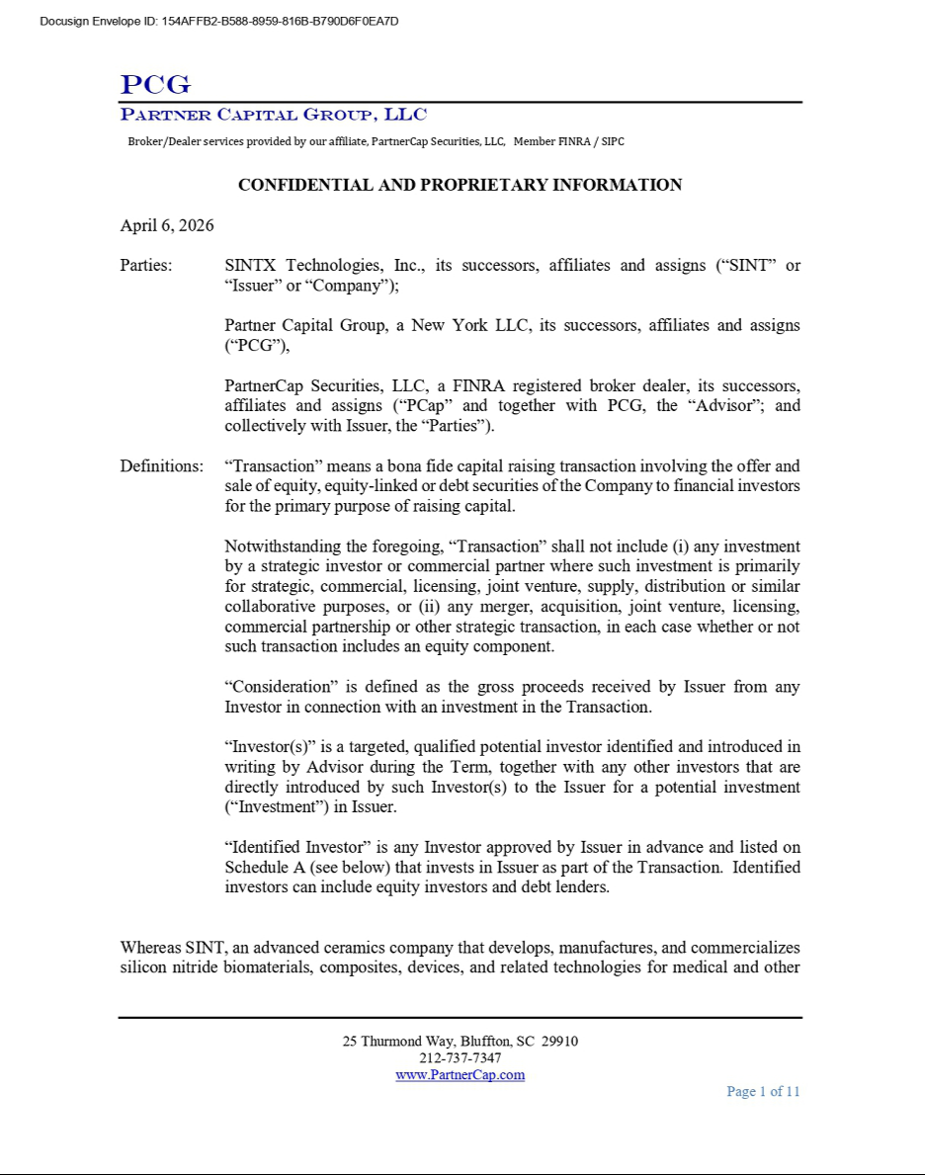

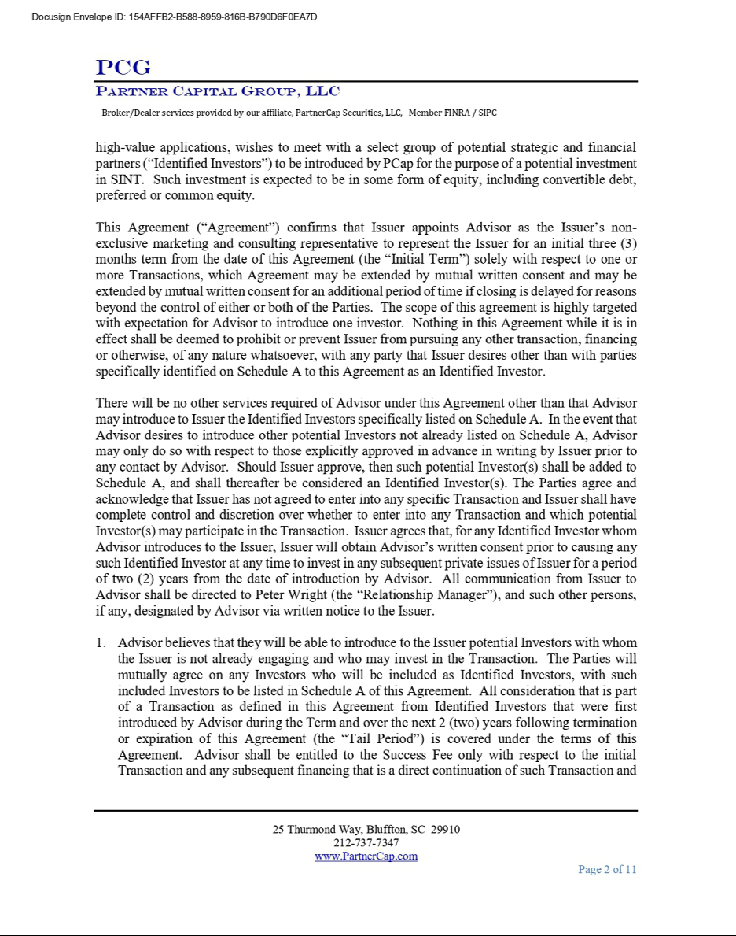

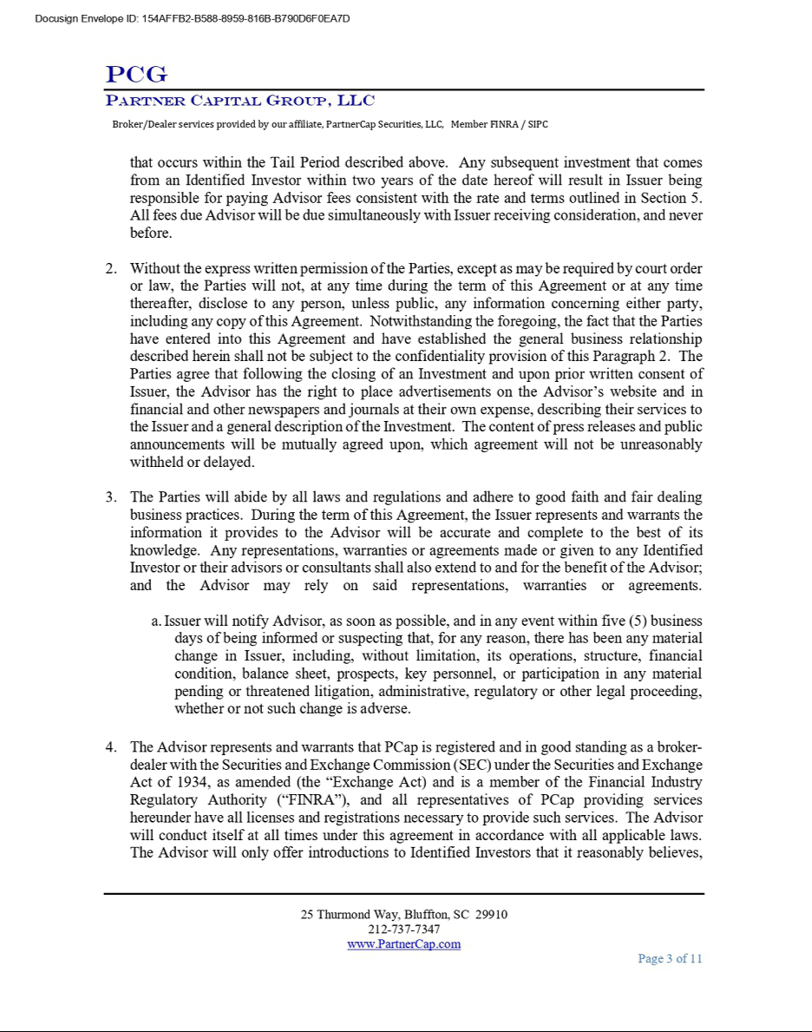

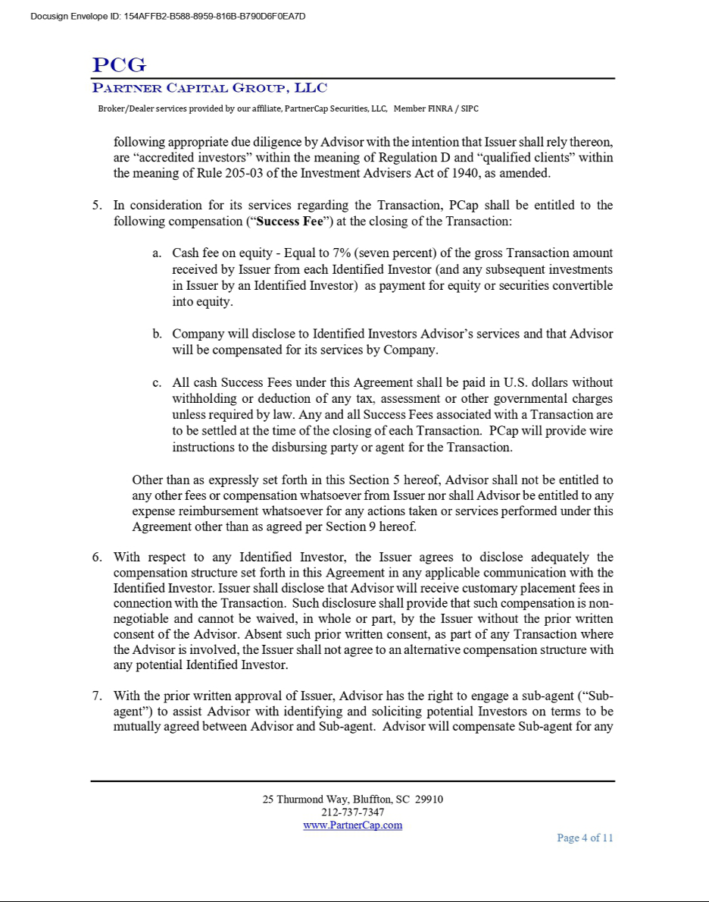

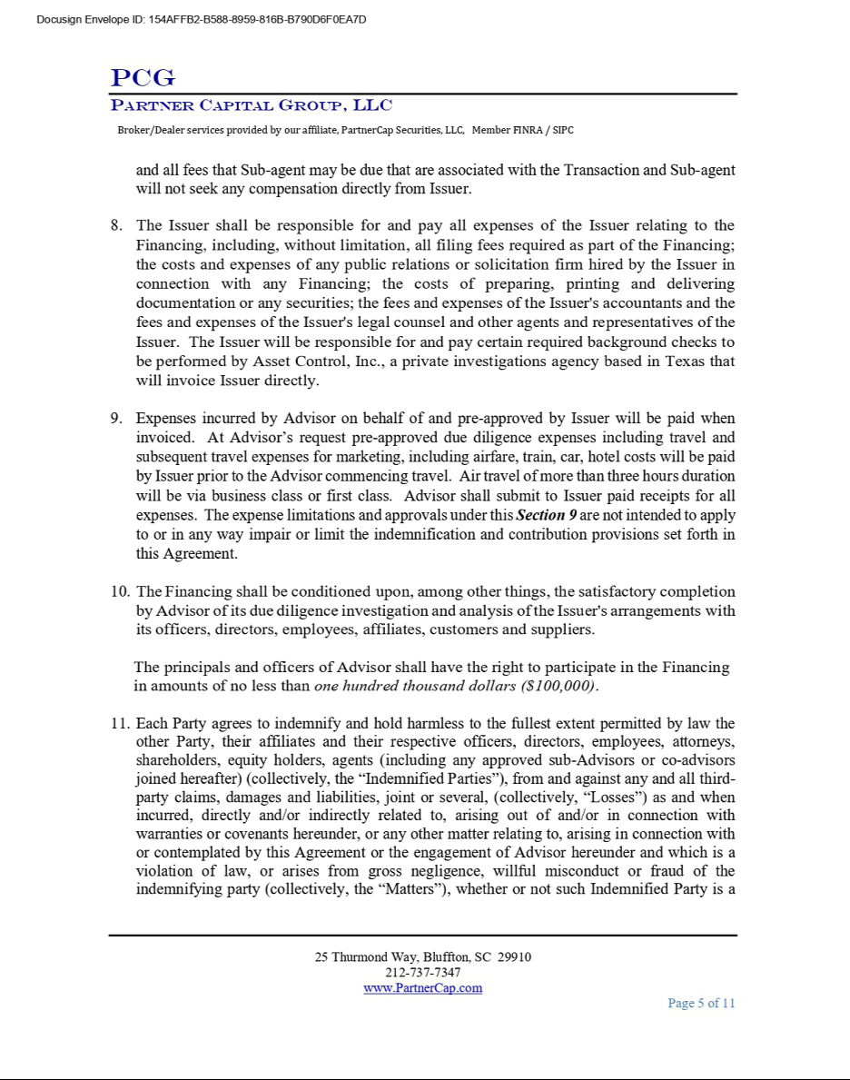

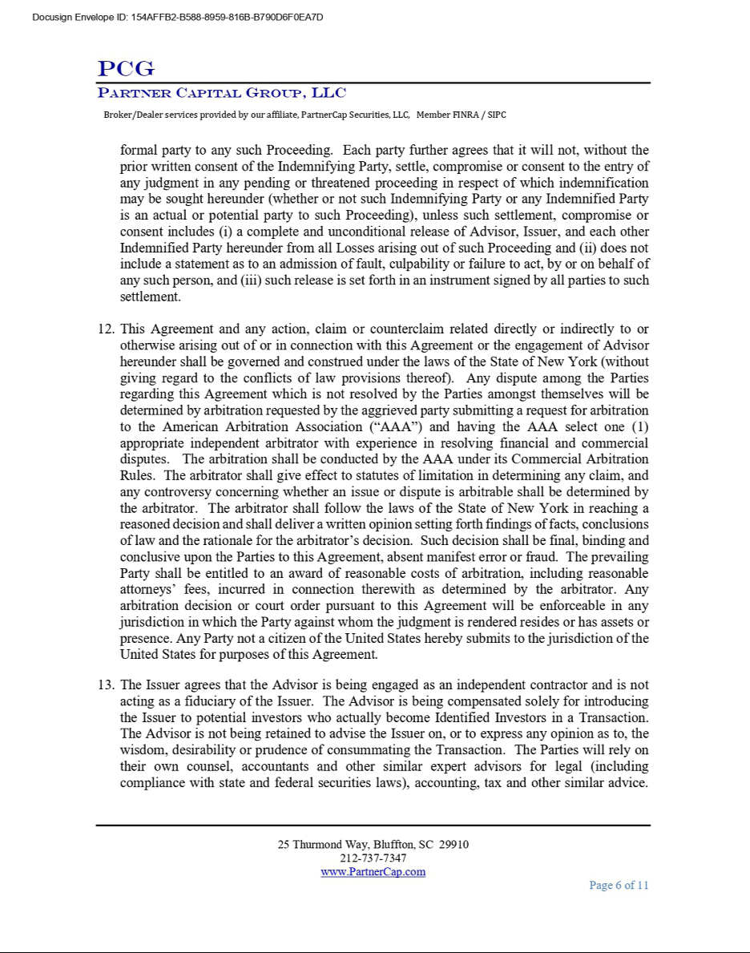

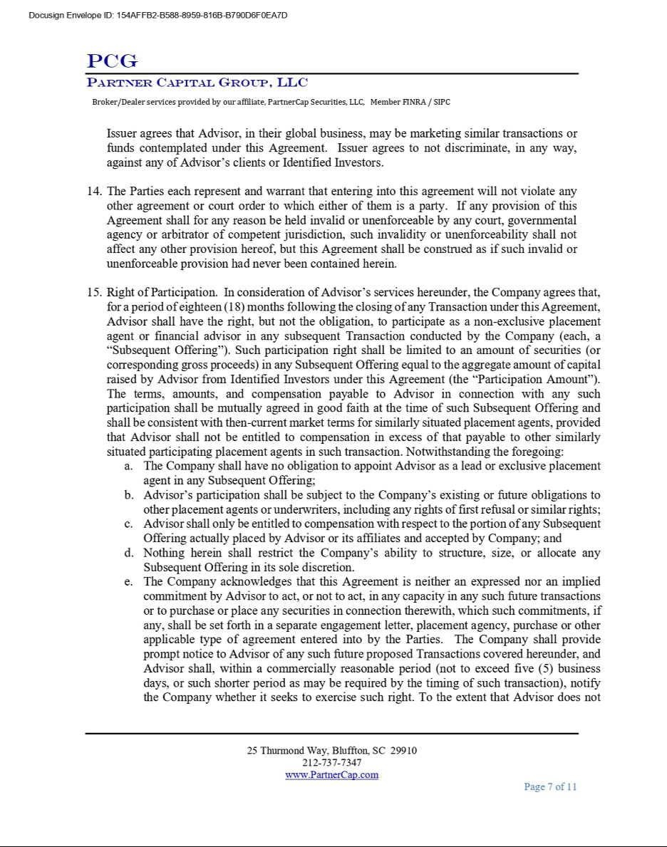

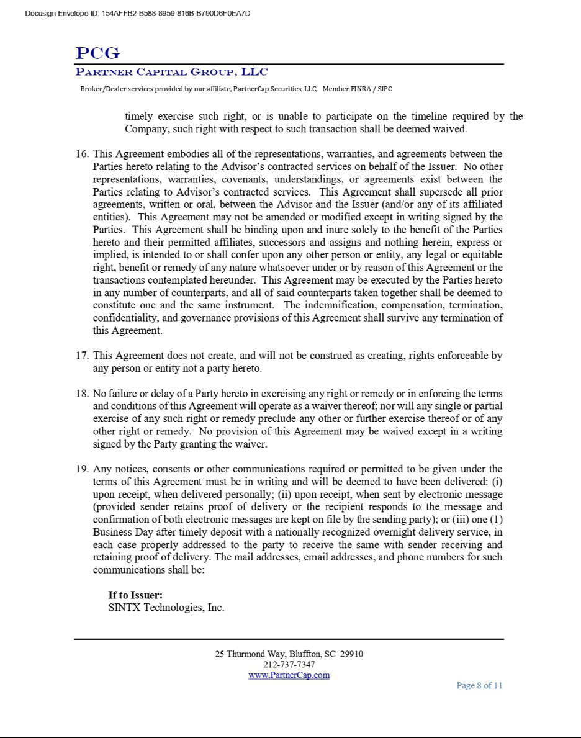

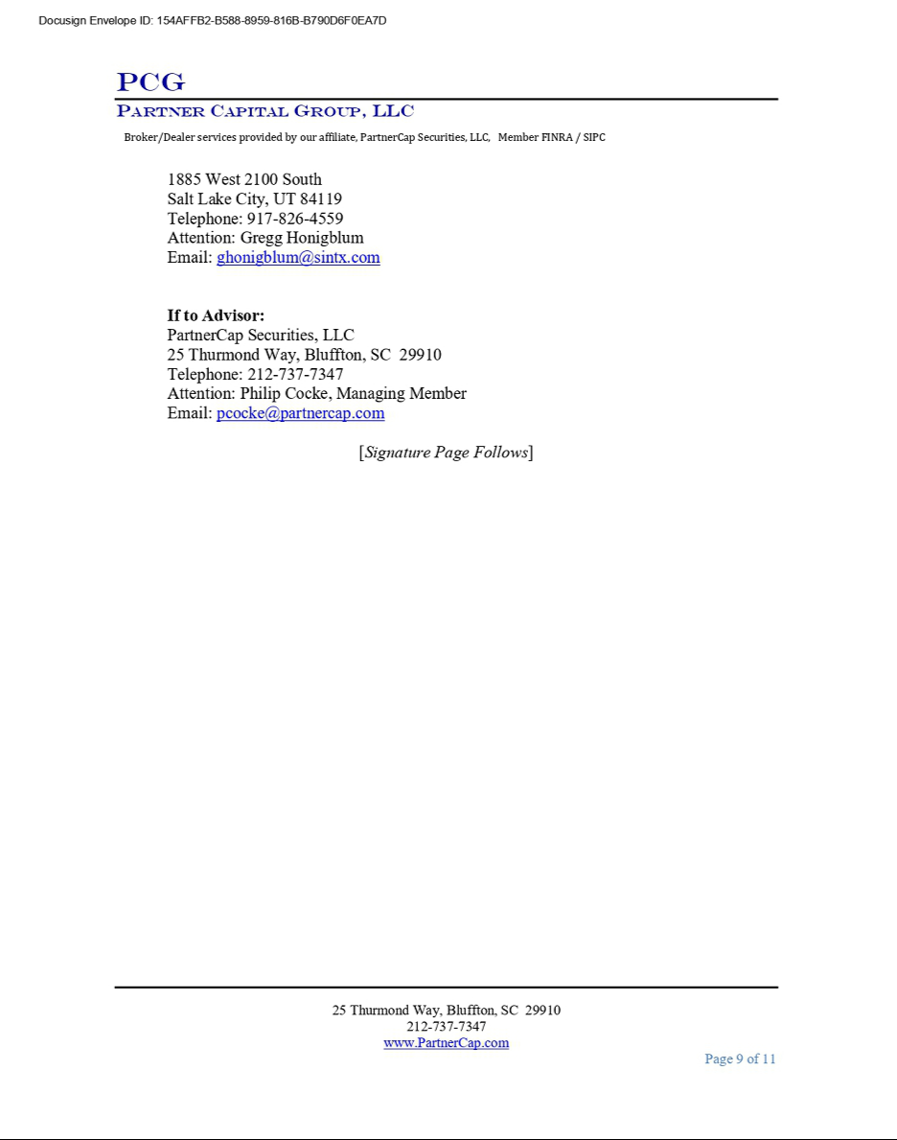

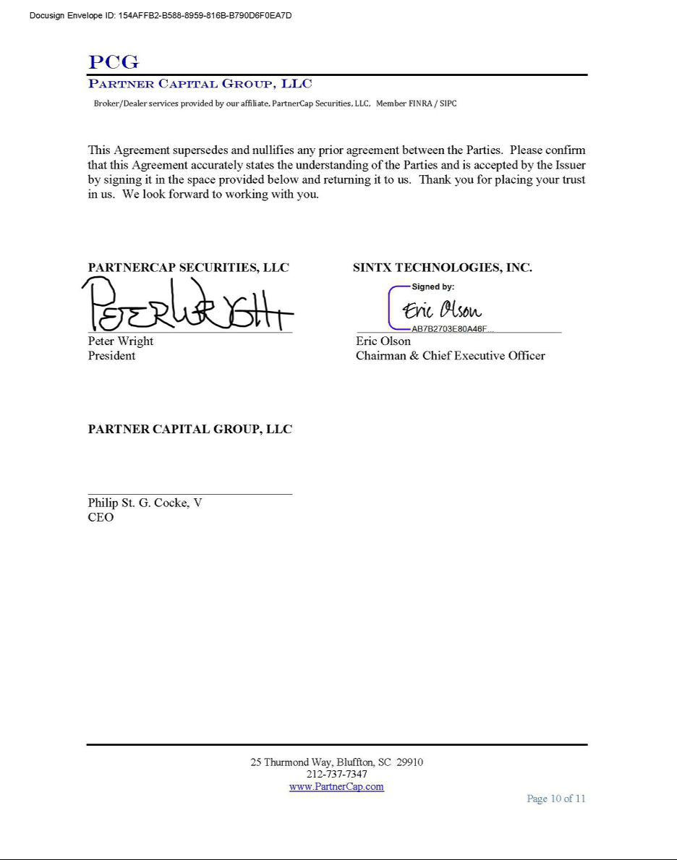

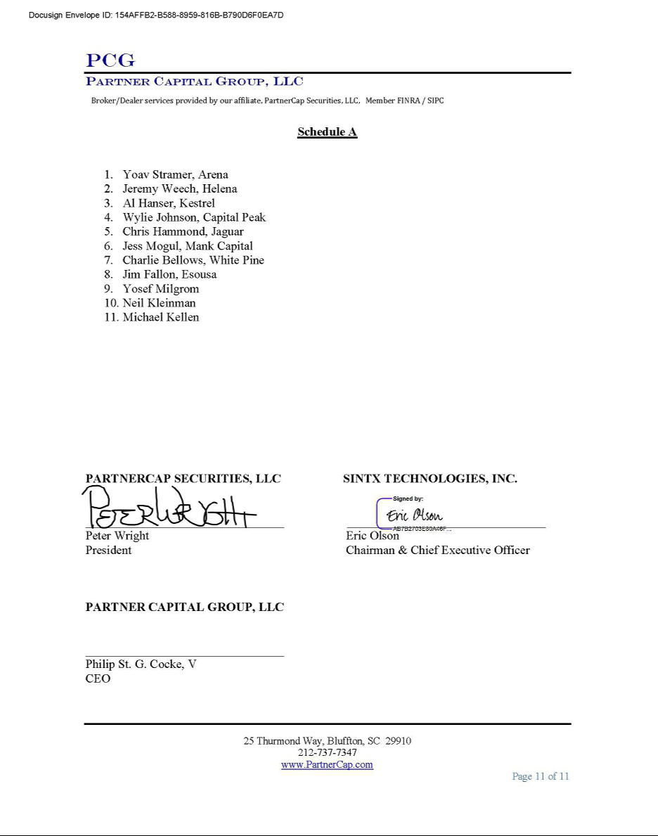

Exhibit 99.1


SINTX Technologies Announces Raise of Approximately $5.0 Million of Capital, Including a $4.5 Million Private Placement Priced At-the-Market Under Nasdaq Rules

SALT LAKE CITY, Utah – June 3, 2026 – SINTX Technologies, Inc. (NASDAQ: SINT) (“SINTX” or the “Company”), an advanced biomaterials company focused on developing silicon nitride technologies for medical applications, today announced that it has entered into securities purchase agreements with institutional and accredited investors pursuant to which the Company agreed to issue and sell an aggregate of 1,882,845 shares of common stock in a private placement priced at-the-market under Nasdaq rules.

In addition, the Company issued to the investors (i) Class A Common Stock Purchase Warrants to purchase up to an aggregate of 1,882,845 shares of common stock and (ii) Class B Common Stock Purchase Warrants to purchase up to an aggregate of 1,882,845 shares of common stock. The warrants are exercisable immediately at an exercise price of $2.14 per share. The Class A Warrants will expire five years from the date of issuance and the Class B Warrants will expire two years from the date of issuance. The combined effective offering price for each share of common stock and accompanying warrants to be issued is $2.39. The offering is expected to close on or about June 3, 2026, subject to satisfaction of customary closing conditions.

The aggregate gross proceeds to the Company from the private placement were $4.5 million before deducting fees and other offering expenses. Together with a previously completed $500,000 purchase of the Company’s common stock through its at-the-market offering program, the Company has raised approximately $5.0 million of equity capital in recent weeks. The Company intends to use the net proceeds from the offering for general corporate purposes, including working capital, commercialization activities, business development initiatives and other strategic opportunities.

“We are pleased to complete this financing and appreciate the strong support from well known Life Science investors,” said Eric Olson, Chairman of the Board and Chief Executive Officer of SINTX Technologies. “We believe this transaction strengthens our balance sheet and enhances our ability to pursue our strategic objectives while continuing to advance the development and commercialization of our silicon nitride technology platform.”

The shares of common stock and warrants described above were offered in a private placement under Section 4(a)(2) of the Securities Act of 1933, as amended (the “Act”) and Regulation D promulgated thereunder and, have not been registered under the Act or applicable state securities laws. Accordingly, the shares of common stock, the warrants and the shares of common stock underlying the warrants may not be offered or sold in the United States absent registration with the Securities and Exchange Commission (“SEC”) or an applicable exemption from such registration requirements. The securities were offered only to accredited investors.

Pursuant to a registration rights agreement, the Company has agreed to file one or more registration statements with the SEC covering the resale of the shares of common stock issued in the offering and the shares of common stock issuable upon exercise of the Class A Warrants and Class B Warrants.

This press release shall not constitute an offer to sell or the solicitation of an offer to buy these securities, nor shall there be any sale of these securities in any state or jurisdiction in which such offer, solicitation or sale would be unlawful prior to registration or qualification under the securities laws of any such state or jurisdiction.

For more information on SINTX Technologies or its biomaterial platforms, visit www.sintx.com.

About SINTX

Headquartered in Salt Lake City, Utah, SINTX Technologies, Inc. (NASDAQ: SINT) is an advanced ceramics company that develops, manufactures, and commercializes silicon nitride biomaterials, composites, devices, and related technologies for medical and other high-value applications. With thousands of medical devices implanted since 2008 and nearly two decades of peer-reviewed research, SINTX has established itself as a leader in high-performance biomaterials that enhance clinical outcomes and patient safety. Supported by a strong patent portfolio, U.S.-based manufacturing, and strategic industry partnerships, the company continues to expand its technology platform through innovation and market diversification, including the recently FDA-cleared SINAPTIC Foot & Ankle Implant System for reconstructive surgery.

Forward-Looking Statements

This press release contains forward-looking statements within the meaning of the Private Securities Litigation Reform Act of 1995 that involve risks and uncertainties. Forward-looking statements can be identified by words such as “anticipate,” “believe,” “continue,” “could,” “estimate,” “expect,” “intend,” “may,” “plan,” “potential,” “predict,” “project,” “should,” “target,” “will,” “would” and similar expressions. These forward-looking statements include, without limitation, statements regarding the anticipated use of proceeds from the private placement, the Company’s ability to regain and maintain compliance with Nasdaq continued listing requirements, the filing and effectiveness of one or more registration statements covering the resale of securities issued in the private placement, future commercialization opportunities, development of new products and technologies, strategic initiatives, operational plans and future business prospects. Forward-looking statements are based on management’s current expectations, assumptions and projections and are not guarantees of future performance. Actual results may differ materially from those expressed or implied in these forward-looking statements due to a variety of risks and uncertainties, including, without limitation, risks related to market and economic conditions, the Company’s ability to maintain compliance with Nasdaq continued listing standards, the Company’s ability to obtain additional financing when needed, risks associated with commercialization of the Company’s technologies and products, the development of new product opportunities, regulatory developments, competition, changes in customer demand and other risks and uncertainties described in the Company’s filings with the Securities and Exchange Commission (“SEC”), including the Risk Factors section of the Company’s Annual Report on Form 10-K filed with the SEC on March 20, 2026, and subsequent filings with the SEC. Readers are cautioned not to place undue reliance on forward-looking statements, which speak only as of the date they are made. Except as required by law, the Company undertakes no obligation to publicly update or revise any forward-looking statements to reflect events or circumstances after the date of this press release.

SINTX Contacts:

Investor Relations

- 801-839-3502

- IR@sintx.com

